VILLAGE OF JAMESTOWN, OHIO MATERIALS AND CONSTRUCTION SPECIFICATIONS
MANUAL JANAURY 1, 2009

DISCLAIMER:

Wherever a conflict exists between this manual and any other reference material, the most stringent guidelines will be used as determined by the Village of Jamestown Engineer or his representative.

 | . | VILLAGE OF JAMESTOWN  MATERIALS AND CONSTRUCTION SPECIFICATIONS  MANUAL  MATERIALS SECTION

VILLAGE OF JAMESTOWN MATERIALS AND CONSTRUCTION SPECIFICATIONS
MANUAL

These specifications are approved by theVillage Council. They are written and approved by theVillage of Jamestown and shall be enforced. TheVillage of Jamestown has the right to make non-
substantial changes to these specifications. No substantial part of these specifications may be altered without the approval of Village Council.
Disclaimer:

Wherever a conflict exists between this manual and any other reference material, the most stringent guidelines will be used as determined by theVillage of Jamestown or their representative.

NOTE: The Cons/me/ion Inspector representing theVillage of Jamestown has the authority to temporarily halt work on projects within theVillage's jurisdiction pending resolution of co,iflicts, disputes or any other problen which may arise during the course of construction

MATERIAL SECTION
I

TABLE OF CONTENTS
MATERIALS SECTION I PAGE
  - General !
  - Standards 1
  - Inspection and Testing 1
  - Samples 1
  - Erosion and Sediment Controls 2
  - C-900 PVC Water Main 2
  - C-900 Water Main 2
  - Materials 3
  - Pipe and Gasket.......................................................................................................-3
  - Marking 3
  - Approvals 3
  - Exposure to Sunlight. 3
  - Extreme Cold 3
  - Receiving, Handling and Storing PVC Pipe 3
  - Ductile Iron Pipe Water Main 3
  - Ductile Iron 3
  - Joints 4
  - Fittings 4
  - Coatings for Ductile h-on Pipe and Fittings 5
- Anchoring Assemblies 5
- Pressure Service Lines 6
  - General. 6
  - Service Pipe 6
  - PE Polyethylene Resin Water Service Pipe (CTS) 7
  - Service Saddle ?
5.S Corporation Stops 7
  - Service Stops 7
  - Service Boxes 7
  - Meter Pit Barrel¾ inch and l inch 7
  - Meter Pit Barrel I ½ inch and 2 inch 7
  - Meter Pit Cover ?
  - Outside Meter Yoke 8
  - Valves and Gates 8
  - General 8
  - Type ofValve 8
  - Valve Boxes 8
  - Gate Valve 8

  - Operating Nnt 9
  - Hand Wheels 9
  - Bypass Valves 9
  - Special Details 9
  - Direction For Opening 9
  - Tapping Sleeves and Valves 10
  - Tapping Sleeves J0
  - Pressure Testing Tapping Sleeve 10
  - Check Valves 10
  - Air Release, Air/Vacuum and Combination Valves 11
- Fire Hydrants ] J
- Sanitary Sewers 12
  - PVC Sanitary Sewer Pipe 12
  - Fittings 12
  - Manufacturer 12
  - Inspection 13
  - Exposure to Sunlight 13
  - Temperature 13
  - Pipe Joints 13
- Truss Pipe 13
10.l General 13
- Reinforced Concrete Pipe 13
! I.I General 13
  - Joints 14
  - Service Connections 14
- CasingPipe 14
  - General 14
I2.2 Reinforced Concrete Casing Pipe 14
  - Steel Casing Pipe 15
- Gravity Pipe 15
- Flexible Couplings 15
- Manholes 15
  - General 15
  - Pre-cast Manhole Base. 15
  - Pre-cast Manhole Barrel. 16
  - Pre-cast Cones 16

  - Flat Slap Manhole Tops 16
  - Steps 16
  - Frames and Covers.................................; 16
  - Chimney Seals 17
  - DropAssemblies 17
  - VentingAssemblies 17
  - Swing Check Valves 17
  - Storm Sewers J8
  - HDPE ( High Density Polyethylene) for Storm Sewers 18
  - Joints 18
  - Matelial Properties 18
  - Reinforced Concrete Pipe RCP 18
  - Joints 18
  - Castings 18
  - TrenchMaterlal....................; 19
  - Pipe Bedding 19
  - Gravel Backfill 19
  - Concrete Encasement, Cradle 19
18.l Strength (concrete) 19
  - Reinforcing Steel 19
  - Restoration 19
  - Topsoil 19
  - Street General 19
  - Sod 20
  - Seeding and Mulching 20
  - Fertilizer 20
  - Concrete 20
  - Street Signs 20
20.l Street Markers and Stop Signs 20
  - Stop Signs 20
  - X-4 20
  - Street Lights 21
21.l Street Lights 21

VILLAGE OF JAMESTOWN
MATERIAL SPECIFICATIONS

  - GENERAL
  - Standards - All material furnished by the contractor to be installed on the project shall conform to the minimum requirements of the latest revisions in effect on the date of the standard specifications published by the described organizations, unless other requirements are stated in these specifications. The standard specifications are combined under a single caption for the sake of brevity whenever referred to in the specifications, as follows:

American Disabilities Act
American Society for Testing & Materials American National Standards Institute American Water Works Association American Concrete Institute
American Association of State Highway & Transportation Officials Village of Jamestown Standard Drawing
Const. And Mat. Specs. Of the State of Ohio, Dept. of Transportation (2005 edition)
Occupational Safety & Health Administration Water Environment Federation
ADA ASTM ANSI AWWA AC!
AASHTO SD-# ODOT

OSHA
WEF

  - Inspection and Testing - The manufacturer of the specific materials shall establish the necessary quality control and inspection practice to ensure compliance with the individual specification outlined above for the particular material. The manufacturer shall, if required by these specifications, furnish a sworn statement that the inspection of all the specified tests have been made and the results therefore comply with the requirements of the particular standard specified. The manufacturer/contractor shall furnish certified copies of such test results if so stipulated in these specifications or requested by theVillage of Jamestown.
  - Samples - The contractor shall be required to furnish samples of any or all mate1ials, proposed to be used, that do not meet Village Standards for approval by theVillage of Jamestown.

No material or equipment, of which samples are required to be submitted for approval, shall be used until approved by theVillage of Jamestown.

Samples of materials or equipment submiUed for approval shall have a label indicating the material represented, its place of origin, the name of the producer, the contractor expecting to use the equipment, and the work for which the material will be used. Samples of finished materials

shall be marked to indicate where they are required by the drawings and specifications. Eacb delivery of samples shall be accompanied under separate cover by a letter, in duplicate, from the contractor, containing a list of samples, an indication of where the materials are intended to be used, the brands of materials, and names of the manufacturers.

Approval of any samples shall not be taken, in itself, to change or modify any specification requirement. Approval shall be only for the characteristics or for the use of the material. After a material has been approved, no change in brand or make will be pennitted. Approved samples of hardware in good condition may be suitably marked for identification and later used in the work. Failure of any material to pass these specified tests will be sufficient cause for refusal to consider any further samples of the same brand of that material for use under these specifications. The Village, whenever it may deem necessary, may take test samples from the various materials or equipment delivered to the work site by the contractor. If any such test sample fails to meet the specification requirements, any previous approvals will be withdrawn and such materials or equipment shall be subject to removal and replacement by the contractor with mate1ials or equipment meeting the specification requirements.

  - Erosion and Sediment Controls - Shall meet all of the following as determined by theVillage of Jamestown or their Representative. In case of a conflict the most stringent guidelines shall govern.
    - Water Pollution Control Federation
    - Federal Water Pollution Control Act
    - Current Edition of 'Water Management and Sediment Control for Urbanizing Areas" published by the Soil Conservation Service USDA.
    - Ohio Environmental Protection Agency
    - Ohio Revised Code
    - Ohio EPA Phase II Storm Water program
    - ODOT Item 207 Temporary Spil Er9sion and Sediment Control
    - Village of Jamestown Codified Ordnances
    - Village of Jamestown Materials and Construction Specifications Manual
    - Village of Jamestown Approved Construction Drawings

C-900 PVC WATER MAINS

  - C-900 Water Main - This specification coven: the manufacturer's requirements for C-900 PVC municipal pipe. The pipe shall meet or exceed the industry standards set forth by the American Water Works Association and the American National Standards Institute.

Unless otherwise indicated on the plans, all pipe 6-inch through 12-inch diameter shall be Pressure Class 350 with the following thickness:

6-inch 8-inch IO-inch 12-inch
0.18-inch (Hydrant connections only) 0.20-inch
0.22-inch 0.24-inch

For larger diameter pipe, pressure class and pipe wall thickness shall be per Table 12, AWWA
CISO, for Earth Load plus Truck Load, using Laying Condition Type 2 for specifying pipe. Alternately, Special Thickness Class 52 may be used unless otherwise noted on the plans.

3,2 Joints - Mechanical joints, bell and spigot joints, and flanged joints for ductile iron pipe in sizes from 3-inches through 48-inches in diameter shall confonn to all of the dimensions, shapes, and requirements of "Ductile and Gray Iron Fittings, 3-inch through 48-inch for Water and Other Liquids," ANSI A21.10 (AWWA C110). The mechanical joint shall also confonn in all respects to "Rubber Gasket Joints for Ductile Iron Pressure Pipe and Fittings," ANSIA21.l 1 (AWWA Clll).

Push-on joints shall be a single rubber gasket joint designed to be assembled by the positioning of a continuous, molded, rubber ring gasket in an annular recess in the pipe, and forcing of the plain end of the entering pipe into the socket thereby compressing the gasket radically to the pipe to form a positive seal. The gasket and the annual recess shall be so designed and shaped that the gasket is locked in place against displacement as the joint is assembled. The push-on type joint shall confo1m to the requirements of ANSI A2l.10 (AWWA Cl!0) and ANSI A21.l l (AWWA Cl 11) where applicable.
Where ductile iron pipe with bell and socket type joints are specified, they shall be of the mechanical gland or expansion and contraction with a positive stop against disengagement of the joint. Up to 15 degrees angular deflection shall be accommodated without leakage and without decrease in full diameter of pipe.

3.3 Fittings - Cast iron or ductile iron fittings in siws 3-inches through 48-inches for mechanical joints, bell and spigot joints, and flange joints shall conform to all the requirements of "Ductile and Gray Iron Fittings, 3-inches Through 48-inches for Water and Other Liquids," ANSI A21.10 (AWWA Cl!0 and AWWA Cl53), and to the requirements of''Rubber Gasket Joints for Ductile and CaSt Iron Pressure Pipe and Fittings,'' ANSI A21.l l (AWWA Cll l) for mechanical joints and push-on type joints.

The fittings for use on ductile iron pipe may be either gray iron or ductile iron. The fittings larger than 12-inches shall have a minimum pressure rating of 150 psi unless otherwise shown on the approved construction drawings.

3.4 Coatings for Ductile Iron Pipe and Fittings - The ductile iron pipe and cast iron or ductile iron fittings shall be furnished with cement mortar lining in accordance with "Cement Mortar Lining for Ductile Iron Pipe and Fittings for Water," ANSI Specification A21.4 (AWWA C104). The lining will be 1/16-inch thick for pipe sizes 4-inches through 12-inches in diameter and 3/32- inch thick for size 14-inches through 24-inches in diameter. A bitwninous seal coat shall be applied to the lining swface immediately following the lining operation to prevent loss of moisture and assure proper curing of the cement mortar. The outside of the iron pipe shall be furnished with a protective bituminous coating.

Anchoring Assemblies and .Joint Restraint
(Standard Drawing #102)
4.0 Anchoring Assemblies and Restraint -Anchor tees and anchor pipe will be required forall fire hydrants and hydrant valves. Joint resn-aint assemblies will berequired forsetting other valves, tees, dead ends, plugs, caps. and bends as shown on theconstruction drawings. Acceptable Joint restraint assemblies are Meg-a-lug type and Bell Joint Restrainers. Mechanical joint restraint, for ductile iron pipe shall be the Series 1100 Megalug resn-aint as produced by EBAA Iron, Inc. or approved equal. The restraint shall be incorporated into the design of thefollower gland. The restraining mechanism shall consist of individually actuated wedges that increase their resistance to pull-out as pressure or external forces increase. The device shall be capable of full mechanical joint deflection during assembly and the flexibility of the joint shall be maintained after burial. The joint resn-aint ling and its wedging components shall be made of grade 60-42-10 ductile iron conforming to ASTM A536. The wedges shall be ductile iron heat treated to a minimum hardness of 370 BHN. Dimensions of thegland shall besuch that it can be used with thestandardized mechanical joint bell conforming to ANSI/AWWA Clll/A21.11 and ANSI/AWWA Cl53/A21.53 of the latest revision. Torque limiting twist-off nuts shall be used toinsure proper actuation of the restraining wedges. They shall have a rated working pressure of 350 psi in sizes sixteen inch and smaller and 250 psi in sizes eighteen inch through forty-eight inch. The devices shall be listed by Underwriters Laboratodes up through the twenty-four inch size and approved by FM up through the twelve-inch size.
Mechanical joint restraint, for PVC pipe, shall be incorpm-ated into the design of the follower gland. The restraint mechanism shall consist of a plurality of individually-actuated gripping swfaces .to maximize restraint capability. Glands shall be manufactured of ductile iron conforming to ASTM A536. The gland shall be such that it can replace the standardized mechanical joint gland and can be used with the standardized mechanical joint bell conforming to ANSI/AWWA Cl l l/A21.l I and ANSI/AWWA Cl53/A21.53 oflatest revision. Twist off nuts, sized same as tee-head bolts, shall be used to insw-e proper actuating ofrestraining devices. The restraining gland shall have a pressure rating equal to that of the pipe on which it is used. The restraining glands shall be listed by UL, and
be approved by Factory Mutual. The restraint shall be the EBAA Iron Series 2000PV or approved equal..

Restraint Harness for Ductile Iron Pipe push on bells size 4" and greater shall be made of ductile iron components. All ductile iron shall conform to ASTM A536. A split ring shall be used behind the bell and restraining ring shall have actuated wedges provide increased resistance to pull-out as pressure of external forces increase. Theconnecting tie rods that join the two rings shall be made of low alloy steel that conforms to ANSI/AWWA Cll l/A21.1l. The assembly shall have a rated pressure of350 psi for size sixteen inch and smaller and a rated pressure of 250 psi in sizes eighteen inch through thirty-six inch. The restraint shall be the Se1ies 1700 Megalug Restraint Harness as produced by EBAA Iron, Inc or approved equal.
Restraint for existing Ductile Irou Pipe push on bells shall be made of ductile iron components conforming to ASTM A536. Thesplit rings shall incorporate individually actuated giipping surfaces on the pipe ring opposite of the bell. A sufficient number of bolts shall be used to connect the bell ring and the pipe ring. The combination shall have a minimum working pressure rating of 350 psi for sizes eight inches and less, 300 psi for sizes ten inches through 16 inches, and 200 psi sizes 18 inches through 36 inches. The restraint shall be the Series 11OOHD Restraint for Existing Push-on Joints for Ductile Iron Pipe as manufactured by EBAA Iron, Inc or approved Equal.
Restraint Harness for C900 PVC pipe bells size 4" - 12" shall be made of ductile iron components. All ductile iron shall conform to ASTM A536. A split ring shall be used behind the bell and a serrated restraint ring shall be used to grip the pipe. A sufficient number of bolts shall be used to connect the bell ring and the pipe ring. The combination shall have a minimum working pressure rating of 150 psi. The restraint shall be the Series I600 as produced by the EBAA Iron, Inc.
Restrained flange adapters shall be made of ductile iron confonning to AS1M A536 and have flange bolt circles that are compatible with ANSIAWWA C115/A2l.l 5. Restraint for the flange adapter shall consist of a plurality of individually actuated giipping wedges to maximize restraint capability. Torque limiting actuating screws shall be used to insure proper initial set of the giipping wedges. The flange adapters shall be capable of deflection during assembly or pennit lengths of pipe to be field cut to allow a minimum 0.6 in. gap between the end of the pipe and the mating flange without affecting the integrity of the seal. For PVC pipe, the flange adapters will have a pressure rating equal to the pipe. For Ductile Iron Pipe, the flange adapter shall have a safety factor of 2:1 minimum. The flange adapter shall be the Series 2100 Megaflange adapter as produced by EBAA Iron, Inc. or approved equal.

  - Pressure Service Lines (Standard Drawing #105 through 109)

S.1 General - The materials for pressure service lines shall meet the following specifications. All service lines shall use compression-type fittings (no flare). No McDonald Fittings

  - Service Pipe and PVC Service Line-Pressure service pipe shall be copper pipeor PVC Service Line and shallconform to the dimensions,weights, and tolerances stated in"Copper Water Tube,"for Type"K," Table No. II,ASTM B88. The copper service line or PVC Service Line shall be
¾-inch through 2-inches in diameter.

  - PE Polyethylene Resin Water Service Pipe{CTS) - Pressure service polyethylene pipe shall conform to ASTM D 2737. The material shall comply with ANSYNSF Standard 61 and meets the requirements of AWWA C 901. ¾ INCH THROUGH 2 JNCH Pipe shall be CTS (copper tube size) 200 PSI PE 3408 SDR 9. All installed Polyethylene resin water services shall have a #10 solid copper coated tracer wire taped to and installed with this type water service.
(Tracer tube type pipe is accepted). Pipe shall be bedded per Village of Jamestown standard for buried pipelines and conduits. (STD Drawing #101 and 102) All inserts shall be stainless steel.
  - Service Saddle - Shall be used on PVC pipe and be epoxy-coated with wide stainless steel straps and bolts. The service saddle shall be the equal of Smith - Blair Inc. type 315 or Romac Ind. Inc. style #IOIn or #202n. Equals must be approved by theVillage Engineer or
Engineer's Representative.

5,5 Corporation Stops - Corporation stops shall be of cast bronze construction with ground key stops of Ford Meter Box Co. F-1000 or approved equal.

  - Service Stops - Service stops shall be of cast bronze or cast brass construction designed to receive copper pipe on each side. They shall be of the solid tee head type with"Tetlon" coat plus top and bottom "O" rings for positive pressure sealing without mechanical means. The stops shall be the equal of Ford Meter Box Company, ¾-inch B44-333, !-inch B44-444, I ½-inch B44- 666, or 2-inch B44-777.

  - Service Boxes - Service boxes shall be plastic, slip style, with a 2 ½-inch shaft diameter or approved equal. The lid shall be made of iron marked "Water" and secured with a brass or bronze bolt inlaid level with the lid surface. The box shall be equipped with a foot piece to straddle the service stop (telescoping type).

  - Meter Pit Barrel ¾-inch and 1-inch Service - The meter pit barrel for outside meter installation shall be Sono-Loc 20-inches dia. the length of the barrel shall be 30-inches. The barrel shall have two notches in the bottom edge on opposite sides approximately 4-inches deep and 2-inches wide to receive the service pipes.

5,9 Meter Pit Barrel I ½-inch and 2-inch Service - The meter pit barrel for outside meter installation shall be Sono-Loc 30-inch diameter x 30-inch length for l ½-inch service and 36- inch diameter by 30-inch length for 2-inch service or approved equal. An extension ring is required to reduce the diameter of tbe pit toVillage meter pit cover standard. The barrel shall have two notches in the bottom edge on opposite sides approximately 4-inches deep and 3-inches wide to receive the service pipes.

  - Meter Pit Cover - Meter pit covers shall be of the single lid type. The top cover and frame shall be of cast iron with an 11 ½-inch lid opening. The assembly shall be 4 ½-inches in depth with the bottom flange sized to fit on the meter pit barrel. The top lid of the cover shall be furnished with a locking de, ce, which will unlock the lid from the frame and raise the lid at the

same time. Lifter-lock bolts shall be forged silicon-bronze Ford Meter Box Co. standard 27/32 inches. The meter pit cover shall be the equal of Type C-3 with 11 Vi-inch lid as manufactured by the Ford Meter Box Company.
  - Outside Meter Yoke - Meter yokes shall be of the riser type with a valve inlet. The body of the yoke shall be cast iron with a brass valve inlet end and a brass ell outlet end. The ends shall be connected to the yoke with brass lock nuts. The valve shall be of the inverted key angle type. The yoke shall contain a brass expansion connection to allow for connecting or disconnecting a meter. The inlet and outlet shall be for copper pipe connections. The yoke shall be the equal ofY502 for ¾-inch service and Y504 for I-inch service manufactured by the For'd Meter Box Company or approved equal.

6.0 Gate Valves and Resilient Wedge (R/W) Valves
  - General Valves of the sizes and types specified or shown on the construction drawings shall be provided for the proper completion of the work included under the project.
Operating nuts, handwheels, gaskets, bolts and nuts, and all necessary appurtenances for a complete installation of the valves and gates shall be furnished with the valves. If valves are not underground they shall be cleaned and painted after installation.

Complete details of all valves to be used on the project shall be submitted to theVillage for approval prior to shipment. All valves shall open right (clockwise).

  - Type of Valve - The construction drawings may state which type of valve is to be used. If the type is not stated and only the size is given, either the gate type or resilient wedge type with a minimum working pressure of 250 PSI may be used.

  - Valve Boxes - A valve box shall be provided for every operating nut of a buried gate valve, with operating mechanism fully protected with a cast iron case. The valve box shall not transmit shock or stress to the valve. It shall be centered and plumb over the wrench nut of the valve.
The box cover shall be flush with the finished pavement or at such other level as may be directed by theVillageEngineer. The assembly shall consist of three pieces and a cover. The cover shall be marked "Water" where the pressure main is installed for water service. The valve box shall be screw-type, cast iron with 5 ¼-inch shaft. A round base that will enclose the valve bonnet shall be furnished with 6-inch and 8-inch valves. An oval base shall be supplied with valves larger than 8-inches.

  - Gate Valves - Gate valves for buried pipe lines shall be iron body, bronze mounted, double­ disc, gate valves with non-rising stems having either parallel or inclined seats in accordance with "Metal-seated Gate Valves for Water Supply Service" AWWA CSOO or "Resilient-seated Gate

  - Materials - All C-900 PVC pipe shall be made from Class 12454-A or Class 12454-B virgin compounds as defined in ASTM D-1784, with an established hydrostatic-design-basis rating of 4,000 PSI for water at 73.4 F.

  - Pipe and Gasket - C-900 PVC pipe shall have a cast iron outside diameter and shall be suitable for use as a pressure conduit. All pipe shall be Pressure Class 150 DR!8 unless otherwise specified on the plans and approved by the Village Engineer. Provisions must be made for expansion and contraction at each joint with an elnstomeric sealing ring. Laying length shall be 20-feet ±. The joint shall be in compliance with the requirements of ASTM D-3139.

  - Marking - C-900 PVC pipe shall be marked as prescribed by AWWA standards; i.e., nominal pipe size, dimension ratio (DR), AWWA pressure class, manufacturer's name and code, and seal of testing agency that certified the suitability of the pipe material for potable water service.

  - Approvals - All C-900 PVC pipe used in Village of Jamestown must be listed by Underwriters Laboratories and comply with all applicable AWWA requirements.

  - Exposure to Sunlight - PVC pipe shall be covered to prevent prolonged exposure to sunlight (ultraviolet rays).

  - Extreme Cold - No installation of PVC pipe shall be permitted when air temperature is below 10 degrees Fahrenheit.

  - Receiving, Handling, and Storing Pipe Shipment - All shipments should be inspected as soon as possible after arrival. After examining the load for any damage that may have occurred during transit and checking the quantity, size, and class of pipe against the packing slip, the unloading of the pipe can begin.

The preferred method of unloading is to remove each unit intact by the use of mechanical equipment. The units should be picked up with a forklift truck or by a sling, being careful to avoid excessive swinging. Since the impact strength of PVC pipe decreases in cold weather, care should be taken neither to drop the pipe nor to set the pipe down on sharp, protruding objects. If the pipe is to be stacked in racks, suppoit it every 4-feet. Do not throw, whip, or drop the pipe
and do not use chains to unload. The pipe should be stored away from mud and water with every attempt to keep it clean.

Ductile Iron Pipe Water Main
  - Ductile Iron - Ductile iron pipe shall conform to the American National Standards Institute Specification for "Ductile Iron Pipe Centrifugally Cast in Metal Molds for Water or Other Liquids," ANSIA21.51 (AWWACl51).

Valves for Water Supply Service," AWWA C509. All gate valves and fire hydrants shall open
left (counterclockwise),

The ends of the valve shall be mechanical joint or flange. Mechanical joint bell ends will be used in buried pipe lines of mechanical joint and rubber seal type or joint cast iron. Flange ends will be used in exposed cast iron piping at the locations shown on the construction drawings.

  - Operating Nuts - Gate valves for buried pipelines shall be furnished with 2-inch square wrench nuts. Nuts shall have a flanged base upon which shall be cast iron an-ows 2-inches long showing the direction of opening, and the word "Open" in ½-inch or larger letters shall be cast on the nut to clearly indicate the direction the wrench is to be turned to open the valve. All valves
in Jamestown opento the left.

  - Hand Wheels - Hand wheels may be specified for operating valves in exposed piping on the construction drawings. The handwheels shall have an an-ow and the word "Open" cast thereon to clearly indicate the direction the handwheel is to be turned to open the valve. The diameter of the handwheel shall conform to the following dimensions for the various size gate valves:
Size of Valve Diameter of Handwheel

4-inch 6-inch 8-inch
10-inch and 12-inch 16-inch and 18-inch
IO-inch 12-inch 14-inch IS-inch 22-inch

  - Bypass Valves - Bypasses shall be furnished on valves when so specified on the proposal sheets or shown on the construction drawings. The bypass valve shall be furnished of the same type as the main line valve to which it is fitted. The size requirements of the bypass shall be as follows:

Valve Diameter - Inches 16 - 20 Valves Required
Bypass Diameter - Inches 4-inch Bypass Minimum

- 6.8 Special Details - The details of other valve requirements and valve appurtenances such as special ends and materials, position indicators, floor stands, cylinders, chain operators, and extension stems and guides shall be described on the construction drawings.

6.9 Direction of Opening - The valves shall open by turning the operator to the LEFT; that is, in a counterclockwise direction.

  - Tapping Sleeves, Valyes i:11.d Check Valves
  - Tapping Sleeves• Tapping sleeves and tapping machine valves of the size specified should be installed by the contractor at the locations shown on the construction drawings or set by the Village Engineer or his Representative. The tapping sleeve shall be field approved by theVillage representative prior tap being made. When it is necessary to cut into au existing water main under pressure the tapping sleeve shall be of the mechanical joint or stainless steel type. It shall be installed in such a manner as to provide a watertight joint with both sections of the sleeve and the existing water main. The sleeve shall be installed so that the axis of the center of the valve opening is level. (Tapping sleeves shall be mechanical joint or stainless steel type.)

  - Pressure Testing Tapping Sleeve• Tapping sleeves shall be hydrostatically pressure tested as follows:

Domestic main installation. 150 PSI for 15 minutes Fire line installation • 200 PSI for 15 minutes

The contractor shall use a suitable large drilling machine to make the cut into the existing water main under pressure. The section of pipe shall be removed and given to theVillage Representative. A-Village representativemust be present during tapping sleeve pressure test and water main taps.

The sleeve and valve shall meet all of the requirements of these specifications and will be field approved by theVillage Engineer or Engineer's Representative and shall be AWWA approved.
ALL VALVES SHALL OPEN RIGHT (CLOCKWISE).
  - Check Valves. Check valves shall be cast iron body, horizontal swing type, fully bronze mounted with a bronze gate, and set rings machined to a watertight surface. The gate shall hang from a stainless steel shaft with a heavy, solid, bronze hinge. The gate shall be assembled in such a manner as to prevent gate rotation, distribute the seat wear, and assure alignment of the gate with the body seat. The check valve body design shall obtain full, nominal pipe diameter with the valve clapper clear of the waterway in the open position. Check valves shall conform to "Swing-Check Valves for Waterworks Service, 2-inch through 24-inch NPS", AWWA C508.
Check valves shall be supplied with removable covers or hand hole plates for inspection and maintenance without removing the valve body from the line.

Underw1iters Laboratories, Inc. check valves, if specified on the construction drawings and/or proposal sheets, shall be provided with two bosses on each side, two bosses on the bottom, and

the inspection seal of the Underwriters Laboratories, Inc. Special taps in the bosses, if required, will be specified on the constmction drawings.

The type outside lever and spring and outside lever and weight accessories for check valves will be specified on the constmction drawings if such accessories are required.

Normally, the check valves shall be supplied with flanged ends. If special ends are required, those ends shall meet the similar specific requirements stated for gate valves and shall be shown on the cons!IUction drawings and approved by theVillage.

AU check valves shall be tested hydrostatically by the manufacturer per AWWA C508, Section 5.2.

The design features of the check valve to be used on the project must be submitted to theVillage for approval prior to installation.

  - Air Release, Air/Vacuum, Combination Air Valves (Water) (See Standard Drawing # I04) Air release valves for water shall have ductile or gray iron bodies, bronze trim, and shall be designed for a working pressure of 150 minimum psi. Each valve shall be of a type wherein a spherical float resting on the surface of the water within the valve casing opens or closes, the air discharge vent hole by means oflevermovement. Valves shall conform to "Air Release, Ai1iVacuum and Combination Air Valves for Waterworks Service," AWWA C512.

The spherical float shall be constructed of stainless steel of sufficient strength to withstand the pressures to which it will be subjected and will be connected by means of a lever movement to the valve stem, thereby providing opening and closing of the discharge port, subject to the position of the float resting on the liquid within the valve chamber.

The cons!IUction of the valve shall be such that there is excess power in the float to assure opening of the valve port under high internal pressure, and the design of the unit shall be such that it will not stick,.shut, or leak under continued long operating conditions.
8_.0 Fire Hydrants (See Standard Drawing #103)
All Jamestown fire hydrants openleft. Fire hydrants shall conform to requirements of
AWWA C-502, "Dry-Barrel Fire Hydrants" "The hydrants shall have a main valve opening of 5
¼-inch minimum and one pumper connection and two hose connections. All newly installed fire hydrants shall be free of lealcs, dirt, grease, mst and shall be painted with safety yellow
Rustoleum before final inspection. All fire hydrants shall be traffic safety models w/stur'z connector (4"). There is a minimum 5 ½ foot burial for new installations.

Fire Hydrant shall be:
    - Mueller Centurion A-423 Traffic
      - Diameter of main valve - 5 ¼-inch
      - Number of nozzles (3) - two 2 ½-inch and one 4 ½-inch (stur'z connector).
      - Threads - national standard
      - Hydrants to open right (clockwise) clockwise
      - The operating nut shall be l ½-inch pentagon measured from point to opposite flat side and OPENLEFT (COUNTER CLOCKWISE),
      - All fire hydrants shall he safety yellow in color
      - In all subdivisions where water mains are installed fire hydrants shall be required. Fire hydrant locations shall he at the entrance of all cul-de-sacs and throughout the subdivision, with a spacing of not more than 500 feet. The Fire Chief due to special conditions in the subdivisions may require additional hydrants.

Sanitary Sewers

9,1 PVC Sanitary Sewer Pipe - PVC sewer pipe and fittings shall meet and/or exceed all the requirements of ASTM D 3034, SDR 35 and have a minimum pipe stiffness of 46 pounds per square inch. All main line PVC sewer pipe shall be 8-inch minimum to 12-inch maximum diameter. All pipe spigots shall have a "home" mark to facilitate joint closure. Maximum depth of cover shall be 15-feet. Pipe needed for greater depth shall meet all requirements of the AS1M/AWWA and be approved by theVillage Engineer.

  - Fittings - PVC fittings shall he factory made and provided with joints of proper design to connect to the pipe or approved adapters shall he furnished to connect the pipe to the fittings.

Adapters shall be provided for connection to pipes of different materials. All joints and fittings shall be fonned to provide a leak-free and easily assembled system. All fittings and accessories shall be manufactured and furnished by the pipe supplier or approved equal and have bell and/or spigot configurations compatible with that of the pipe.
All fittings shall be of the same material and rating as the pipe: SDR-35 main - SDR 35 fittings
SDR 26 main - SDR 26 fittings etc...

  - Manufacturer - The manufacturer of the PVC sewer pipe furnished shall provide installation instruction and literature to the contractor so that he will he aware of the manufacturer's

recommended procedure and practice of installing pipe and fittings. The cost of this instruction shall be included in the price bid for the pipe and the fittings.
  - Inspection -All pipe and fittings will be inspected by theVillage Engineer or his autholized representative immediately plior to installation and all rejected pieces must be completely removed from the project. Pipe acceptable to the VillageEngineer or Engineer's Representative must be substituted for rejected pieces at the contractor's expense. No repairs of pipe or fittings will be allowed; undamaged lengths of straight pipe may be salvaged by neatly sawing off the damaged portion of the pipe. Minimum pipe length shall not be less than two (2) feft.

  - Exposure to Sunlight - Care shall be taken to cover and protect PVC sewer pipe from prolonged exposure to heat or direct sunlight (ultraviolet rays).

  - Temperature - No installation of PVC sewer pipe shall be made when the air temperature is below 10°F.

  - Pipe ,Joints - PVC sewer pipe joints shall be elastomerically gasketed and shall conform to ASTM D 3212. The joint shall be so designed to avoid displacement of the gasket when installed in accordance with the manufacturer's recommendation. All gaskets shall be molded into a circular form and shall consist of a properly vulcanized, high-grade elastomeric compound. The gasket shall be the only element depended upon to make the joint flexible and watertight. Solvent cemented joints may also be permitted provided the procedures and installation conform to ASTM D 2855. All cut to length pipe shall be champhered and marked with a "Home" indicator. Not less than 2' feet or one & one half times the length shall be the diameter of the
pipe, whichever is the greater length.

10.0 Truss Pine
10.1 General - Truss pipe and fittings shall meet or exceed all requirements of ASTM D 2680 SDR 23.5 and have a minimum pipe stiffness of 100 psi (pounds per square inch) per ASTM test method D-2412. All pipe spigots shall have a ''home" mark to facilitate joint closure. All truss pipe joints shall be gasketed-joint type (no solvent-welded joints) with maximum depth of cover of 40-feet. Pipe needed for greater depth shall meet all ASTM/AWWA requirements and be approved by theVillage of Jamestown Engineer.

Truss pipe shall be as shown on the construction drawings and approved by theVillage Engineer.

Reinforced Concrete Pi.u.e

  - General - Reinforced concrete pipe shall conform in all respects to the requirements of "Reinforced Concrete Culvert, Storm Drain, and Sewer Pipe," ASTM C76. Wall "B" thickness

designs shall be supplied. Table V of AS1M C76 shall be modified as specified in ODOT ITEM 706.02.

Class for the reinforced concrete pipe shall be as shown on the construction drawings and approved by theVillage Engineer.

  - Joints - The joints for reinforced concrete pipe shall conform to "Joints for Circular Concrete and Culvert Pipe Using Flexible, Watertight, Rubber Gaskets," ASTM C443. The rubber gaskets shall be circular in cross section. Lubricants and/or adhesive required for assembling the completed joint shall be supplied in sufficient quantities for the project.

  - Service Connections - Shall be shown on the submitted plans showing type and manufacturer and must be approved by theVillage Engineer.

  - Casing Pipe (SeeStandardDrawing#ll0)

12,1 Casing Pipe General - The Contractor shall furnish and install casing pipe where shown on the plans as herein specified.

The furnishing and laying of the casing pipe shall confonn to the requirements and regulations of
the appropriate agency, utility and theVillage of Jamestown. The Contractor shall prepare necessary shop drawings, working schedule, description of type of materials and methods of construction. This
data shall conform to the requirements outlined in the AREA Specifications for Pipe Line Crossing Under Railway Tracks, where applicable.

The Contractor shall, before commencing work on the encasement, present evidence to prove to the satisfaction of theVillage Engineer previous expetience in tunneling or boring through ground similar to that found on the project, or shall employ a superintendent able to furnish such evidence and shall keep such a supervisor continuously employed until the tunnel work is completed.

The contractor shall notify the appropriate agency or utility at least two working days in advance of commencing any construction work on the encasement.

The Contractor shall be responsible for costs that may result due to the agency or utility requirements relative to the furnishing of watchmen, inspectors and supervision by their forces.

Sizing of casing pipe shall be a minimum of 6-inches larger than the bell and retainer ring of the carrier pipe.

12.2 Reinforced Concrete Casing Pipe - Reinforced concrete casing pipe shall be culvert pipe meeting the requirements of ASTM C-76 of the class shown on the plans and approved by the Village Engineer,

12.3 Steel Casing Pipe • Steel casing pipe shall be steel pipe meeting ASTM A-139 Grade B and shall be installed within the limits and at the location shown on the plans. The casing pipe shall be galvanized with a minimum of two ounces per square foot and conform to ASTM A-120.
Steel casing shall have a minimum wall thickness of 0.38-inches and shall be approved by the Village Engineer.

- Gravity Service Lines. Sanitary sewer service pipe shall be Ductile h-on, PVC ASTM D3034, SDR 35, SDR 26 or Truss Pipe, as shown on the construction drawings

- Flexible Couplings - Where the use of flexible couplings is required to join pipes, they shall be Mission, Fernco, or approved equal. All new sewer main and lateral repairs shall be with solid sleeves.

- Manholes (See Standard Drawing#202 and 203)

1S.1 General - Manholes shall be watertight structures of pre-cast or cast-in-place construction. If cast-in-place manholes are considered, they must have a wate1tight, flexible, rubber-type gasket joint at the barrel connections and all of the materials and details must meet the approval of theVillage prior to use on the project.

1S.2 Pre-cast Manhole Bases - All pre-cast manhole bases shall meet the material and test requirements of "Pre-cast Reinforced Concrete Manhole Section," ASTM Specification C478. The bottom of all pipe entering a pre-cast base shall be at least 3-inche. above the base so that final channel may be installed and shaped. The installation of the final channel may be done either in the field or at the point of fubrication of the pre-cast base. The top of the pre-cast base shall extend above the top of the main line sewer pipe.

Where pipes 24-inch diameter and smaller enter manholes, the connection shall be made through a flexible joinL The manhole connection should be either "Res-Seal" as manufactured by Scales Manufacturing Corp., "Link Seal" as manufactured by the Thunderline Corp., or approved equal. Manhole bases for sewer pipe up to and including 18-inch diameter shall have an inside dimension of 4-feet diameter. Manhole bases for sewer pipes 21-inches and 24-inches shall have an inside diameter of 5-feet.

Pre-cast manhole bases for sewer pipes 27-inches and larger shall have an inside diameter of 5- feet or greater as determined by theVillage Engineer and shall have pre-cast holes in the base of sufficient size to allow installation of the pipe sewer with proper grouting of pipes with nonshrink grout.

  - Pre-cast Manhole (Barrel) - Pre-cast manhole riser sections, cones, and flat slab top shall confom1 to the requirements of "Pre-cast Reinforced Concrete Manhole Section," ASTM C478.

Joints for pre-cast manhole sections shall conform to the requirements of "Joints for Circular Concrete Sewer and Culvert Pipe Using Flexible, Watertight, Rubber Gaskets," ASTM Specification C443.

Pre-cast riser sections shall be 48-inches in diameter and be in increments of 16-inches in height. The completed barrel shall contain a minimum number of sections.

  - Pre-cast Cones - The conical top section shall be a minimum of 32-inches in height and coverage from a 48-inch diameter opening to a minimum opening of 24-inches. The wall thickness shall be 5-inches at the 48-inch section and 8-inches·at the top of the cone. Eccentric cones only. shall be used.

The cones for pressure top manholes shall have (4) 1/2 -inch diameter anchor bolts and sleeves cast within when fabricated.

  - Flat Slab Manhole Tops - When a manhole is too shallow to pennit a cone, a 12-inch pre­ cast, reinforced, concrete flat slab top shall be furnished. The slab shall contain a minimum of
½-inch diameter reinforcing rod located at no more than 8-inches center to center spacing. The concrete used for casting the slab top shall have a minimum 28 days strength of 4,000 psi.
  - Steps - Manhole steps shall be made of plastic coated metal, or fiberglass. Step spacing shall be a maximum of 16-inch.

  - Frames and Covers - The manhole frames and covers shall be Neenah Catalog No. R-1767 with four-hole lid or East Jordan Iron Works No. 1600 with type C lid. For a watertight manhole, they shall be Neenah Catalog No. R1916-D or East Jordan Iron Works No. 1600 WT.
The manhole frames and covers shall be constructed of first quality. gray iron or high strength semi-steel in accordance with ASTM A48, Class 30. The compound materials shall produce a tough, gray metal, close and even grained, soft enough to permit drilling and machining, and capable of showing indentations from a sharp blow of a hammer without flaking.

The castings shall be free from dirt, grease. sand, scale, or other foreign substances. After the castings have been inspected, they shall be thoroughly painted with one heavy uniform coat of coal, iar pitch varnish, or asphalt base paint.

Watertight type manhole castings shall be bolted down.
Castings on manholes not located in street pavement shall be bolted down.

All manhole covers, seating frames, and adapter rings shall be machined to a firm and even bearing and fit truly into the frames. The manufacturer's name shall be cast upon the manhole covers and frames.

 | NEENAH | EASTJORDAN
Catch Desin Castings Vlllagt of Jamutomi l)pl! 2
I. Chairback Curb I-inch radius | R-3290 Grate T=• C or L | 7380 Tl Grate M2 or M6
2. Cbaitback Curb 3-inch radius | R-3290 Grate Tvoe C or L | 7380 -Tl Grate M2 or M6
3. Barrier Curb | R-3290 Grate Type C or L | 7380 -Tl Gmte M2 or M6
4. Roll Curb | R-3290-D Grate Tvoe C or L | 7030- T2Grate M2 or M6
5. Drive Annroacb | R3290-A Grate Tvne C | 7034 Grate 1'vn<, M2 or M6
6. Roll Drive Annroach | R3290-A Grate T= C | 7030 T3 Grate M2 or M6
Catch Ba.dn CartingVDlagt of Jamuiown 'l)pt 3 | R-3295-2 Grate woe C or L | 7031 Tl Grate Tv"" M2 or M6
Village of Jamestown Type 3 Roll Curb | R-3295-2-D | 7031 T2 Grate Tvoe M2 or M6
Catch Basin 2-2-B | R-4852 | 5115-M2
Manhole Castin• | R-1767 VENTED LID | 1600 VENTED LID
Manhole Castin Water Tite | R-1916-D | 1600 WatcrTite

15,8 Chimney Seals - Chimney Seals may be required as detennined by tbeVillage Engineer or the Engineer's Representative.

  - Drop Assemblies (See Standard Drawing #203) - Drop assemblies shall be installed where the change in elevation of pipes through a manhole exceeds 24-inches. Drop manhole assemblies shall consist of a standatd tee of the main line pipe, line diameter with the spur diameter as specified on the drawings. The riser pipe, the standard short elbow, and the short hob section shall be the same material as the main line. The entire assembly shall be encased in a minimum of 5-incbes of concrete, reinforced and anchored to manhole with I-inch diameter reinforcing bars. Reinforcement shall be shown on the construction drawings. Drop assemblies shall be constructed on the outside of the manhole.

  - Venting Assemblies - Manhole venting assemblies shall be constructed of 4-inch ductile iron pipe and fittings. The locations of venting assemblies with the individual length of run and height of rise and elevation of vent are shown on the construction drawings.

  - Swing Check Valves All new construction shall install a swing check valve if any of the following criteria bas been met or at the discretion of theVillage of Jamestown.
    - The building has a basement or crawl space within 250 ft of a known 100 year flood boundary.
    - The building has a basement, crawl space, or finish floor elevation within 5 ft of a known 100 year base flood elevation.
The swing check valve must meet the requirements of theVillage of Jamestown and/or Greene County Plumbing Inspection. The swing check valve installation must be installed in a manor that allows access for cleaning, repairing, and replacement.

16.0 Storm Sewers

16.l HOPE <High Density Polyethylene) for Storm Sewers - HDPE storm pipe in diameters 12- inches and larger shall have smooth interior and exterior corrugations. Pipe 12-inches through 36-inches diameter shall meet all requirements of AASHTO M294 Type S. 42-inch and 48-inch diameter pipe shall confonn to MSHTO MP6-95. 54-inch and 60-inch diameter pipe shall have minimnm pipe stiffness of 16 and 14 psi respectively, and shall meet all other requirements of
MSHTO M294. Manning's "N" value shall not exceed 0.010. Pipe shall have a minimum cover of 24 inches.

  - Joints - Joints shall be bell-and-spigot inc01porating a gasket, making joint silt-tight. The pipe manufacturer shall install gaskets.

  - Material Properties - Pipe material shall meet the requirements of ASTM D3350, minimum cell classification 335420C; or ASTM D1248 Type ID, Class C, Category 4, Grade P33.

  - Reinforced Concrete Pipe• Reinforced concrete pipe shall conform in all respects to the requirements of "Reinforced Concrete Culvert, Storm Drain, and Sewer Pipe," ASTM C76. Wall "B" thickness designs shall be supplied.
Table V of ASTM C76 shall be modified as specified in ODOT ITEM 706.02.
Class for the reinforced concrete pipe shall be as shown on the construction drawings

- S .Joints - The joints for reinforced concrete pipe shall confonn to "Joints for Circular Concrete and Culvert Pipe Using Flexible, Watertight, Rubber Gaskets," ASTM C443. The rubber gaskets shall be circular in cross section. Lubricants and/or adhesive required for assembling the completed joint shall be supplied in sufficient quantities for the project.

16.6 Castings: All catch basin castings shall have and environmental logo cast on top.

 | Curb Type | Neenah | East Jordan
I. | Chair Back | R-3295 | 7030
2. | Barrier | R-3295 | 7030
3. | Roll | R-3290A | 7034
4. | Drive Approach | R-3290A | 7034
NOTE: All Castings available in double unit

- QTrench Material (Standard Drawing#lOO and 101)
  - Pipe Bedding - All pipe shall have bedding including service lines. The pipe bedding shall be as follows:

    - Water Main and Services - No. 8 washed gravel, 75% to 100% crushed, and shall be a minimum of 4-inches under pipe lo a minimum of l 2-inches over pipe.
    - Sanitary Sewer Main and Laterals -No. 8 washed gravel, 75% to JOO% crushed, and shall be a minimum of 4-inches under pipe to a minimum of 12-inches over.

    - Storm Sewer - Shall be No. 57 washed gravel, a minimum of 4-inches under pipe to a minimum of 6-inches over pipe. The remainder of the backfill in the 1ight-of way to sub­ base grade shall be the equivalent of ODOT ITEM 603 unless othenvise approved by the Village Engineer.
  - Gravel Backfill - Gravel backfill, where required, shall consist of durable particles graded from fine to coarse. It shall conform to the ODOT ITEM 603, Grading A Specifications (Old ODOT Item 310.02). It shall not contain lumps or frozen material. All such materials shall be subject to approval by theVillage Engineer.
  - Concrete Encasement, Cradle (Standard Drawing #308)
  - Strength - The concrete used for encasement and cradle shall have a minimum 28 day compressive strength of 4,000 psi.

  - Reinforcing Steel - The submitted construction drawings shall show the locations, lengths, sizes, and numbers of reinforcing bars required. The reinforcing steel shall conform in all respects to "Deformed Steel Bars," Al5 "Billet Steel Bars," A16 "Rail Steel Bars," and A160 "Axle Steel Bars," ASTM Specifications A305.

Restoration

  - Topsoil - Imported topsoil shall meet the requirements of ODOT ITEM 653.02 Minimum of
- 6-inches deep.

  - Street General - The street restoration materials shall meet the following specifications:

    - Base Course - The base course shall be the equal of ODOT ITEM 304.0Z as specified in the construction drawings.

- Bituminous Surface Treatment - This type of surface restoration shall be approved by theVillage Engineer prior to application. It shall include the application of a prime coat, a seal coat, and cover aggregate. These materials shall meet the following ODOT Specifications:
  - 408 Prime Coat-MC-70 or RT-Z at 0.5 gallons per square yard, as per specified by ODOT ITEM 408
  - Seal Coat - MC-3000, RT-8, CBAE-2, MS or MS-2 at 0.5 gallons per square yard
  - Cover Aggregate - shall meet the requirement of ODOT ITEM 408.03
    - Asphaltic Concrete - Asphaltic concrete shall conform in all respect to the requirements of ODOT Item 404 (448 type I). The asphaltic concrete shall be plant mixed, delivered, spread, and compacted according to ODOT ITEM 401.

    - Joint Sealing -Joints between new surface restoration and existing asphaltic concrete must be sealed with AC-20, or the same bituminous material used in the mixture of the asphaltic concrete. Also, all edges are to be sealed between asphalt & gutter around all manholes and valve boxes after asphalt has been placed. (AC-20)
  - Sod- Sod shall be well-rooted Kentuck-y Blue Grass (poa pratensis) containing a growth of not more than 30 percent of other grasses and clovers, and free from all noxious weeds. The sod shall be covered with grass recently mowed to a length of not more than 3-inches.

  - Seeding and Mulching - All seeding and mulching shall meet ODOT ITEM 659.
19.S.Fertilizer - Fertilizer shall be N-P-K 12-12-12 mixture.

19.6 Concrete - Concrete for replacing concrete street pavements, concrete driveways, concrete curbs, and concrete sidewalks shall have a minimum 28 day compressive strength of 4,000 psi.
  - Street Signs (See Standard Drawing #406)

  - Street Markers and Stop Signs - Street markers and stop signs shall be purchased from the
Village of Jamestown Street Dept. NOTE: Only Street Markers, Stop Signs, Post and Brackets are included. The Developer shall purchase all other signs.

  - Stop Signs - Stop signs shall be 30-inches octagon (8 sided) aluminum Engineer grade material with white letter & outline on a red background.

  - X-4 End of street marker- sign shall be Engineer grade material and red in color.

* New Sub-Divisions - The Developer is responsible to see that all street signs are installed before occupancy is permitted

  - Street Lights

21,1 Street Lights - All new subdivisions shall have a street light plan submitted with the subdivision's construction drawings showing the location of all street lights and conduits.

A detail of street light drawings shall show type and model of light and supports to be used. Street lights are approved by theVillage of Jamestown and generally purchased from DP&L.

Street lights shall be located at each intersection and one light on each cul-de-sac, and spaced a maximum of 250-feet on straight streets.

VILLAGE OF JAMESTOWN

MATERIALS AND CONSTRUCTION SPECIFICATIONS
MANUAL

CONSTRUCTION SECTION .
November 2008

VILLAGE OF JAMESTOWN MATERIALS AND CONSTRUCTION SPECIFICATIONS
MANUAL

These specifications are approved by theVillage Council. They are written and approved by theVillage of Jamestown and shall be enforced. TheVillage of Jamestown has the right to make non-
substantial changes to these specifications. No substantial part of these specifications may be altered without the approval of Village Council.
Disclaimer:

Wherever a conflict exisL between this manual and any other reference material, the most su'ingent guidelines will be used as determined by theVillage of Jamestown or their representative.

NOTE: The Construction Inspector representing theVillage of Jamestown has the authority to temporarily halt work on projects within theVillage's jurisdiction pending resolution of co,iflicts, disputes or any other problem, which may arise during the cow·se of construction.

CONSTRUCTION PROCEDURES SECTION
II

TABLE OF CONTENTS

SECTION II• CONSTRUCTION PROCEDURES PAGE

  - General 22
  - Construction Site 22
  - Climatic Conditions 22
  - Pnblic Access 22
  - Storing of Materials 22
  - Holiday Work 22
  - Inspection 22
I.7 Erosion and Sediment Controls 23
  - Safety 22
  - OSHA 23
  - Traffic Control 23
3.0 Excavation 23
  - General Excavation 23
  - Open Excavation 23
  - Sheeting and Shoring 23
  - Removal ofWater 23
  - Rock Excavation 23
  - Unsuitable Foundation 24
  - Unauthorized Excavation 24
  - Removal of Excavated Material 24
  - Storage of Excavated Material 24
4.0 Pipe Handling 24
  - Handling Pipe 24
  - Defective Pipe 25
  - Concrete Encasement and Cradle 25
  - Installing Casing Pipe 26
  - General 26
  - Boring 26
  - Jacking 26
  - Restoration 26
  - General Restoration 26
  - Street Restoration ......................................................................, 27
  - Concrete Sidewalks and Curbs 27
  - Restoration of Agriculture Land 27
  - Trees and Shrubs..........,, 27
  - Grass Plots 28
  - Sodding 28
  - Seeding 29
  - Street Construction 29
  - Sub-grade 29
  - Base Asphalt 29
  - Leveling Course 30
  - Wearing Surlace 30
  - Removal of Existing Pavement. 30
  - Aggregate Base Course (ODOT 304) 31
  - Scadfying, Grading, Shaping and Compacting 31
  - Asphaltic Concrete 32
  - Concrete Pavement 32
  - Concrete Repairs or Restorations 32
  - Concrete Sidewalks and Curb 32
  - Drive Approaches 33
  - Sidewalk and Curb 33
  - General 33
I0.0 Bike Path 34
JO.I General 34
10.2 Cuts in Bikeway Smfaces 34
  - Pressure Pipe 35
  - General 35
  - Trench Depth 35
  - fustalling Pressure Pipelines 35
  - Deflection and Ductile Iron Pipe 36
  - Bending PVC C-900 Pipe 36
  - Reinforced Concrete Pressure Pipe 36
  - fustallation 36
  - Pipe Fittings 37
  - Back:filling 37
  - Bedding 37
  - Initial Backfill 38
  - Balance ofBack:fill. 38
  - Installing Gate Valves 38
  - General 38
13.0 Joint Restraint/Anchorage 38
13.l General 38
13.2 Joint Restraint 39
  - Air Release and Vacuum Valves 40
  - General 40
  - Pressure Service Lines¾ inch through 2 inches 40
  - General 40
  - Meter Wells 41
  - Pre-cast Pits for 3 inch and Larger Services 41
  - General 41
  - Fire Lines with or without Domestic Service 42
  - Installing Fire Hydrants 43
  - ScopeofWork ......................................................., 43
  - Installation 43
  - Back:filling...................................., 43
  - Disinfection and Testing 43
  - Disinfection 43
  - Testing 44
  - Leakage test. 44
- Xenia Standard (Expected) Order of Water Main Installation 46
- Gravity Pipelines 46
  - Trench Excavation 46
  - General 46
  - Trench Depth 46
  - Compaction 47
  - Gravity Pipe Installation 47
  - Pipe Bedding 47
  - Initial Backfilling 47
  - Balance of Back:fill 48
- Manhole Installation 48
  - Pre-cast Manhole Base Section 48
  - Pre-cast Manhole Barrel and Cone Section 48
  - Adjusting Rings 49
  - Manhole Frames and Covers 49
  - Gravity Pipeline Connections 49
  - Manhole Flow Channels 50
  - Finishing Manholes 50
- Installing Gravity Service Lines 50
  - General 50
  - Installation 51
  - Marking Sanitation Service Line 51
  - Cleaning and Alignment Check 51
  - Backwater/Swing Check Valve 51
  - Testing 51
  - Responsibility of the Contractor/Developer 51
  - Air Testing ................................................, 52
  - Deflection Testing (PVC) 53
  - Vacuum Testing of Manholes 53
  - Chimney Seals 54
  - Storm Water 54
  - Catch Basins 54
  - Casting Chart 54
  - Storm Water Pipe 55
  - Repairs to PVC Storm Pipe 55
  - Ready Mix Concrete 55
  - Record Plans and As- Builts 55
  - Record Drawings and Electronic File 55
  - Procedures for Record Plans and As-Builts 56

VILLAGE OF JAMESTOWN CONSTRUCTION PROCEDURES

  - GENERAL
  - Construction Site - The conslruction area is the site of all the actual phases of the work described including delivery and storing of material and all vehicular traffic related thereto. The construction area shall be confined to the limits of the public right-of-way in streets, !he limits of the construction easements on private prope1ty as set forth by theVillage, or to the designated plots of ground belonging to the owner.

  - Climatic Conditions -All work that will be affected by climatic conditions (wind, rain,
fros!, or freezing) shall be suspended unless permission is given by theVillage Engineer to proceed. Wl1enever work proceeds under any such conditions, the Contractor shall provide approved facilities for protecting all the materials and finished work. This will include heating of
materials, if required, for their proper installation. Dust Control - Fugitive dust shall be controlled and minimized on all construction sites. Contractors will comply with ODOT ITEM 616.

  - Public Access - The Contractor shall provide and maintain temporary access to all properties in which such access is interrupted by the construction of this project. Detour plans must be approved by theVillage Engineer.

  - Storing of Materials - Materials reqnired in the work maybe stored on !he sides of the roadway and/or upon the site of the project if directed by theVillage Engineer, but all such materials, tools, and machinery shall be neatly and compactly piled in such a manner as to cause the least inconvenience to the property owners and to traffic.

Materials, tools, and machinery shall not be piled or placed against shade trees, unless said trees shall be properly protected against injury there from. All materials, tools, machinery, etc., stored upon public thoroughfares must be provided with warning lights, signs, and barricades to alert traffic of such obstructions. The warning lights shall be illuminated from s,mset to sunrise.

  - Holiday Work - Contractors/Developers - No work will be allowed on designated Village Holidays without prior approval of Village Engineer.

  - Inspection - Excavation on anyVillage street for iustallation or repair of street, water line, sewer/lateral, sidewalk curb or drive approach requires a pe1mit obtained through theVillage of Jamestown Street Department. TheVillage of Jamestown must be notified 24-hours prior to start of work to schedule an inspector for job.

  - Erosion and Sediment Controls See the Erosion and Sedimentation Section in this manual.

  - SAFETY

  - OSHA - TheVillage of Jamestown requires that all Department of Labor and Occupational Safety and Health Administration (OSHA) standards be followed within theVillage of Jamestown jurisdiction
  - Traffic Control - TheVillage of Jamestown requires that the,"Ohio Manual of Uniform Traffic Control Devices" be followed within theVillage of Jamestown jurisdiction

  - Excavation

  - General Excavation - Excavation shall be limited to rights-of-way, ea ements, or lands controlled by the owner orVillage. Erosion and sediment control must be installed prior to start of earthwork.

  - Open Excavation - All excavations within public right-of-way limits shall be completely closed at all times when there is a delay in the progress of the work. The Contractor shall provide suitable lights, signs, and barricades to adequately warn the public. The lights shall be illuminated sunset to sunrise.

  - Sheeting and Shoring - The Contractor shall furnish, put in place, and maintain such piling, sheeting, bracing, etc., as required by OSHA.

  - Removal of Water -All excavation must be kept dry for laying pipe or for placing concrete.

The Contractor shall provide, at all times during the construction, adequate equipment for the removal of water and like wastes from all excavations. The disposal of the water and wastes shall be in such a manner as not to interfere with the proper construction of pipelines or masonry.
The Contractor shall not dispose of ground and/or surface water intonewly constructed sanitary sewers or existing sanitary sewers. Connection of newly constructed sanitary sewers to existing sanitary system shall llil!be made until authorized by theVillage Engineer.

  - Rock Excavation - Contractor must secure written pennission from tbeVillage Engineer 48 hours prior to blasting operations. The Contractor shall exercise all possible care in any blasting to avoid injury to persons and adjacent property. The rock shall be well covered and sufficient warning shall be given to all persons in the vicinity of the work before blasting. Proper care shall be exercised to avoid injury to water pipes or other structures either below or above ground.
Caps or other exploders shall not be kept in the same place in which dynamite or other

explosives are stored. All federal, state, or local regulations covedng the use of explosives shall be strictly observed; and in addition, the Coutractor shall conform to any further regulations, which theVillage may deem necessary in this respect.

The Contractor shall remove all rock that is shattered below grade due to a too deep drill hole, a too heavy charge of explosives, or for any other reasons and refill the excavation to the required grade with compacted gravel.

Excavated rock must be disposed of by the Contractor and shall not be used for backfill.

  - Unsuitable Foundation - If theVillage determines that the material at or below the normal grade of the bottom of the pipelines or structures is unsuitable for foundation, it shall be removed tosuch depths and widths as theVillage may direct or be replaced by the Contractor with such material as theVillage may direct at the owner's expense.

  - Unauthorized Excavation -Any excavation not authorized by theVillage beyond the limits required for the proper construction shall be backfilled by the Contractor with materials approved by theVillage at the Contractor's expense.

  - Removal of Excavated Material - For trenches located within roadway rights-of-way, the excavated material shall be disposed of directly by the equipment excavating the trench into approp1iate type carders which will transport the excavated matedal from the site of the construction. The street surface will be brushed and cleaned during the construction period so that excess material is immediately removed as it drops from the construction trucks and equipment. The Contractor shall exercise extreme care to protect an existing street surface and base adjacent to the open trench excavation from failures due to the loads of the construction trucks and equipment. The contractor shall repaidreplace any damage caused by, or as a result of, the removal or excavation.

It will be the Contractor's responsibility to dispose of all the excavated material unless the plans or the specifications show or direct otherwise.

  - Storage of Excavated Material - When excavated material is to be used as trench backfill, the excavated material shall be placed so that free access may be had at any time to all parts of the work. The excavated material should be neatly piled to cause as little inconvenience to the general public as possible.

  - PiJ!e

  - Handling Pipe - All pipe shall be protected during shipping, unloading, and lowering into the trench against impact, shocks, and free fall. No lifting hook or other device shall be used

over the end of a section of pipe, which may damage the pipe ends or barrel during unloading or lowering of the pipe into the trench.

Pipe must be handled so tbat the coating and lining will not be damaged. If, however, any part of the coating or lining is damaged, the repair will be made by the Contractor in a manner satisfactory to theVillage.
The Contractor is responsible for the safe storage of material furnished by or to him, and accepted by him, and intended for the work until it has been incorporated in the completed project. The inierior of all pipe, fittings, and other accessories should be kept free from dirt and foreign matter at all times.
  - Defective Pipe - The Contractor will carefully inspect for cracks and other defects prior to installation. The pipe and fittings will be subject to an inspection by theVillage in the field. The Village may reject any unsuitable pipe in the field even though it may bear a stamp showing plant testing. All defective materials furnished by the Contractor shall be promptly removed by him from the site of the project.
  - Concrete Encasement and Cradle - Buried pipelines shall be encased or cradled where shown on the construction drawings or to the extent and/or at other locations as determined by theVillage.
Concrete encasement shall provide a minimum concrete thickness of 6-inches beneatl1 and above the pipe O.D. and shall extend laterally to the undisturbed wall of the pipeline trench. Additional thickness of concrete encasement, if required, shall be shown on the constmction drawings.
Concrete cradle shall be installed where shown on the construction drawings. These drawings will also show the dimensions of the cradle required.
All encasement and cradle shall be reinforced. The construction drawings will show the size and spacing of the reinforcing steel.
Granular bedding materials shall not be required for any buried pipeline encased or cradled in concrete. Pipelines to be encased or cradled shall be supported filmly in place so that the pouring of the concrete encasement or cradle will not alter the established line and grade. Initial backfill material shall not be required for pipelines encased or cradled in concrete. In areas subject to flooding or stream meandering, backfill shall consist of large stone not less than 2-inches in diameter or other material suitable for preventing erosion if approved by theVillage Engineer.

S.O Installing Casing Pipe (StandardDrawing#l!O)
  - General - Casing pipe shall be inslalled by the boring method, tl1e jacking method, or by tunneling as shown on the construction drawings. The Developer/Contractor will obtain permits for any railroad, state, or federal highway crossings. The Developer/Conh-actor shall coordinate scheduling of construction of crossings with railroads and highway departments and shall pay any charges established therefore for work accomplished by these outside agencies. Special construction requirements defined by railroads and highway departments will be shown on the construction drawings and shall be adhered to by the Contractor. Installation of casing pipe shall not commence without the written permission of theVillage.

The annular space between the casing pipe and the contained carrier pipe shall be filled with grout or with granular materials unless specified otherwise on the construction drawings. Each end of the casing plpe shall be sealed with a bulkhead.
  - Installation by Boring - Steel pipe shall be installed by the boring method utilizing an auger-type boring machine or a machine.of such design meeting the individual requirements of the railroad, state, or federal highway system being crossed. The Contractor shall provide an approach pit completely sheeted and of sufficient size to operate the boring equipment and to receive l 2-foot lengths of pipe. The operation of the boring equipment shall be subject to continuous checking by the Contractor to ensure proper alignment of the cover pipe as installed.
  - Installation by .Tacking - The Contractor will provide an approach pit for the jacking operation, excavated so the jacking face is a minimum of 3-feet above the pipe. This open face should be shored securely to prevent displacement of the embankment. The pit shall include a backstop of sufficient size to take the thrust of the jack. The guide rails that support the pipe as it enters the bore shall be accurately placed to line and grade. The entire approach pit shall be sheeted.

Hydraulic or mechanical jacks may be used in this operation. The number of jacks and capacity of the jacks shall be adequate to complete the operation. A jacking head shall be used to transfer the pressure from the jacks and the jacking frame to the pipe. If an auger is used, the pipe shall be jacked simultaneously with the auguring. The Contractor shall check the construction work at frequent intervals to insure proper line and grade of the installation.

Restoration
  - General Restoration - The Contractor shall provide for protection of existing streets and strnctures; the maintenance of streets, dtiveways, sidewalks, curbs. guuers, reseeding, and resodding; removal of trees; restoration of agiicultural land; and the maintenance of the construction area to its original condition at the completion of the work.

Tbe Contractor sball continuously carry on with the final restoration of the construction area after the backfilling is completed and directed by theVillage. He shall proceed to restore to its original condition areas that were damaged, disturbed, or occupied by the Contractor in connection with any phase of the work.
Pavements. trees, shrubbery, fences, poles, or other property and surface structures which have been damaged, removed, or disturbed by the Contractor (whether deliberately or through failure to employ usual and reasonable safeguards) shall be replaced at the expense of the Contractor.
The completed restoration of the streets, drives, curbs, and sidewalks within public rights-of-way must meet with the approval of theVillage Engineer, the State of Ohio Department of Transportation, Greene County Engineering Department, and the Township Trustees, whichever bas jurisdiction over said rights-of-way. The Contractor shall, insofar as is reasonably possible, maintain streets and driveways open
  - Street Restoration -The Contractor shall restore allVillage streets damaged during the construction. Repairs shall meet all the street construction requirnments set forth in this manual or as determined by theVillage Engineer or Engineer's Representative.
  - Concrete Sidewalks and Curbs - (ref. 8.2) The Contractor shall restore all sidewalks and curbs to their original shape and dimensions if damaged duting construction. Concrete for curbs and walks shall have a minimum 28-day compressive strength of 4,000 psi and be air-entrained. Individual sections of sidewalk damaged during construction shall be replaced full width and between adjacent lateral construction joints or dwnmy joints. Concrete shall be removed by sawing at the nearest joint or dummy joint. Minimwn thickness of concrete shall be as follows:
Sidewalk- Residential & Commercial - 4" Sidewalk through Residential Approach - 6" Sidewalk through Commercial Approach - 8"

Sidewalks shall be placed on a well-compacted 3-inch thick base of materials corresponding to ODOT ITEM 304. Grade A. Curbing shall be placed in conjunction with roadway pavement and subgrade granular material.

  - Restoration of Agriculture Land - Existing topsoil along pipeline excavations in cultivated fields shall be removed and stockpiled separately from the balance of the excavated material. The topsoil shall be replaced to a minimum depth equaling that of the in-place soil in the backfilled excavation, neatly rounded over the top of the trench to a sufficient height to allow for settlement. The replaced topsoil shall not contain rocks and/or stones from the excavated material below the depth of the original topsoil.

  - Trees and Shrubs - Trees and shrubs located on privately owned land which interfere with the construction operation may be removed by the Conu·actor only within the limits of the

temporary conslluction easements obtained by the owner; however, care shall be exercised to prevent damage to or removal of trees and shrubs which do not actually interfere with the Contractor's operations. If trees are necessarily removed, the tree stumps shall also be taken out of the ground.

Trees or shrubs, which may not be disturbed, shall be indicated on the construction drawings. Repair, removal, and replacement of any such designated trees or shrubs shall be at the Contractor's expense.

Trees and shrubs outside of the temporary construction easement shall not be trimmed, removed, or otherwise disnrrbed by the Contractor except with the express written permission of the owner of the property. Obtaining such written pennission shall be the responsibility of the Contractor and the Contractor shall cover any expense involved.
Any trees or shrubs that are damaged by the Contractor's operations shall be removed or satisfactorily repaired by the Contractor under the direction of theVillage Engineer or his representative.

All branches, trunks, stumps, and brush removed during the construction operations shall be hauled from the project site and disposed of by the Contractor. Burning/ burying of these items is Sll-ictly prohibited

6,6 Grass Plots • All grass lawns disturbed during construction shall be reseeded or resodded as
- directed by theVillage Engineer or Engineer's Representative.

6.7 Sodding • The sod shall be cut into rectangular sections which may vary in length from 3- feet to 6-feet and shall be of a uuifonn width not to exceed 18-inches. The depth of cut shall be equal to the growth of the fibrous roots but in no case less than Z,.inches. All sod must be delivered to the job site within 24 hours after being cut and shall be installed witWn 36 boms after being cut. During dry weather, sod shall be watered before lifting to prevent the dropping off of the soil during handling and to ensure its vitality.

The sod bed shall be prepared so that the surface of the sod material, after placing, shall be flush with the surrounding ground surfaces. The sod bed shall consist of excavated topsoil and be leveled, free from all clay lumps, stones, or other deleterious matedal. The surface of the sod bed shall be loosened by raking and moistened before the sod is laid. After laying, the sod shall be watered thoroughly and tamped with approved sod tampers sufficiently to incorporate the sod with the sod bed and to ensure tight joints between adjacent strips of sod. The sod bed shall be fertilized at the rate of 2 pounds per 100-square feet of bed.

It shall be the responsibility of the Contractor to furnish clean water and maintain proper moisnrre content of the sod and sod bed consistent with climatic conditions until the completion of the construction contract.

6.8 Seeding • Seeded areas shall be fertilized after topsoil has been placed in the backfilled trench. Dry fertilizer shall be applied at the rate of20 pounds per 1,000-square feet and thoroughly raked into the soil at a depth of not less than 1-inch. Liquid fertilizer shall be applied in the manner recommended by the supplier of the fertilizer. The soil shall then be hand-raked to a finely divided planting surface and unifonnly sown with clean lawn grass seed at the rate of 3 pounds per 1,000-square feet. The completed seed area shall be covered with a mulching material. The topsoil shall be placed a minimum depth of 4-inches in a backfilled trench where seeding is required.

  - Street Construction (New Development or Reconstruction)
(See Standard Drawing #400)
  - Sub-grade - The Contractor shall obtain the permits for the work involving state, federal, county, township, or municipal roadways. The Contractor shall notify the highway officials in advance of construction and arrange for any required protection of traffic. The Contractor shall be responsible for the cost of protection of traffic or any other requirements relative to the work

l. The sub-grade shall be proof rolled by means of a fully loaded tandem axle truck with a gross weight of at least 20 tons.

Material shall be removed from all soft areas as necessary and replaced with #2 stone and the
area re-rolled. This procedure shall be repeated until the area in question is acceptable to theVillage Engineer or Engineer's Representative.

The surface of the sub-grade shall be smoothly finished and roUed to seal the surface for minimizing penetration of water. Compact to l 00% of the maximum dry density iu accordance with ASTM D698 Standard Proctor Method.

Compaction Density Testing- Shall be required at theVillage Engineer or Street Superintendent's discretion.The cost for the compaction density testingshall be at the developers/
contractor's expense.
  - Base Asphalt

Base Option 1

    - Aggregate Base ODOT Item 304, two five-inch lifts, 10-inch compacted shall be uniform in texture. If segregation occurs, limestone screenings shall be added to remove any voids between the coarser aggregate sizes.
    - Each lift shall be compacted to at least 100% of the ASTM 0698 maximum diy density.
    - Do not install base course over wet or frozen sub-grade.

Base Option 2

      - Full depth asphalt base item 301 shall be installed in equal lifts, 3-inch each, 6-inch minimum.
2. Do not install base course over wet or frozen sub-grade.

  - Leveling CQurse

I. ODOT Item 402 • J.75-inches thick

7,4:Wem-l!!g_Surfim:
I. ODOT Item 404 (ODOT 448 type I) • 1.25-inches thick
- Comply with materials and methods of construction requirements of ODOT Construction and Materials Specification.
- Install asphalt surface materials only when base is dry and air temperature is 39° For above.
- Do not apply prime and tack coats when temperature Is 39° F or below.
- Do not apply prime and tack coats to wet base surfaces.
- Asphalt courses should be compacted uniformly immediately after the asphalt has been spre;id.
- Make butt joints between old and new pavement and between successive days work to ensure a continuous bond between adjoining works.
- Begin rolling operations when the mixture will bear the weight of the roller without excessive displacement. Compact areas inaccessible to rollers shall require hand held tampers or vibrating plate compactors.
- Perform breakdown rolling immediately following the rolling of transverse and longitudinal joints and the outside edge.
I0. Perform second rolling as soon as possible after the breakdown rolling. while the mixture is hot and in condition for proper compaction.
I I. Perform finish rolling while mixture is still warm enough for removal of roller marks.
Continue rolling until all roller marks are eliminated and the course has attained maximum density.
- Provide positive drainage as indicated by finish elevations. Allow no pockets or depressions to collect water. Maximum surface variation allowed: ¼-inch in JO-feet.
- Tack coat shall be used between all layers of asphalt.

  - Removal of Existing Pavement • The Contractor shall use such suitable equipment, tools, and methods for cutting and trimming which will remove the road surface materials to a neat line at the limits of the top of the trench or to the limits indicated on the construction drawings. The Contractor will not, in any manner, disturb or damage the sections of road base or road surface, which are to remain in place. Disturbed or damaged sections of road base or surface, including

pavement markings, outside the limits of the trench excavation shall be replaced at the expense of the Contractor. Power chisels or power saws shall be used whenever the type or density of existing road surface is being trimmed to a neat line. If the amount of road surface removal is of sufficient width to warrant the use of power shovels, graders, maintainers, or similar equipment, they shall be operated in such areas and in such a manner that will not violate the above provisions.
7,6 Aggregate Base Course (ODOT ITEM 304) - A well-compacted aggregate course shall be placed as a base for the restoration of paved areas in stTeets, roadways, and driveways. The compacted base course shall be IO-inches in thickness (compacted) applied in two or more layers with the maximum compacted depth of any one layer not exceeding 5-inches.
The aggregate base course shall be placed in the entire area where road base material was removed or destroyed by the excavation process. A suitable excavation to the lower limits of the base course shall be made prior to the placing of any aggregate base material if the area has been completely backfilled above its limits.
The aggregate base materials shall be evenly spread on the snbgrade with suitable spreading machines or boxes capable of placing the aggregate true to grade. Approved hand placing methods may be used in small or irregular shaped areas where machine spreading is impractical. Each course of the aggregate base material shall be thoroughly compacted with rollers or vibratory equipment to provide a dense, compacted thickness as specified.

All irregularities that develop in the surface of the aggregate base course during compaction shall be corrected by loosening the surface, adding or removing material, and recompacting until the surface presents a smooth, regular smface true to grade.

Any damage that is done to the finished aggregate base course by local traffic prior to surface treatment shall be repaired by loosening, reshaping, recompacting, use of necessary water, and the addition of more aggregate base course if necessary. Reshaping and recompacting operations shall be done at the expense of the Contractor.
7,7 Scarifying. Grading, Shaping. and Compacting - Existing surface treated streets and road shoulders which are to be restored with bituminous surface treatment shall be scarified to a depth of 8-inches or to the bottom of an existing acceptable road base material if specified on the construction drawings. Stones 3-inches or larger in one dimension, which are brought to the surface in the scarifying process, shall be removed from the construction site.
Additional base material may be added at the direction of theVillage Engineer or Engineer's Representative. Such material shall meet the requirements of base course, ODOT ITEM 304.02.

The roadway area shall be shaped and graded to confonn with the roadway section shown on the construction drawings. The section shall be thoroughly compacted to provide a firm, smooth base for the surface treatment.

7.8 Asphaltic Concrete - The installation of asphaltic concrete for roadway and driveway pavements shall conform to ODOT ITEM 401 as modified by ODOT ITEM 404. TI1e finished compacted thickness of asphaltic concrete shall be 3-inches applied in two courses to a well­ compacted aggregate base course, which has received a prior prime coat as specified by ODOT ITEM408.

Tack sealing material shall be placed along the edge of existing pavements, cnrbs, or other structures immediately prior to placing the asphaltic concrete. AC-20 bimminous sealing Material shall also be placed over the joint between new and old pavement, cnrb, or other structnre to provide a watertight seal after asphalt is placed.

7.9 Concrete Pavement - Replacement of concrete streets, driveways, or base courses shall consist of a single course of concrete having a minimum 28-day compressive strength of 4,000 psi constructed on prepared aggregate base. The thickness of the pavement replaced for concrete streets shall be the same as the original pavement or base course with a minimum of 8-inch thickness. Forms shall be used on open sides so that the completed pavemem has its original shape. Reinforcing, if required, will be as shown on the constmction drawings. Concrete driveways thickness shall be 6-inch minimum.

Concrete pavement shall be removed by sawing for a minimum of I-foot outside the limits of the trench excavation.

Concrete Repairs or Restorations

  - Concrete Sidewalks and Curbs - The Contractor shall restore all sidewalks and curbs to their original shape and dimensions if disturbed in any manner by the construction. Concrete for curbs, drive approaches and walks shall have a minimum 28-day compressive strength of 4,000 psi and be air-entrained. Individual sections of sidewalk damaged shall be replaced full width and between adjacent lateral construction joints or dummy joints. Concrete shall be removed by sawing at the nearest joint or dummy joint. Minimum thickness of concrete sidewalks shall be 4- inches. Where sidewalk runs through drive approach the concrete thickness shall match drive approach thickness.

Sidewalks shall be placed on a well compacted 3-inch to 6-inch thick base of materials con-esponding to ODOT ITEM 304. Cnrbing shall he placed in conjunction with roadway pavement on the base specified in the construction drawings.

  - Drive Approaches - Drive approaches shall be placed on a well compacted 3-inches to 6- inches granular base of materials corresponding to ODOT ITEM 304. Concrete shall be 6-inches thick for residential drives and 8-inches thick for commercial drives with a 28-day compressive strength of 4000 PSI. Damaged drive approaches shall be repaired to the satisfaction of the owner/resident and theVillage Engineer. '
The completed restoration of the streets, drive approaches, curbs. and sidewalks within public rights-of-way must meet with the approval of theVillage Engineer, the State of Ohio Department of Transportation, Greene County Engineering Department, and the Township Trustees, whichever has jurisdiction over said rights-of-way.
The Contractor shall, insofar as is reasonably possible, maintain streets and driveways open and passable at all times. Roadways. streets, and driveway pavements removed or damaged by the construction operation shall be replaced with the type of pavement damaged or removed in accordance with the applicable sections of these specifications.
The Contractor shall, upon completion of construction in public or private roadways, immediately restore the road stuface to pe1mit travel thereon, and maintain the same in that
condition until he has received the approval of theVillage to proceed with the final restoration. The maintenance work shall constitute continuous, effective work with adequate equipment and
forces to ensure that the roadways and conslrllction areas are kept in a satisfactory condition at all times.
9.0 Sidewalks and Curb (See Standard Drawing #401 and 404)

9.1 General - Concrete for any type curb and sidewalk shall be air-entrained 4000-PSI class C in accordance with ODOT ITEM 499. Excavation shall be made to the required depth and to a width that will permit the installation and bracing of forms. The sub-grade shall be shaped and compacted to a firm surface conforming to plans or as directed by theVillage Engineer or Engineer's Representative. Three inches of granular fill equal to ODOT ITEM 304 shall be placed between sub-grade and concrete. The gr,!Vel used sl)all be thoroughly compacted before concrete pour.
Forms - Shall be of wood or metal and extend for the full depth of the concrete and be of sufficient strength to resist the pressnre of the concrete without springing.
Curb Joints - Expansion joints shall be ½-inch pre-molded joint filler meeting the requirements of ODOT Item 705.03. One-half inch expansion joints shall be spaced a maximum of 200-feet apart. Expansion material shall be constructed in the curb and gutter section in such a manner than the joint seal will extend the full width of the gutter and into the curb face a sufficient distance to seal the joint to an elevation of at least 2-lnches above the flow line. Dowel bars may
be required in the curb and gutter section at expansion joints as determined by theVillage Engineer or Engineer's Representative.

Sidewalk Joints - Expansion material shall be constructed in the sidewalk section in such a manner that the joint seal will extend the full width. Expansion joints shall be installed against all existing concrete·and at all changes in concrete thickness. Dowel bars may be required in the
sidewalk at the expansion joint as determined by theVillageEngineeror Engineer's Representative.

Finish - Concrete shall be thoroughly compacted and have a smooth and even finish. The finished surface shall be made with a fine broom.

Curing of concrete shall be done by coating the exposed surface with a white/transparent membrane curing material of approved quality, which shall be applied through an atomizing spray nozzle after the concrete has been finished. Any other curing method must be approved in writing by theVillage Engineer.

10.0 Bike Paths

10,1 General -All Bike Path plans shall be submitted to theVillage of Jamestown for approval prior to construction.The plans shall meet theVillage of Jamestown and Greene County requirements for Bilce Paths.
10.2 Cuts in Bi!i!lway Surfaces - Cuts in bikeway surfaces shall be restored as follows:

I. Trench or cut shall be backfilled with city approved fill material. Material shall be placed in 12" lifts and compacted with plate compactor or vibratory tamp.

- Base material shall be a minimum of six-inches (6") after compaction of ODOT item #304, crushed limestone aggregate. Compaction shall be attained using a plate compactor or vibrating tamp and shall be smooth and unifonn.

- Damaged asphalt pavement shall be saw cut to provide a clean, smooth, sharp edge.
Edge of cut shall be coated with Item #407 Bituminous Tack Coat. No tack material shall be left on the wearing surface of the bikeway.

- Asphalt shall be laid in two lifts. The first lift shall be item #402 or Item #448, Intermediate course, type 2, being I ¾" after compaction. Compaction shall be attained using a plate compactor. The second lift shall be item #404 or item #448, surface course, type 1, being 1 ¼" after compaction. Compaction shall be attained using a plate compactor. A steel roller is prefen-ed on areas over Thirty- (30) square feet. Finished surface shall conform with existing pavement and shall be smooth and free of defects.

- All work shall be supervised, inspected and approved by Village of Jamestown Engineer or his/her representative.

Pressure Pipe
  - General - Trenches for buried pressure pipelines shall be so excavated that the pipes and appurtenances may be installed and joined to the alignments and grades required
  - Trench Depth - The depth of pressure pipeline trenches shall be a minimum of 54 inches to top of pipe, plus the outside diameter of1he pipelines measured from 1he existing street grade or the proposed street grade, plus a minimum of 4 inches of bedding. Unless o1herwise approved by theVillage Engineer. At no time shall depth be greater than 7-feet from final grade.
After excavation, the trench shall be filled with a minimum of 4-inch bedding (granular #8 75-
100% crushed gravel) material to ensure a uniform and continuous bearing on the barrel between bellholes. Twelve-inches of bedding material shall be used as pipe cover. (#8 gravel 75-100% crnshed)
When rock is present in the trench bottom, the trench shall be excavated to a minimum depth 6- inches below the outer-most dimension of the pipeline. Excavated rock shall be disposed of by the Conn-actor and not used for backfilling. Granular bedding of 6-inch depth shall be placed under pipe using #8 gravel 75-100% crushed with a minimum of 12-inches over pipe.

  - Installing Pressure Pipelines - The specifications for the installation of pressure pipelines are intended to conform with AWWA Specification C600 "Installation of Ductile-Iron Water Mains and Their Appurtenances" and C-605 "Underground Installation of Polyvinyl Chloride (PVC) Pressure Pipe and Fittings for Water," the same as if they were totally incorporated herein except where these specifications direct otherwise.
Pressure pipelines shall be laid and maintained to the required Jines and grades with fittings and valves set at the required locations, spigots centered in bells, and all valves and hydrant stems plumb. All pipe and fittings shall be carefully examined for cracks and other defects while suspended above the trench immediately prior to installation in final position. Spigot ends shall be examined wi1h pruticular care. Defective pipe or fittings shall be removed from the job site immediately.
Precautions shall be taken to prevent foreign material from entering the pipe while it is being placed in the line. lf the pipe laying crew cannot put the pipe into the trench and in place without getting earthen material into it, theVillage may require that prior to lowering the pipe into the trench, a heavy, tightly woven canvas bag of suitable size be placed over each end and left there until the connection is to be made to the adjacent pipe. During pipe laying operations, no debris, tools, clothing, or other materials shall be placed within the barrel of the pipe.

As each length of pipe is placed on the trench, the spigot end shall be centered accurately in the bell and the pipe forced home and brought to correct line and grade. Precautions shall be taken to prevent dirt from entering the annular joint space.
At times when pipe laying is not in progress, the open ends of pipe shall be closed by a watertight plug or other means approved by theVillage. If groundwater rises in the trench, such a seal shall remain in place until the trench is pumped completely dry and is therefore ready for continued pipe laying operations.
The cutting of pipe for the insertion of valves, fittings, or closure pieces shall be done in a neat and workmanlike manner without damage to the pipe or lining so as to leave a smooth end cut at right angles to the main axis of the pipe.
Pipe shall be laid with bell ends fa.cing in the direction of laying unless directed otherwise by the Village.Where pipe is laid on a grade of 10 percent or greater,the laying shall start at the bottom and shall proceed upwards with bell ends of the pipes upgrade.
A 10-gauge minimum, coated solid strand copper wire shall be placed in the PVC pipe trench and run throughout the length of the installation.

11,4 Deflection of Ductile Iron Pipe• Whenever the construction drawings require the deflection of ductile iron mechanical joint or push-on joint pipe in order to form a long, radius curve, the amount of the deflection shall not exceed the maximum limits specified in Table 4 (Push-on Joint) or Table 5 (Mechanical Joint) in AWWA C600.

  - Bending of PVC Pipe - Whenever deflection or bending of PVC pipe is required, the maximum bending radius shall be as specified in AWWA C605, Table I and Section 5.6.
  - Reinforced Concrete Pressure Pipe - The bottom of the excavated trench shall be checked for alignment and grade with a "grade square." The "grade square" shall also be used to measure the amount of joint offset for grade and line changes when pipe is deflected after joining two sections of the material.
11,7 Installation - Both the bell or hub and spigot ends of the pipe shall be thoroughly cleaned of all dirt, dust, and foreign matter. The Contractor shall use rags; a wire brush, emery cloth, or a file to clean and smooth the pipe ends of the joint assembly.

Lubricating compound shall be of the type recommended by the pipe manufacturer. The compound shall be maintained at a workable consistency even during cold weather.
At such time as the pipe is lowered halfway into the trench, the spigot rings should be lubricated. Care should be taken to lubricate the complete depth of the gasket groove. A lubricated gasket

shall then be stretched around the spigot end of the pipe and seated in the gasket groove. The gasket and the inside of the bell ring shall be covered thoroughly with lubricating compound.

The section of the pipe shall be lowered in a horizontal manner exactly on alignment opposite the bell or bub end of the pipe in place. The spigot end of the pipe shall be guided into the bell end of the pipe and in such a manner that dirt does not touch the lubricated spigot ring.

Joint stoppers 5/8-inch thick shall be inserted into the joint on opposite sides of the inside of the pipe for pipe diameters in excess of 20-inches. The placement of the gaskets shall be checked with a feeler gauge. The joint shall be taken apart and the gasket checked for imperfections if irregularities are noted with this gauge. If necessary, the gasket will be replaced. If the gauge indicates no irregularity, the joint stopper shall be removed and the pipe shoved home with construction equipment or pull jacks.

An external feeler gauge will be used to check the gasket from the outside for 16-inch, 18-inch, and 20-inch diameter pipe. The pipe must be removed and the gasket inspected as outlined above if any irregularity is noted.

A joint deflection shall be made between the two sections of the pipe after they have been joined and checked in the manner described if such a deflection is required on the construction drawings. The joints shall be cracked no more than the amount specified. The alignment of the pipe shall then be checked.

  - Pipe Fittings - Pipeline fittings, plugs, and caps of the required size and type shall be furnished and installed at the location shown on the construction drawings or as directed by the Village. It shall be the responsibility of the Contractor to furnish and install all proper size fittings for both horizontal and vertical deflections which are required to construct the pressure main to the line and grade shown on the construction drawings or as established in the field by theVillage. The fittings, plugs, and caps shall be set and joined to !he pipe in the manner heretofore specified for installation.

  - Bacldllling - The construction drawings shall indicate trenches, which shall be completely backfilled with gravel. In this case, the excavated material from the trench shall be disposed of directly from the equipment excavating the trench into appropriate type caniers for removal from the construction site. Where gravel trench backfill is indicated on the construction drawings, all of the matetial used to backfill and the balance of the backfill shall be of the gravel type material as specified by theVillage Engineer.

  - Bedding - All water and sanita1y sewer pipe bedding shall be #8 gravel 75% to 100% crushed, 4-inches to 6-inches under and 12-inches over top of pipe.

PVC storm sewer pipe shall be bedded with a minimum of 4 inches of washed #57 gravel under the pipe and a minimum of 6 inches of washed #57 gravel over the pipe.

All R.C.P and ductile iron storm sewer pipe shall be bedded in washed #57 gravel to spring line in clean soil conditions with six-inches under and six-inches over in all other soil conditions, as determined by theVillage Engineer or Engineer's Representative.

  - Initial Backfill - The trench shall be backfilled by approved mechanical methods from the centerline of the pipe to a height of !-foot above the top of the pipe. The materials used shall be the equal of those specified for bedding. The Contractor shall use special care in placing this portion of the backfill so as to avoid injuring or displacement of the pipeline. Mechanized equipment such as bulldozers, front-end loaders, etc., shall, under no condition, be used to push excavated material directly into the open trench as backfill between the bottom of the trench and a point 1-foot above the top of the pipe.
11,12 Balance of Backfill - Where gravel trench backfill is specified, the backfill material from I-foot above the pipe to the street or shoulder grade (or subgnidc of pavement) shall consist of gravel that shall be compacted above bedding with mechanical or vibrator equipment in no greater than 12-inch lifts. Jetting may also be used with the approval of theVillage of Jamestown Engineer. The Contractor shall furnish the necessary tank trucks, water pumps, and all equipment required to settle the gravel backfill by the jetting method

Where backfill with excavated materials is indicated on the construction drawings, the Contractor may backfill the trench from I-foot above the top of the pipe to the top of the trench with excavated material, provided that such material consists of loam, clay, sand, gravel, or other
materials that, in the opinion of theVillage, are suitable for backfilling. Care shall be taken to cany the backfill up evenly in the trench. Backfill shall be neatly rounded over the top of the trench to a sufficient height to allow for settlement to grade after consolidation. If settlement below grade occurs, the Contractor shall be responsible and backfill immediately.

12.0 Installing_Q3te Valves
12.t General - Gate valves shall be installed of the size and at the loca.tion shown on the construction drawings. Vertical valves shall be set plumb and horizontal valves installed so that the valve body is level. The valves shall be set to the new pipe in the manner specified for cleaning, laying, and jointing pipe. Mechanical joint, rubber compression seal, or bell
and spigot shall be used for buried pipelines. Other types of joints for pipelines within stmctures will be shown on the constmction drawings.

  - Joint Restraint/Anchorage (See Standard Drawing #102)

  - General - The Contractor shall use Joint Restraint/anchor all dead end valves, plugs, caps, tees, and bends in excess of to-degrees by use of ductile iron or PVC C900 approved meg-a-lugs

and pipe joint retainers using the proper amount of pipe joint restrainers as required by Standard Drawings. The Contractor shall use anchor tees and anchor pipe for hydrants.

The length of pipe with restrained joints called for in the standard drawings shall be considered as a minimum for the stated test pressure with trenches backfilled and compacted over the pipe.

The pipeline is tested at a high pressure and/or without the stated minimum compacted pipe cover, additional restrained joints will be required and shall be furnished and installed by the Contractor at no cost to theVillage. No pipe shall be tested at a high pressw-e without being backfilled with approved compacted material.

  - .Joint Restraint Mechanical joint restraint, for ductile iron pipe shall be the Series I100 Megalug restraint as produced by EBAA Iron, Inc. or approved equal. The restraint shall be incorporated into the design of the follower gland. The restraining mechanism shall consist of individually actuated wedges that increase their resistance to pullout as pressure or external forces increase. The device shall be capable of full mechanical joint deflection during assembly and the flexibility of the joint shall be maintained after burial. The joint restraint ring and its wedging components shall be made of grade 60-4210 ductile iron conforming to ASTM A536. The wedges shall beductile iron heat treated to a minimum hardness of 370 BHN. Dimensions of thegland shall be such that it can be used with the standardized mechanical joint bell conforming to ANSI/AWWA Cl l l/A21.l I and ANSI/AWWA C153/A21.53 of the latest revision. Torque limiting twist-off nuts shall be used toinsure proper actuation of the restraining wedges. They shall have a rated working pressure of 350 psi in sizes sixteeninch and smaller and 250 psiin sizes eighteen inch through forty­ eight inch. Thedevices shall be listed by Underwriters Laboratories upthrough the twenty-four inch size and approved by FM up through the twelve-inch size.
Mechanical joint restraint, for PVC pipe, shall beincorporated into thedesign of the follower gland. The restraint mechanism shall consist of a plurality of individually-actuated gripping surfaces to maximize restraint capability. Glands shall be manufactured of ductile iron conforming to ASTM A536. The gland shall besuch that it can replace thestandardized mechanical joint gland and can be used with the standardized mechanical joint bell conforming to ANSI/AWWA Cl I I/A2l. l l and ANSI/AWWA Cl53/A21.53 oflatest revision. Tuist off nuts, sized same as tee-head bolts, shall be used to insure proper actuating of restraining devices. The restraining gland shall have a pressure rating equal to that of the pipe on which it is used. The restraining glands shall be listed by UL, and be approved by Factory Mutual. The restraint shall be the EBAA Iron Series 2000PV or approved equal.
Restraint Harness for Ductile Iron Pipe push on bells size 4" and greater shall be made of ductile iron components. All ductile iron shall conform to ASTM A536. A split ring shall be used behind the bell and restraining ring shall have actuated wedges provide increased resistance to pullout as pressure of external forces increase. The connecting tie rods that join the two rings shall be made of low alloy steel that conforms to ANSI/AWWA Clll/A21.ll. The assembly shall have a rated pressure of 350 psi for size sixteen inch and smaller and a rated pressure of 250 psi in sizes eighteen

inch through thirty-six inch. The restraint shall be the Series 1700 Megalug Restraint Harness as produced by EBAA Iron, lnc or approved equal.
Restraint for existing Ductile Iron Pipe push on bells shall be made of ductile iron components conforming to AS1M A536. The split ringsshall incorporate individually actuated gripping surfaces on the pipe ring opposite of the bell. A sufficient number of bolts shall be used to connect the bell ring and the pipe ring. The combination shall have a minimum working pressure rating of 350 psi for sizes eight inches and less, 300 psi for sizes ten inches through 16 inches, and 200 psi sizes 18 inches through 36 inches. The restraint shall be the Series 11OOHD Restraint for Existing Push-on Joints for Ductile Iron Pipe as manufactured by EBAA Iron, Inc or approved Equal.
Restraint Harness for C900 PVC pipe bells size 4"- 12" shall be made of ductile iron components. All ductile iron shall confonn to ASTM A536. A split ring shall be used behind the bell and a serrated restraint ring shall be used to grip the pipe. A sufficient number of bolts shall be used to connect the bell ring and the pipe ring. The combination shall have a minimum working pressure rating of 150 psi. The restraint shall be the Series 1600 as produced by the EBAA Iron, Inc.
Restrained flange adapters shall be made of ductileiron conforming to ASTM A536 and have flange bolt circles that are compatible with ANSIAWWA Cl 15/A21.15. Restraint for the flange adapter shall consist of a plurality of individually actuated gripping wedges to maximize restraint capability. Torque limiting actuating screws shall be used to insure proper initial set of the gripping wedges. The flange adapters shall be capable of deflection during assembly or permit lengths of pipe to be field cut to allow a minimum 0.6 in. gap between the end of the pipe and the mating flange without affecting the integrity of the seal. For PVC pipe, theflange adapters will have a pressure rating equal to the pipe. For Ductile Tron Pipe, the flange adapter shall have a safety factor of 2:1 minimum. The flange adapter shall be the Series 2100 Megaflange adapter as produced by EBAA Iron, Inc. or approved equal.
14.0 Air Release and Vacuum Valves (SeeStandardDrawing#l04)
14.1 General -All installations of air release valves and vacuum valves shall conform to the Design Engineer's recommendation with all details indicated on the consuuction drawings, and then given to theVillage of Jamestown for approval.

Pressure Service Lines ¾-inch through 2-inches
(See Standard Drawings #105 through 108)

  - General - Installation of a water service line shall begin with a service saddle epoxy coated with wide stainless steel straps and bolt if water main is PVC. If ductile iron main, the corporation can be installed directly into the main. From the corporation F-1000 (Ford or approved equal), the K-copper shall be installed as one continuous line to terminate a minimum of 2-feet behind curb in center of lot away from drive approaches and sidewalks in front of

property to be served. The letter "W" shall be stamped into top of curb where water service crosses. The service line shall be terminated with a curb stop and plastic (non-treaded) curb box:

Ford Meter Box Co. ¾-inch B44-333 or approved equal
I-inch B44-444 or approved equal
1 ½-inch B44-666 or approved equal 2-inch B44-777 or approved equal

In new developments the Contractor shall install a 4-inch by 4-inch treated wooden pole at the termination point of the service line. The pole shall be installed on a vertical plane extending from the service stop to a point 12-inches above ground installation. If wooden pole is removed or broken before job completion, the Contractor shall replace at their own expense. The water service line shall be tested for leakage and disinfected in conjunction with water main and fire hydrants.

  - Meter Wells - Meter wells shall be installed between curb and sidewalk where green space is provided. ff no green space is provided meter well shall be as close to back of walk as possible. The meter well lid shall be flush with the finish grade.

16.Q J>re-castPits for_3-inch and Larger Services
  - General - All 3-inches and larger domestic services shall be ductile iron C151 Pressure Class 350 or C900 PVC Class 200 DR14. All pipe shall have a minimum of 54-inches cover. Valves in pit shall be handwheel-operated rising stem OS&Y and open in same direction. Valves used outside of pit shall be Jamestownstandard gate valves, shall open right (clockwise).

Drains and sumps in all pits shall have a french drain with a minimum of I-cubic yard washed gravel. Floor drains require a raised or beehive-domed grate with floor sloping l/8-foot to drain. As directed byVillage Engineer, a sump pumpwith a discharge of at least .500 gph may be required after excavation (depending on groundwater conditions). Contractor should dig a test hole.

Meters shall be purchased by the Contractor and meet all Village of Jamestownstandards. All meters shall he in cubic feet, compound meter only.

All 3-inch and larger services shall have a bypass to ensure continued service and shall only be operated byVillage of Jamestown personnel. •

Lids shall be 48-inches x 48-inches Bilco JD-2AL centered on meter spread.

All pipe entering or exiting pit shall be anchored to wall with wall sleeve and link seal.

All meters, valves, backflow preventers, and check valves shall be properly supported and at least 18-inches off floor.

NO FIBLD SOLDERED JOINTS.

  - Fire lines with or without Domestic Services -All fire lines shall be C-900 PVC Class 200 DRl4 or CI51 Pressure Class 350 ductile iron. All pipe shall have a minimum of 54-inches of cover. Domestic services 2-inches and smaller shall be K-copper.

All valves in pit shall be handwheel-operated rising stem OS&Y and open in same direction.
Gate valves located outside of pit shall meet Jamestown's standard for gate valves and shall open right (clockwise)

All underground piping shall be hydrostatically tested in accordance with NFPA-24.

The pit shall be concrete either precast or poured-in-place and shall have a reinforced concrete top and bottom. All pits shall have a minimum 6-feet working height. All exterior walls shall be waterproofed.

All pits shall have a french drain or a sump pump. French drains shall have a minimum of
!-cubic yard of washed gravel. Floor drains shall have a raised or beehive-domed grate. A sump pump with a discharge of at least 500 gph shall be required depending on groundwater conditions. Contractor should dig a test hole.

Water meter shall be purchased by the Contractor and must meet Village of Jamestown standard. All meters are read in cubic feet. Meters larger than 2-inches shall be compound meters, AWWA andVillage of Jamestown approved.

All domestic services larger than 2-inches must have a bypass to insure continued service and shall be opernted by Village of Jamestown personnel only.

The door shall be 48-inches x 48-inches Bilco JD-2AL, centered on meter spread. Door shall have a ½-inch hole for hazardous gas testing.

All pipe entering or exiting pit shall be anchored to wall with wall sleeves and link seals.

All meters, valves, backtlow preventers, and check valves shall be properly supp011ed and at least 18-inches off floor.

NO FJELD SOLDERED JOINTS IN PIT.

An OEPA approved double detector check valve shall be fitted with necessary K-copper or brass plumbing and proper OEPA and Jamestownstandard monitor meter and backflow assembly (Ames 3000 or approved equal).

  - Installing Fire Hydrants (SeeStandardDrawing#l03)

  - Scope of Work - The Contractor shall furnish all labor, tools, materials, and equipment necessary to furnish and install new fire hydrants at the locations shown on the drawings or as directed by theVillage.
The item shall include all excavation. furnishing and installing the new fire hydrant complete with proper jointing, restraint, backfill, and all other incidental work necessruy to complete this item of work. Hydrant shall be yellow in color. A final coat of paint shall be field applied befqre final acceptance.

  - Installation - Unless otherwise shown on the plans or directed by the Engineer, fire hydrants shall be located 2-feet behind the back of curb line or 5-feet from edge of paved areas on non-curb streets. They shall be of proper length to suit the depth of cover over the water line at the locations shown on the plans. The Contractor shall provide the necessary extensions to obtain the proper bmy.
The trench for the fire hydrant shall be so excavated that when the hydrant is installed, it shall rest on undisturbed soil and the hydrant shall be set plumb with the center of the pumper nozzle outlet approximately 18-inches from ground line. Hydrants shall be set in accordance with grade line that is approximately 2-inches below the bottom of the brea:k flange on the hydrant standpipe.

  - Backfilling-Fire hydrant backfilling shall consist of l cubic yard of#57 washed gravel around weep holes for hydrant drainage crushed stone or gravel, power tamped in layers not to exceed 18-inches in depth. This granular backfill shall extend from the bottom of the pit or trench to siibgrade of road and curb, then the appropriate surface installed (Asphalt- Curb­ Topsoil and Seed)

  - Disinfection and Testing

  - Disinfection - All new water mains and repaired sections or extensions to existing water mains shall be chlorinated before being placed in service so that a chlorine residual of not less than 50 ppm remains in the water in the test section after 24 hours standing in the pipe. The

procedures for disinfecting the water mains and the chemicals to be used shall be in accordance with the current requirements of AWWA C65I and Ohio EPA

Water from the existing distribution system shall be controlled so as to flow slowly into the newly laid pipeline during the application of chlorine.

Following chlorination, all treated water shall be thoroughly flushed from the newly laid pipeline at its extremities until the replacement water throughout its length shall, upon test, be proved comparable in quality to the water serving the public from the existing water supply system and approved by the public health authority havingjmisdiction. This satisfactory quality of water delivered by the new main should continue for a period of at least two full days (two samples, one each 24 hours) as demonstrated by laboratory examination of sample taken from a tap located and installed in such a way as to prevent outside contamination. Samples shall not be taken from an unsterilized hose or from a fire hydrant because such samples will seldom meet bacteriological standards. All samples shall be taken by theVillage for delivery to Greene County
Laboratory. The results shall be reported to theVillage, all laboratory examination fees shall be
paid by the Contractor.

Should the initial treatment fail to result in the condition specified, the following original chlorination procedure shall be repeated until satisfactory results are obtained. The disinfection procedure shall precede the pressure testing of water mains.
  - Testing - The Contractor shall subject the completed pressure pipeline to a leakage test. The test shall be perfo,med on all newly laid pipe in lengths not to exceed 2,000-feet. The length of the te t section shall exceed the specified maximum only with expiicit approval of theVillage. The test may be conducted after the trench has been backfilled but must be completed before replacement of pavements and final restoration. All testing shall be done in the presence of the Village.

  - Leakage Test - The Contractor shall furnish the pump, pipe connection, temporary testing plugs and caps, and all necessary apparatus including pressure gauges, meters, and a supply of approved water. The Contractor shall make all necessary taps into the pressure pipelines. The Contractor shall be responsible for all labor and equipment necessary to conduct the tests including excavating and backfilling the test fittings at the location selected by theVillage.
The completed pipeline shall be slowly filled with water. All air shall be expelled from the pipe at high points by means of test plugs in valve bonnets, fire hydrants, or through corporation stops installed by the Contractor for this purpose. After all air has been expelled, the opening shall be closed and the test pressure applied by means of a test pump connected to the pipe in a manner satisfactory to theVillage.

Test pressure for leakage shall be 150 percent of the normal operating pressure at the lowest point in the section of line under test as corrected to the elevation of the test gauge. The duration of each leakage test shall be two hours. Test pressure shall be not less than 150 psi.
The exposed piping and/or surface of the backfilled trench shall be carefully inspected during the test for any signs of leakage. Any cracked or defective pipe, fittings, valves, hydrants, etc., discovered in consequence of the leakage tests shall be removed and replaced by the Contractor with sound material and the test repeated until satisfactory results are obtained. The Contractor is responsible for the location, excavation, and backfilling of a pressure pipeline trench at no cost to theVillage, in addition to replacing the defective material if the leakage test is conducted on a backfilled pressure pipeline. The Contractor shall maintain the specified hydrostatic pressure at all times during the leakage test through his test pump.
Leakage shall be defined as the quantity of water that must be supplied into the newly laid pipe or any valved section thereof, to maintain the specified leakage test pressure after the air has been expelled, the pipe has been filled with water, and the pressure initially applied. No pipe installation will be accepted if the amount of leakage is greater than that specified in Table 6, Allowable Leakage, AWWA C600 (Ductile Iron), and Table 3, Allowable Leakage, AWWA C605 (PVC).
TABLE
Table 6 Hydrostatic testing allowance eer 1,000 ft ofei line* - gplt.*
:
Avg:Test  ""'"; "' 3 | 4 | 6 | 8 | IO | 12 | 14 | Notnin  16 | al Pie  18 | DiMlt'.'lc  20 | r-- i1t.  24 | 30 | 36 | ., | 48 | 54 | 60 | 64
450 0.48 | Q64 | 0.95 | 1.27 | 1.59 | 1.91 | 2.23 | 2.55 | 2.87 | 3.18 | 3.82 | 4.78 | 5.73 | 6.69 | 7.64 | 60 | 9.56 | 10.19
400 OAS | Q60 | 0.90 | 1.20 | 1.50 | 1.80 | 2.10 | 2.40 | 2.70 | 3.00 | 3.60 | 4.50 | 5.41 | 6.31 | 7.21 | 8.11 | 9.01 | 9.61
350 0.42 | 0.56 | 0.84 | 1.12 | 1.40 | 1.69 | 1.97 | 225 | 2.53 | 2.81 | 3.37 | 421 | 5.o6 | 5.90 | 6.74 | 758 | 8.43 | 8.99
300 OS9 | 0.52 | 0.78 | 1.0-I | 1.30 | 1.56 | J.&2 | 2.0S | 2.34 | 2.60 | J.J2 | 3.90 | 4.68 | 5:.46 | 6.'24 | 7.02 | 7.00 | 8.32
275 0.37 | 0.50 | 0.75 | 1.00 | l.24 | 1.49 | 1.74 | 1.99 | 2.24 | 2.49 | 2.99 | 3.73 | 4.48 | 5.23 | 5.98 | 6.12 | 7.47 | 7.97
""' 0.36 | 0.47 | 0.71 | 0.95 | 1.19 | 1.42 | 1.66 | 1.90 | 2:.14 | 2.37 | 2.85 | 356 | 4.27 |  | .'i.70 | 6.41 | 7,12 | 7.60

4.99
225 0.34 | 0.45 | 0.68 | 0.\10 | 1.13 | 1.35 us 1.80 2.03 2.25 2.70 3.38 4.05 4.73 5.41 6.03 • 6.76 7.21
200 0.32 | 0.-43 | 0.64 | 0.85 | 1.06 | 1.28 1.48 1.70 J.91 2.12 255 3.19 3.82 5.rn .i.73 637 6.80

175 | 0.30 | 0.40 | O.S9 | .080 | 0.99 | 1.19 | 1.39 | I.59 | 1.79 | 1.98 | 2.38 | 2.98 | 3.58 | ....  4.17 | 4.11 | 5.36 | 5.% | 6.36
150 | 0,28 | o.:n | 0.55 | 0,74 | 0.92 | 1.10 | 1.Z9 | 1.47 | 1.66 | 1.84 | 2.21 | 2.76 | 3:31 | 3.86 | 4.41 | -4.97 | 5.52 | 5.88
125 | 0.25 | Q34 | 0.50 | 0.67 | 0.84 | 1.01 | l.l8 | 1.34 | 1.51 | 1.68 | 2.01 | 2.52 | 3.02 | 3.53 | 4.03 | 4.53 | 5.1>1 | 5.37
100 0.23 0.JO 0.45 0.60 0.75 0.90 1.05 1.20 l.;i5 1.50 1.80 2.25 2.70 3.1.5 3.60 4.05 4.50 4.00
*Jftbe pipeline uodtt lest contains sections of various diameters, the !esting allowance will be the sum oflhe tesling allow'dnce for each s.11.e.
*Cakolaled on lhc basis ofEq. I.
Table 3 Allowable leakai\e 50 joints of PVC fie;•- ht

Avg. Test |  |  |  |  |  | Nomina | l Pipe Dia | meler. in. | (mm)
Pressure, |  | 4 | 6 | g | JO | 12 | 14 | 16 | 18 | 20 | 24 | 30 | 36
e_si (kl'a! |  | (IO0) | (150) | (200) | !250) | 000) | (350) | !400) | (450) | (500) | (6!0) | !761)) | (915)
JOO | (2.070) | 0.47 | 0.70 | 0.94 | 1.17 | 1.40 | 1.64 | 1.87 | 2.11 | 2.34 | 2.81 | 351 | 4.21
275 | (l.900) | 0.45 | 0.67 | 0.00 | 1.12: | 1.34 | 1.51 | 1.19 | 2.02 | 2:.24- | 2.69 | 3.'.l6 | 4.03
250 | (1,720) | 0.43 | 0.64 | 0.85 | 1.07 | J.28 | 1.50 | 1.71 | 1.92 | 2,14 | 2.56 | 3.21 | 3.85
225 | (1,550) | 0.41 | 0.61 | 0.81 | 1.01 | 1.22 | 1.42 | 1.62 | J.82 | 2.03 | 2.43 | 3.04 | 3.65
200 | (1.380) | 0.38 | 0.5) | 0.76 | 0.% | I.IS | l.34 | 1.53 | 1.72 | 1.91 | 2.29 | 2.87 | 3.44
175 | (1,2!0) | 0.36 | 0.54 | 0.12 | 0.89 | 1.07 | 1.25 | 1.43 | 1.61 | 1.79 | 2.15 | 2.68 | 3.22
150 | (1.030) | 0.33 | 050 | 0.66 | Q83 | 0.99 | 1.16 | 1.32 | J.49 | 1.66 | 1.99 | 2.48 | 2.98
125 | (860) | 0.30 | 0.45 | 0.60 | 0.76 | 0.91 | 1.06 | 1.21 | 1.36 | 1.51 | 1.81 | 2.27 | 2.72

100 | (690) | 0.27 | Q.41 | 0.54 | 0.68 | 0.81 | 0.95 | 1.08 | 1.22 | 1.35 | l.62 | 2.03 | 2.43
15 | (520) | 0.23 | 0.35 | 0.47 | 0.59 | 0.70 | 0.82 | 0.94 | 1.05 | 1.17 | 1.40 | 1,76 | 2.11
50 | (340) | _ 0,19 | 0.29 | 0.38 | 0.48 | 0 1 | _0.67 _ | 0.76 | 0.86 | 0,96 | 1.15 | 1.43 | 1.12
•If the pipeline under test comnins sections of various diruneten, the nllownb1¢ leakage will be lhc sum of the C-OIDJ)\ltcd lcnkagc for c.wb
size.
; To obtain IcaJmge in litres per hour, multiply the vnloes in the tnbJe by 3.72.

19.0 JamestownStandard (expected) Order of Water Majn Installation:
I. Stake or mark proposed locations.
- Call OUPS three working days ahead of schedule.
- Sawcut asphalt or concrete. Clear trees, shrubs, and debris.
- Dig trench (use safety standards).
- Bed (4-inches under pipe, crushed #8 gravel).
- Install pipe, including service lines.
- Bed (12-inches over pipe, crushed #8 gravel).
- Place 10 gauge coated wire.
- Backfill (compacted) to Standard Drawing #1.
- Disinfect two samples (48 hours) (need two good samples before proceeding to item 11 to pressw-e test).
- Pressure test (150 psi for two hours).
- Apply Prime coat or sow grass seed.
- Place Asphalt (24-hours after prime coat).
- AC (seal) joints.

  - Gravity Pipelines

  - Trench Excavation (See Standard Drawing#) - All Erosion and Sedimentation Controls shall be in place prior to start of trench excavation.

  - General - Trenches for underground gravity pipelines shall be excavated so that the pipes and appurtenances can be installed to the alignments and grades required.

  - Trench Depth - The trench shall be excavated to a minimnm depth of 4-inches below the outer-most dimension of the pipe barrel or pipe bell to be installed therein.

Rock, if present in the trench bottom, shall be excavated to a minimum depth of 6-inches below the outer-most dimensions of the pipeline.

The trench for lateral service gravity pipelines shall be excavated to a minimnm depth of
4-inches below the outer-most dimension of the pipe barrel or pipe bell to be installed therein.

Rock, if present in the lateral service gravity pipeline n·ench bottom, shall be excavated to a minimum depth 6-inches below the outer-most dimensions of the pipeline.
  - Compaction - All trench material shall be compacted, 12-inch lifts maximum.

  - Gravity Pipe Installation - The gravity pipelines shall be laid in a finished trench commencing at the low point with the spigot ends pointing in the direction of the flow. All gravity pipe, including service laterals, shall be placed on a dry, stable bedding material shaped to receive the bane! support for the full length of the pipe and form a straight gravity pipeline with a uniform grade true to the established line and grade. If the open end of the pipe section is low, the individual pipe must be removed and the bed prepared to the proper grade.

Line and grade for gravity pipeline shall be established by the Contractor using laser equipment, the preferred method. Each manhole location shall be marked with a hub designating line. A grade stake shall be offset from each manhole location. Grade stake shall be placed at points about 25-feet and 125-feet from each manhole and at additional intervals as required by length and grade of the sewer span.

  - Pipe Bedding-A cradle of pipe bedding shall be furnished for all gravity pipelines. The bedding material shall be thoroughly compacted by hand tamping and shall be placed in such a manner to completely support the pipeline in its entire length. There shall be a minimum of 4- inches of bedding between the outer-most dimension of the pipe and the bottom of the excavation in areas for n01mal excavation. There shall be a minimum of 6-inches of bedding between the outer-most dimensions of the pipe and the bottom of the excavation in areas of rock excavation.

As soon as possible after the joint is made, the balance of the bedding material shall be placed up to the spring line of the pipe to offset conditions that might tend to move the pipe off from line or grade. Disturbing the pipe in any manner after the joints have been made shall not be permitted. The balance of the bedding material shall be thoroughly compacted by hand tamping.

The pipe bedding shall extend laterally to the outer-most limits of the trench.
,{!tmestownPipc Bedding Chart:

Water Main and Services - 75% to 100% crushed #8 gravel Sanitary Sewer Main and Laterals - 75% to 100% crnshed #8 gravel
Storm Sewer - Stonn sewer pipe shall be bedded in washed #57 gravel. Ductile and RCP storm pipe bedding shall be washed #57 gravel.

  - lnitial Backfilling - The backfill material from the top of the cradle of bedding material to a point I-foot above the upper-most top of the pipe shall be the specified bedding material for main line pipe.
The Contractor shall use special care in placing this portion of the backfill so as to avoid injuring or movement of pipe. The initial backfill material shall be thoroughly compacted by hand tamping and shall extend laterally to the outer-most limits of the trench.
  - Balance of Backfill - The construction drawings show where the balance of the backfill shall be gravel material. This shall be suitably compacted by jetting with water after the trench is backftlled. The Contractor shall furnish the necessary water and equipment to properly settle the gravel backfill by the jetting method. Backfill may also be compacted above bedding with mechanical and vibratory equipment in 12-inch lifts.
Where the construction drawings do not indicate gravel trench backfill, the Contractor shall backfill the balance of the trench from a point 1-foot above the top of the pipe with 310 granular material per ODOT 2007 Construction Manual. Care shall be taken to carry backfill up evenly in the n·ench
Trenches shall not lay open for periods greater than 24 hours after installation of the 1111!11!
line.

  - Manhole Installation (SeeStandard Drawings #202 and 203)
  - Pre-cast Manhole Base - Precast bases for gravity pipelines 48-inch diameter and smaller shall be installed level and true to established line and grade on a 6-inch layer of thoroughly compacted bedding matelial. The bedding material shall be properly shaped to provide continuous bearing and support for the bottom slab of the precast base. All precast manholes shall be installed on washed #57 gravel bedding material with the minimum thickness of to be 6- inches.
Poured bottoms for gravity pipelines 48-inch diameter and larger shall be installed on a reinforced, concrete foundation. The bottom section shall be securely blocked and braced true to established horizontal and vertical alignment while the concrete foundation is poured in place.
The concrete foundation shall extend a minimum of 8-inches beneath the lower-most dimension of the base section. The reinforcing bars shall be firmly held in place a distance of 5-inches beneath the lower-most dimension of the base section.

The initial backfill for all precast manhole bases shall be gravel thoroughly compacted by extending laterally to the outer-most limits of the trench. Jnitial backfill shall extend from the trench bottom; bedding material or concrete foundation upwards to within I-inch of the upper­ most limit of the precast base.

  - Pre-cast Manhole Barrel and Cone - Barrel and cone sections shall not be installed on base sections for a minimum of 72 hours after the field concrete foundation has been placed.

Care shall be taken to ensure that the balance of the backfill material be brought up evenly around the barrel and cone sections to prevent movement or misalignment of these manhole components.
All manhole section joints shall be sealed with a mbber O-Ring supplied by the manufacturer. In addition to the O-ring mastic shall be required in wet areas as di.reeled by theVillage of Jamestown Engineer or his representative.
Non-shrinking grout shall be used in filling any lifting or handling holes in precast bases, ban-els, or cones.
  - Adjusting Rings - The tops of all non-pressure type precast manholes shall be adjusted to grade by using reinforced precast manhole (donut) rings. Adjusting rings shall be grout finished. 16-incb maximum ring adjustment.
  - Manhole Frames and Covers - Frames shall be centered accurately on the top of the manhole at the elevations shown on the construction drawings. Care shall be exercised during backfilling and/or repaving operations so that the frame shall not be displaced. All frames shall be mortared in place.
Pressure-type frames shall be bolted to the four anchor bolts provided in the cone section. Pressw-e-type lids shall be bolted to the frame casting.

 | NEENAH | EAST JORDAN
Catch Basin Castinas·fvne 2
1. Chairback Curb I-inch radius | R-3290 Grate wne C or L | 7380-Tl Grate M2 01· M6
2. Chairback Curb 3-inch radius | R-3290 Grate Tvoe C or L | 7380-TI Grate M2 or M6
3. Banier Curb | R-3290 Grate Tvne C or L | 7380-TI GrnteM2orM6
4. Roll Curb | R-3290-D Grate -,voe C or L | 7030 - T2 Grate M2 or M6
5. DriveAnnroach | R3290-A Grate T= C | 7034 Grate Tune M2 or M6
6. Roll Drive Annroach | R3290-A Grate wnc C | 7030 - T3 Grate M2 or M6
Catch Basin Casting Tuoe 3 | R-3295-2 Grate Tvoc C or L | 7031-TI Grate Tvoe M2 or M6
Tune 3 Roll Curb | R-3295-2-D | 7031- T2 Grate Tvru, M2 or M6
Catch Basin 2·2-B | R-4852 | 51l5-M2
Manhole Castin« | R-1767 VENTED LID | 1600 VENTED LID
Manhole Castin Water Tile | R-1916-D | 1600 Water Tite

  - Gravity Pipeline Connections - All gravity pipelines 24-inch diameter and smaller shall connect to precast manhole bases with a flexible, watertight joint. This joint shall be installed in

field or according to the instruction of the manufacturer of the joint material. Dura-seal III, Press Wedge II, Kor-n-seal or approved equal.
All gravity pipelines 27-inches through 33-inch diameter shall connect to precast manhole bases by inserting the pipe and filling the remaining annular space around the pipe with non-shrink grout. The pipelines must be protected against movement at any time after the grout has been installed.
All pipe entering the manhole shall be flush with inside wall of the manhole.

  - Manhole Flow Channels - Manhole flow channels shall be precast or pow-ed in place; the flow channel shall be constructed within the precast base using 4,000-psi concrete with a smooth finish.
The lower half <:>f tl1e channel shall be circular in cross section to match the cross section of the pipeline from spring line to invert. The upper portion of the channel shall be constructed with sloping sides so that the width of the channel at the walkway is I-inch larger than the inside diameter of the sewer pipe. The walkway around the channel shall be at the elevation of the crown of the mainline gravity pipeline at the channel edge and slope up and away from the channel at I-inch per foot.
Changes of direction of flow within the manhole shall be made with a channel with as Jong a radius as possible. All incoming pipelines into a manhole shall ruscharge into the outgoing pipeline through channels formed in such a manner as to prevent flow turbulence.
Cross sections of channels shall vary uniformly from inlet to outlet where pipelines of varying sizes enter and leave a manhole.

  - Finishing Manholes - Manholes shall be dressed inside and outside with non-shrink grout over damaged areas, lift holes, joints and adjusting rings.

  - Installing Gravity Service Lines

  - General - Gravity service connections to mainline gravity pipes shall not be installed until their location has been approved by theVillage on the construction drawings. No service lines are to be backfilled until checked by theVillage Engineer or Engineer's Representative.
Gravity service lines shall not be installed until theVillage has approved the location and depth of the upper end on the construction drawings. Gravity service lines shall tenninate at a point 5- foot behind sidewalk of the property to be served, unless otherwise indicated by theVillage Engineer or Engineer's Representative. Gravity service lines will be fitted with a stopper into the upper end. The slope of the service line from upper end toward the mainline gravity pipeline

shall be 2-feet per I00-lineal feet of service line unless otherwise authorized or approved by the Village Engineer or Engineer's Representative.The service line shall be laid on a straight grade unless otherwise directed or approved by theVillage. No sewer line may be cut or broken iu the field to permit the installation of a service wye or tee unless authorized or approved by theVillage Engineer or Engineer's Representative.

  - Installation - Appropriate sections of this specification for trench excavation, pipeline installation, flushing, cleaning and testing, pipe bedding, initial backfill, and balance of backfill shall apply to the installation of the specific type of material used for the gravity service Jines. The balance of backfill material shall be gravel for all gravity service lines installed within street or right-of-way.

  - Marking Sanitation Service Line - The Contractor shall install a 2-inch x 4-inch treated wooden pole at the immediate upper end of all gravity service lines. The pole shall be installed in a vertical plane extending from the bottom of the service pipe to a point 12-inches above ground elevation. The pole shall be marked "sewer service" by painting it green. Care shall be exercised to keep the pole plumb during backfilling operations and to preserve the aboveground extension during cleanup and restoration operations. The curb shall be stamped with the letter "S" where sewer service crosses curb.

  - Cleaning and Alignment Check - The Contractor shall clean out the completed gravity pipeline of all sand, gravel, stones, or other debris by pulling proper size buckets through the sewer. Other methods such as flushing may be used if approved by theVillage Engineer or Engineer's Representative. Patticular cat-e shall be taken at the location where a connection is made to an existing system to prevent foreign material from entering an operating pipeline. Use of the new sewer is not pennitted until testing has satisfied the Village Engineer or Engineer's Representative.

  - Backwater/Swhlg Check Valves All new construction shall install a swing check valve if any of the following criteria has been met or at the discretion of theVillage of Jamestown
    - The building has a basement or crawl space within 250 ft of a known 100 year flood boundary.
    - The building has a basement, crawl space, or finish floor elevation within 5 ft of a
known 100 year base flood elevation.
The swing check valve must meet the i-equirements of theVillage of Jamestown and/or Greene County Plumbing Inspection. The swing check valve installation must be installed in a manor that allows access for cleaning, repaiting, and replacement.

23.0 Testing

23.l Responsibility of the Contractor - Unless otherwise specified, the Contractor shall fumjsh all the necessary equipment and be responsible for conducting all low-pressure air test, mandrel

test and vacuum test. In addition, the Contractor is responsible for any necessary repair work on sections that do not pass the test. No sealant shall be used in any newly installed sewer without the prior approval of theVillage Engineer. Using sealant in a sewer is not the equivalent of a sound sewer pipe. Proper structural repair work will be required by theVillage Engineer.
  - Air Testing - The equipment and personnel used to conduct the low-pressU1-e air test for sanitary sewers shall be subject to the approval of theVillage Engineer.

The Contractor may desire to make an air test prior to backfilling for his own purposes. However, the acceptance air test shall be made after backfilling has been completed and compacted.

All wyes, tees, or end of side sewer stubs shall be plugged with flexible-joint caps or acceptable alternate, securely fastened to withstand the internal test pressures. Such plugs or caps shall be readily removable and their removal shall provide a socket suitable for making a flexible-jointed lateral connection or extension.
TheVillage Engineer or Engineer's Representative shall witness all low-pressure air tests and verify the accuracy and acceptability of the equipment utilized. TheVillage Engineer or Engineer's Representative shall inform the Contractor regarding acceptable methods of repair in the event
one or more section fails to pass the low-pressure air test. TheVillage Engineer or Engineer's Representative shall also report to the Contractor/Developer regarding the acceptability of the Contractor's work.

Regulatory agencies at the state, federal. and/or local level may be legally entitled to witness any air testing and/or review the results. The Contractor/Developer shall check to see that the low­ pressure air test specified for his installation is at least as stringent as those that may be required by such regulatory bodies.

It is extremely important and essential that all plugs be installed and braced in such a way that blowouts ar-e prevented. As an example of the hazard, a force of 250 pounds is exerted on an 8- inch plug by an internal pipe pressure of 5 psig. and aforce of2,250 pounds is exerted on a 24-
inch plug by an internal pressure of 5 psig. It must be1-ealized that sudden expulsion of a poorly
installed plug or of a plug that is partially deflated before the pipe pressure is released can be very dangerous. For this reason, it is required that every plug be positively braced against the manhole walls, and that no one be allowed in the manhole adjoining a line being tested so long as press1u·e is maintained in the line.

lt is required that no internal pressure of more than 9 psig be permitted except for leak location equipment where the plugs are firmly tied together.

All pressurizing equipment used for low-pressure air testing shall include a regulator or relief valve set no higher than 9 psig to avoid over-pressurizingand displacing temporary or permanent

plugs. As an added safety precaution, the pressure in the test section should be continuously monitored to make certain that it does not, at any time, exceed 9 psig (It may be necessary to apply higher pressure at the control panel to overcome friction in the air supply hose during pressurization). All PVC sanitary sewer pipe shall be tested at a minimum 5 psi fQI,i mi!lutes unless otherwise directed by the VillageEngineer.

  - Deflection Testing PVC - PVC sewer pipe diameter shall not exceed 5 percent deflection and all installed mainline pipe shall be tested for deflection 180 days or more after the trench has been backfilled to final grade. Mandrels are to be used for the deflection test and are to be provided by the Contractor. The Contractor shall hand-pull the "go, no go" mandrel through the sewer lines. No mechanical devices are to be used.

The "go, no go" mandrel shall have a minimum of eight evenly spaced rums for an 8-inch sewer and a minimum of five evenly spaced arms for IO-inch, 12-inch, and 15-inch sewer and permit 5 percent or less deflection in the installed pipe. Dimensions for the mandrels are listed below:
PVC PIPE MINIMUM MANDREL SIZE S PERCENT DEFLECTION
Nominal Pipe
Diameter (Ins.) AverageI.D. BaseU:>

8 | 7.50 | 7.28
IO | 9.37 | 9.08
12 | 11.15 | 10.79
15 | 13.66 | 13.20

The Contractor must provide a suitable proving ring for each mandrel. Any pipe failing the deflection test shall be replaced, and all costs associated with the replacement and associated restoration shall be the responsibility of the Contractor.

  - Vacuum Testing of Manholes - This procedure shall be required at the request of theVillage Engineer or Engineer's Representative:

l. Each manhole shall be tested after assembly.
- All lift holes are to be blind and shall be grouted when manhole is in place.
- No grout will be placed in the hotizontal joints before testing.
- All pipes entering the manhole shall be plugged, taking care to securely brace the plugs from being drawn into the manhole.
- The test head shall be placed at the inside of the lop of the cone section and the seal inflated in accordance with the manufacturer's recommendation.

- A vacuum of IO-inches of mercury shall be drawn and the vacuum pump shut off. With the valves closed, the time shall be measured for the vacuum to drop to 9-Jnches. The manhole shall pass if the time meets or exceeds the following table:

MINIMUM TEST TIME FOR VARIOUS MANHOLES
Depth of Manhole | 48-Jnch Dia. | 60-Inch Dia. | 72-Inch Dia.
0 - IO feet | 40 sec. | 90 sec. | 120 sec.
11 - 20 feet | 80 sec. | 120 sec. | 150 sec.
21 - 30 feet | 120 sec. | 150 sec. • | 180 sec.

- If the manhole fails the initial test, necessruy repairs shall be made with a non-shrink grout while the vacuum is still being drawn. Re-testing shall proceed until a satisfactory test is obtained.

  - Manhole Chimney Seals - Where necessary due to leakage or where specified by theVillage Engineer or Engineer's Representative, Cretex Internal Manhole Chimney Seals or approved equal shall be utilized as per manufacturer's specifications.

Should any standing water be noted inside the sewer pipe the affected joints shall be considered unacceptable and shall be dug up, replaced and retested at the cost of the Contractor

Storm Sewers
  - Catch Basins - All catch basins are to be precast concrete structures unless otherwise
approved by theVillage of Jamestown. Precast units shall have a minim_um wall thickness of 6-inches. Pre-cast basins shall be placed on a gravel bed having a minimum thickness of 3-inches (75mm).
This bedding shall be compacted and provide uniform support for the entire area of the base.
Catch basins' size and casting shall be approved by Village of Jamestown before purchase. All catch basins large euough for access and deeper than 6-feet shall have manhole type steps installed.

All openings in the structures shall be thoroughly grouted inside and out with cement mortar or other suitable material after placing of pipe. Special care shall be exercised to prevent the entrance of earth or debris into the pipe connecting the catch basin. All such earth or debris resulting from construction operations shall be removed from the pipe by the Contractor.
  - Casting Chart

CntcltBnsif! Castinw,Type 2
 | NEENAH | EAST JORDAN
l. Chairback Curb I-inch radius | R-3290 Grate Tvoe C or L | 7030-TI Grate M2 or M6
2. Chaittack Curb 3-inch radius | R-3290 Grate Type C or L | 7030-TJ Grate M2 or M6
3. Barrier Curb | R-3290 Grate Tvoe C or L | 7030-TI Grate M2 or M6

4.Rol!Curb | R-3290-D Grate Tvnc C or L | 7030-T2 Grate M2 or M6
5. Drive A.-.nroach | R-3290-A Grate·rv= C | 7034-Grate T= M2 or M6
6. Roll Drive A'"''"roach | R-3290-A Grate Type C | 7030-T3 Grate M2 or M6

Catch Basin Castinl(S Type 3
 | NEENAH | EASTJORDAN
I. Chairback l" or 3" radius | R-3295-2 GrateTvne C or L | 7031-TI Grote M2 or M6
2. Tvoe 3 Roll Curb | R-3295--2-D Grate T·- C or L | 703l-T2 Grote M2 or M6

Catch Basin 2--2-B

NEENAH EAST JORDAN
Catch Basin 2-2-B R-4852 5115-M2

Manhole Castings
 | NEENAH | EAST JORDAN
Manhole Castin• | R-1767 VENTED LID | 1600 VENTED LID
Manhole Casti.112: Water Tite | R-1916-D | 1600 Water Tite

All frames and castings shall be free of dirt, grease, sand and scale (rust) and shall be thoroughly painted after installation with one heavy coat of coal tar pitch varnish or asphalt base paint or black rustoleum.

  - Storm Sewer Pipe - Shall be either reinforced concrete (RCP) or HDPE corrugated outside, smooth walled inside. Sizing of pipe shall be taken from Village approved construction drawings. All pipe shall be bedded in #57 granular material. The bedding under the storm pipe shall be a minimum of 4-inches (75 mm) and provide uniform support the entire length of the pipe. All storm pipe shall have a minimum gravel fill around and over the top of storm pipe of 6-inches (150 mm). All joints shall be such that the ends are fully entered and !he inner surfaces are reasonably flush and even. The joint shall then be sealed, as per the pipe manufacturer's recommendalion.

All Storm Pipe in paved areas will be RCP and all storm pipe buried less tbau 24-inch (cover) will be RCP.

  - Repairs to PVC Storm Pipe -A manufacturer's band or clamp must be utilized for repair to punctured or ripped storm pipe as well as other methods deemed necessary by theVillage lnspec1or.

  - Ready Mix Concrete - All concrete used in storm manholes shall be 4000 PSI 28 day strength.

2S.Q Record Plans and As-Builts
  - Record Plan and Electronic File- All Developers and Contractors shall provide record plan drawiugs aud computer disks on AutoCAD at the completion of contract or each phase or section of development. The as-builts and disk are to show all changes from the approved plans, including additions, deletions, elevation changes, location changes and material changes.
  - Procedures for Record Plans - The following procedure is to be followed:

    - One set of paper prints shall be submitted to theVillage of Jamestown for checking.

- After review, the Design Engineer shall be notified of acceptance or corrections by the Village of Jamestown. The changes shall then be recorded by the Design
Engineer and given to theVillage Engineer as the record plan on Mylar and with an electronic file compatible with AutoCAD.

- The final as-built plans on Mylar and electronic file shall be recorded and stored in the Village of Jamestown (AutoCAD). Bond sball not be released until the Mylar and electronic file has been received by theVillage Engineer.

VILLAGE OF JAMESTOWN
MATERIALS AND CONSTRUCTION SPECIFICATIONS
MANUAL
EROSION & SEDIMENTATION SECTION

VILLAGE OF JAMESTO\VN MATERIALS AND CONSTRUCTION SPECIFICATIONS
MANUAL

These specifications are approved by theVillage Council. They are written and approved by theVillage of Jamestown and shall be enforced. TheVillage of Jamestown has the right to make non-
substantial changes to these specifications. No substantial part of these specifications may be
altered without the approval of Village Council. Disclaimer:
Wherever a conflict exists between this manual and any other reference material, the most stringent guidelines will be used as determined by theVillage of Jamestown or their representative.

NOTE: The Cons/ruction Inspector representing theVillage of Jamestown has the authority lo temporarily halt work on projects within theVillage's jurisdiction pending resolution of co11f/icts, disputes or any other problem, which may arise during the course of construction.

EROSION AND SEDIMENTATION SECTION III

TABLE OF CONTENTS
SECTION ill-EROSION AND SEDIMENTATION CONTROLS PAGE
  - Erosion and Sedimentation Controls 57
  - General 57
  - Violations 58
1.2 Inspections 58
  - Maintenance 58
  - Seeding, Sodding and Mulching 58
  - Preserve Existing Vegetation 58
  - Silt Fence 58
  - Straw Bales 58
  - Soil Piles 58
  - Gravel Drive 59
  - Catch Basin 59
  - Sediment, Erosion and Mud Clean-up 59

Erosion and Sedimentation Controls
  - Erosion and Sedimentation Controls
(See Standard Drawings 500 through 504)
  - General -Erosion and Sedimentation Controls used at any construction site under theVillage of Jamestown jurisdiction shall conform to the requirements of the approved plan and the latest revision published by the following described Organizations and/or Specifications:
    - Water Pollution Control Federation
- Federal Water Pollution Control Act
- Cuuent Edition of "Water Management and Sediment Control for Urbanizing Areas," published by the Soil Conservation Service USDA.
- Ohio Environmental Protection Agency
- Ohio Revised Code
- Ohio EPA Phase II Storm Water program
- ODOT Item 207 Temporary Soil Erosion and Sediment Control
- Village of Jamestown Codified Ordnances
- Village of Jamestown Materials and Construction Specifications Manual IO.Village of Jamestown Approved Construction Drawings

Notes: If a conflict exists between these requirements/specifications the more restrictive will be used as determined by theVillage of Jamestown or their Representative.
Erosion and sediment controls shall be in place prior to any major soil disturbance and maintained until construction is completed and vegetation has been re-established.
TheVillage of Jamestown or their Representative may request additional measures to minimize on or offsite erosion problems during construction.

Sequencing of work shall be preformed in such a way as to minimize potential erosion and sediment pollution. When, in the judgment of theVillage Engineer or his Representative, work sequencing should be altered, the contractor will comply.
The site shall at all times be graded and maintained such that all storm water runoff is diverted to soil erosion and sediment control facilities.

Maximum side slopes of all exposed surfaces shall not exceed 3:1 unless otherwise approved by theVillage Engineer.
All dewatering operations must discharge directly into a sediment filter area.

  - Violations- TheVillage of Jamestown does issue citations for violations of the above listed requirements per ourVillage of Jamestown Ordinances, ; ; Violators may be required to appear in court, face all applicable penalties and pay fine. .

  - Inspections• The Developer/Contractor shall inspect all erosion and sedimentation controls a rninirnum of once every seven calendar days and within 24 hours after any
storm event where rain fall amounts are ½ inch or greater. TheVillage of Jamestown Engineer or his representative shall be constantly monitoring the erosion controls to ascertain weather
they are doing their intended job and if additional measures are needed, Any additional
measures the city feels are needed shall be installed at the developers/ contractors expense and installed in a timely manner.

  - Maintenance- All temporary and permanent erosion and sedimentation controls shall be maintained and repaired as needed to assure continued performance of their intended function. Close attention shall be paid to the repair of damage, undennining or loss of support and shall be repaired or replaced promptly. Sediment deposits should be removed after each rainfall. They must be removed when the level of deposition reaches approximately½ the height of the hairier.

  - Seeding, Sodding, and Mulchlng- The contractor shall initiate permanent seeding of disturbed areas within 7 days after the final grade has been established on any part of the construction site completed or dormant, and if no construction activity will take place for 45 days or longer. Mulch shall be used if the season prohibits permanent or temporary seeding. (After October 31⁵¹) Sod shall be placed on a minimum of 3" clean topsoil, fe1tilized and watered in accordance with the supplier's recommendations until the lawn is well established.

  - Preserve Existing Vegetation - Whenever possible preserve existing vegetation; Do not grade, place soil piles, park vehicles or disturb vegetation unnecessruily around the construction site. Existing vegetation helps prevent erosion.
  - Silt Fence- Silt Fence shall all be ODOT item 712.096 type C sediment fencing, installed prior to any major soil disturbance at the construction site. Silt fence shall be installed on the down slope side(s) of the site and shall be entrenched a min. of 6 inches deep. It shall be placed parallel to the contour of the land to allow water to pond behind it. Silt fence shall also be installed per/approved plans with additional fence required as determined by theVillage Engineer or his representative.

  - Straw Bales - Shall only be used with prior approval of theVillage Engineer or his representative.

  - Soil Piles - Shall be not be located within 50-feet from any down slopes, streets, driveways, streams, lakes, wetlands, ditches or drainage swells. Soil piles shall be seeded and surrounded with silt fence.

  - Gravel Drive- All construction sites, (including building lots) shall install an access drive using 2-inch gravel to prevent mud from being tracked onto existing paved roads. The gravel dtive shall be maintained throughout construction. All construction traffic making deliveries shall use drive.
  - Catch Basins - All catch Basins on or near construction site shall be protected by a Village of Jamestown approved method.(#57 gravel baskets or beaver dam/dandy bags) All storm drain outlets shall be stabilized before discharge points become operational.
  - Sediment, Erosion and Mud Clean-up- Scrape and sweep up all mud tracked onto city streets or off site at the end of each day or if very bad immediately. After any sto1m check and repair any damage to sediment and erosion controls (silt fence, straw bales, check dams... etc).Remove all sediment that has built up on or against any erosion controls (inlet protection, silt fence... etc) as soon as problem has been observed

GENERAL NOTES
- STEtL PLATES SHALL BE PLACED OVER lRENCH WITH CONlROLLED DENSITY ALL FOR A PERIOD OF 24 HOURS PRIOR TO PLACING CONCRETE OR ASPHAl.T
- CONCRETE SlREETS SHAil BE REPLACED WITH A MINIMUM OF.a· CONCRETE or REPLACED \\ffil THE {EXISTING THICKNESS t 2') CONCRETE, WHICHEVER IS GREATER
3, ASPHALT SlREETS SfW.l BE REPLACCO WITH 1 3/4" ODOT ITEM 402 LEVEUNG COURSE ANO 1 1/4" ODOT ITEM 404 o/ EXISTING PAVEMENT THICKNESS, WHICHEVER IS GREATER

o o
:z ON
,,: -, I
5 .:,iS,i
'-' w;:c
t::
ti) i.,.;;;.
o o
:t 1
'5 .Id:,;!
u Lu
;;:; Sij'!;
u.;§1;:

PROP PAVEMENT SUBGRADE 10' ODOT ITEM 304
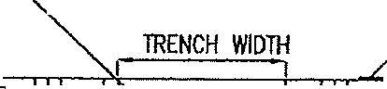
.COMPACTED IN 5" LIFTS

12•.J J TRENCH WIDlH .._L12•

,--- SEE NOTE

-11 c --rr.• ·•;-,-. ---,.-.,-_:-c•,'FIT!:=-
11 111 :.·-:: I I
.! •:::·---:

-=:ill I ::· \·. •-,,
FOR MATERIAL EXIST
STREEt MATERIAL
TT:;:::'fil:: ;,ID=iTi

=I I f-1 _.rt9n-9o4h01i.. ,
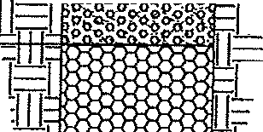
11 I
·-• ....0. 0'-'-'tLlL4Ln 1
, , ,;a"
a.. ov Q.Q O: qQ
/:
.-<;> .,.,_ go 1=
r

•-w1 :. •. ,' . ,,-
·ooorll!ll 613
-=:11i- &;g gum 310 G!Will!AA IIAITRl!l.

CON1ROU£D IJ!NSl1Y ll-lCl<flll
·.:< ·;,= 11 (flOW/&£ All)
J I I:.·, ;i:
•-,
-.
COMPACTED IN 12' UflS

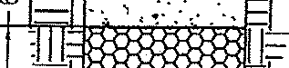
·=-.1,.1-1• .·,..-·•,··
-·.:..,·...••.T1=


I - f8 $ION£
ITRENCH WIDTH j
PIPE DIA + 12
75lH!m CRUS!iED

zID1111
-

· I

-,11:
' II
,1
:,.
- -
lRENC

fa Sfo«E
75%-100% CRWlEO

:,;
""
-:..
z
5
-
- \\'IDTtt= PIPE DIA + 12·

EXISTING STREET CROSSING
INSTALLATION WITHIN PROPOSED ROADWAY

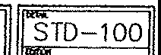

Village of Jamestown, Ohio Standard Construction Drawing
Trem;h Detail 2008

6" TOPSOIL MINIMUM
ffiENCH WIDTH. SOD OR SEED PER PLAN

Till! :;-e '""l:':-:i-1' UJ 1ITT:1::
11¹¹¹1 r
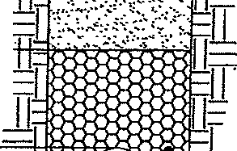
°:'=I I_.Il .. . _. .."'. ·o:CAVAIEO llAITRW.
COMPACTED IN 24' UF1S
t
:I
;;; 11-1:'::JQ-Q-f f #8 STONE
"" 75%-l<m CRUSIIED
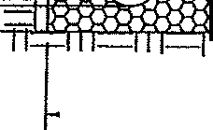
"a"s ::_: =•.:- ='III­
;,,.
PIPE DIA + 12'
illage of Jamestown, Ohio  Standared Construction Drawings | STD-101
Trench Detail, Non-roadway Ar.eas | 2008

REQUIRED RESTRAINED JOINTS FDR BENDS E-DEGREE OF DEFLECTION

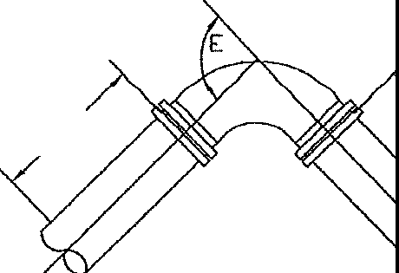
L L
:;:,:.:'''"":V1

L - REQUIRED LENGTH OF RESTRAINED JOINTS
D-INSIDE DIAMETER OF PIPE

D-DIAMETER OF PIPE
 | 4• | 6' | 8' | 10' | 12' | 16' | 20' | 24'
1 •.. | 1 | 2 | 2 | 2 | 3 | 5 | 5 | 6
';,2• · | 2 | 3 | 4 | 5 | 6 | 8 | 10 | 12
145• | 4 | 8 | 12 | 14 | 20 | 30 | 36 | 45
lc,n• | 25 | 34 | 50 | 60 | 70 | 100 | 125 | 145

E-DEGREE OF DEFLECTION

L - REQUIRED LENGTH OF RESTRAINED JOINTS
IN FEET

REQUIRED RESTRAINED JOINTS FDR DEAD END VALVES, PLUGS, CAPS AND TEES

L

- --=-() f
r'7,_,P,uc

.._tr
E -

DIAMETER OF PIPE IN INCHES
D | 4• | 6' | a· | 10' | 12· | 16' | 20· | 24'
L | 25 | 34 | 50 | 60 | 70 | 100 | 125 | 145
LENGTH OF RESTRAINED JOINTS IN FEET

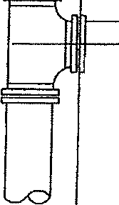

Villageor1amestown, Ohio Standard Construction Drawings Required Restrained Joints
STD-102 2008

MAKE OF HYDRANT APPROVED IN VILLAGE OF JAMESTOWN
MUELLER CENTURION A-423

HYDRANT DATA
NOTE: 1. All. VALVES AND HYDRANTS H LEFT TO OPEN"
2. 5.25 VALVE OPENING
- USE ANCHOR PIPE BETWEEN VALVE AND HYDRANT 3. 3 NOZZLES (2)2,5 & (1)4.5
- NO THRUST BLOCKING 4. W/STORZ NOZZLE CONNECTOR
All. THREADS ARE NATIONAL STANDARD
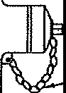
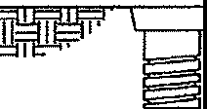

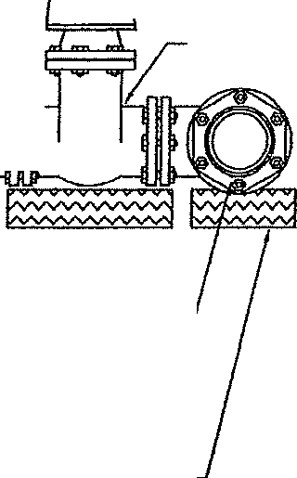
- HYDRANTS SHALL BE 5. 1.5 INCH FIVE SIDED OPERATING NUT PAINTED YELLOW 6. ALL HYDRANTS TO BE TRAFFIC MODEL
  - HYDRANT TO BE YELLOW IN COLOR
  - SELF DRAINING
  - 5 1/2' LOWER BARRELL SECTION
@
REMOVE CHAINS FROM CAPS

FINISHED GRADE
'I
'T 5.25"DIA. CAST IRON
ROAD BOX
FOUR ill PIECE
LID MARKED WATER TOP SECTION EXTENSION
BELL TYPE BOTTOM
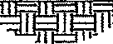
3'x3'x3'
1 CY WASHED GRAVEL
(f57 STONE)
AROUND DRAIN HOLES 6" WATCH VALVE

ANCHOR PIPE SHALL BE CLOW NO. F-1216 OR APPROVED EQUAL
MECHANICAL JOINT ANCHORING TEE CLOW NO. f-1217
OR APPROVED EQUAL

SUPPORTS SHALL BE
PRESSURE TREATED LUMBER OR 4• OF #57 GRAVEL
Village of Jamestown, Ohio  Standard Construction Drawings  Firettvdrant Assembl | STD-103  -2008

STANDARD MANHOLE FRAME AND LID NEENAH CATALOG NO. 11-1767 OR EQUAL

FINISHED GRADE

PRECAST ADJUSTMENT RING (MAX. ADJUSTMENT 12")

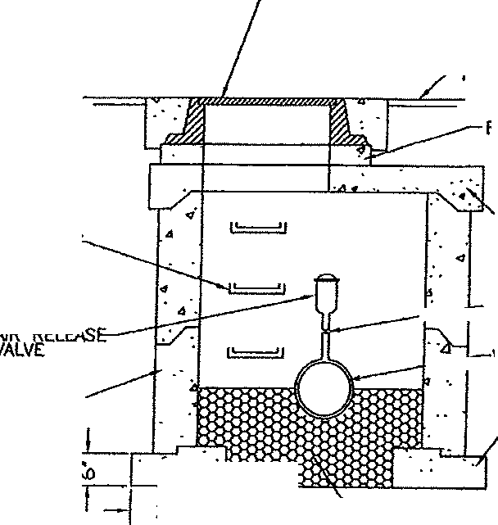
MANHOLE STEPS
l#'\t\3[ 6) /]ffiN 0 EffAfJ/LAT
THE VILLAGE ENGiNEE'

...1--r VALVE

i..-:---i--WATER MAIN

PRECAST MANHOLI POURED IN PLACE
RISER SECTION FOOTER
₄'
!'-6' I- WASHED GRAVEL (/157 STONE)
NOTE: IN WET AREAS SEAL
BOTTOM WITH POURED CONCRETE BASE OR PRECAST MANHOLE BASE.
Vilfage of Jamestown, Ohio  Standard Construction Drawings Air Release Valve | STD-104 2008

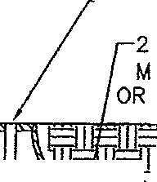
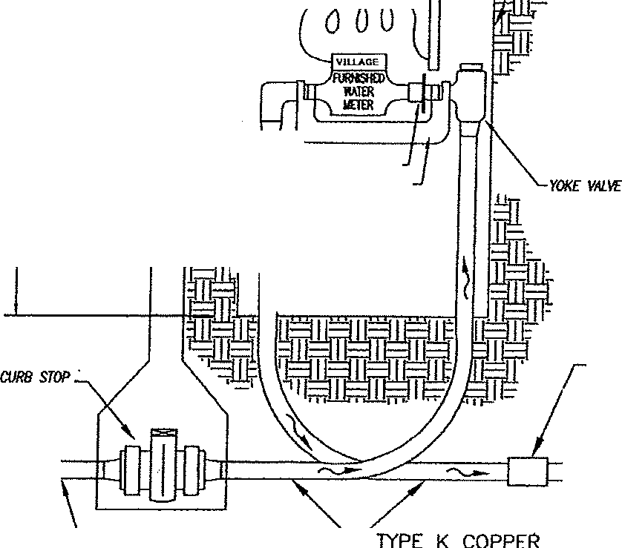
FORD •c-3• RING AND FORD "C3-f LID
FORD •c3-TT" fOR IRRIGATION
FINISHED GRADE
•r
FR1F1
AMR TRANSMITTER
O" x 30" SONO-LOC ETER PIT
VILLAGE APPROVED EQUAL

;f,2t

- g
1;:;';JI': II
I

,;;:ffl.' ,t::"':.
w I f
COOPI..ING
(oulsde me1e< ,.i)
{f

"'--- CORP TYPE K COPPER
0 ,:I) "- EXIST. WATER MAIN

All BRASS PARTS LISTED ARE MANUFACTURED BY THE FORD MEIER BOX COMPANY
OR VILLAGE APPROVED EQUAL (NO McDONALD)
UNDERGROUND PARTS
SERVICE SADDLE TO BE EPOXY COATED Willi WIDE STAINLESS STEEL STRAPS AND BOLT
CORPORATION STOP FORD F-1000 CC-THREAD
ALL SERVICE LINES TO BE K-COPPER
OR PE POLYETHYLENE PIPE (ASTM D 2737

CORP STOP: CURB STOP:

AU. I\OOK MIER COll!'t.m
SHAil. COOl'I.Y l\llH
GfiEIN£ COUNIY STNilllROS
MITER WILL BE SET AFTER
AN ACCOUl{f WIT/I l.fflLflY BIWN(;
HAS BEEN ESTABLISHED
(937)675-5540

SERVICE SIZE
3L4" | I 1.0·
F-1000-3 | F-1000-4
B44-333 | 844-444

METER SET-UP

CURB BOX
2 1/2" DIA. ADJUSTABLE 3s•-so·
PLASTIC (SUP STY!.£)
WllH IRON LID MARKED "WATER"
ANGLE VALVE: AV-94-323W AV-94-444W YOKE ELL: L94-23 L94-44
EXPANSION WHEEL: EC-23 EC-4
YOKE BAR: Y502 Y504

Village of Jamestown,Ohio Standard Construction Drawings
Domestic Water Service 3/1 and 1 Inch
....
STD-105
2008

FlNISH GRADE

,._
FORD C-J2 RING WITH 11 1/2" LIO OR APPROVED EQUAL
AMR TRANSMITTER

lg
'-'
;.:;
:::e

".o,,

;!:
,,,
g
.
•
"'

g
r-o
,,,111 r2'r 600 ) ll
1 1.U

JII
ff· 1
,,
"1·
Jr
t'
:O"x30" SONO-LOC ErER PIT OR PROVED EQUAL

Rf/WI IJICHOR FOR AIIR
-

ITI:.
.. L

;:lli­
·1-1,-1
_m}'­
Jl .1
,uM
?

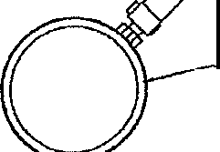
- lYPE K COPPER EXIST WATER MAIN
METER SET-UP TO INCLUDE
I.) (2) KY43-332W WATTS ANGLE VN..VE
2,) PRESSURE REDUCER
- TYPE K COPPER
- Po/yelhjle,,e Wole, Seni<e Pipe (CTS) 200 psi SOR9.
Inserts slloR be sloinless sleol. NI polyelh e,,e pipe sh<ll hove • #10 """ «>Pf" lroCOf we from corp. st()j) lo
curb SW!'

  - "s" TUBE w/SII METER NUTS (Sf-3-3/4 METER)
  - VILLAGE FURNISHED WATER METER
UNDERGROUND PARTS
SERVICE SADDLE TO BE EPOXY COATED WITH WIDE STAINLESS STEEL STRAPS AND BOLT
CORPORATION STOP FORD f-1000 CC-THREAD CURB STOP FORD 844-333
1/ElER l!7U. Bf SET AFTER
NI NXOU/IT 111111 l/llUIY 9/LLINI!
™S BID/ ESTABLISl/fJJ
(937)675·5540
ALL SERVICE LINES TO BE K-COPPER CURB BOX
2 1/'l: DIA. ADJUSTABlE 36"-60"
PUSTIC (SUP S1Y1£)
\ITIH l«J!i LIO IWlKED "WA!ER"
ALL BRASS PARTS LISTED ARE MANUFACTURED BY THE FORD METER BOX COMPANY
OR APPROVED EQUAL


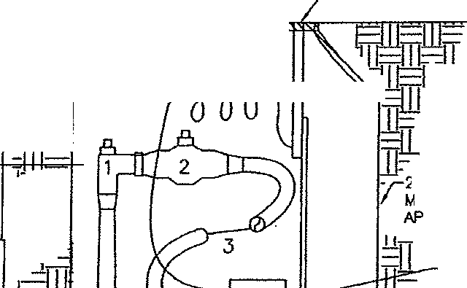
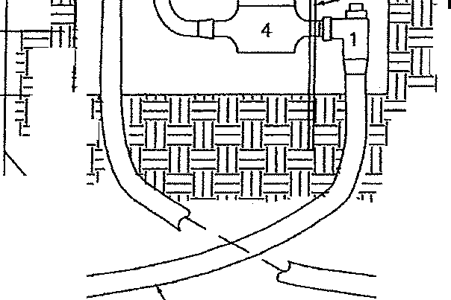

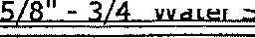
Village of Jamestown, Ohio Standard Construction Drawings
II \ .l.1-L - •• .,... - -- .l
STD-106 2008

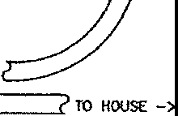

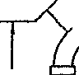
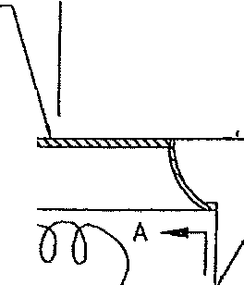
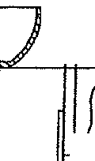
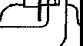
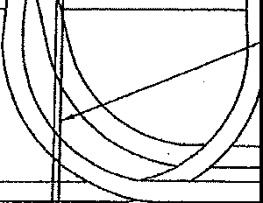
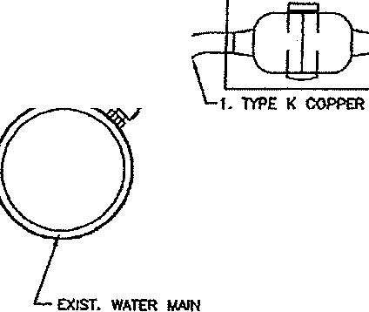
)
'-"' NOTE- m SING! E
VILLAGE OF JAMESTOWN SHAl..l A.S.S.E. #1011-WATTS
PROViOE ANO INSTAU, METER ONLY #NF6 OR EQUAL VACUUM 6RfAKER
MEIER IIJLL BE SET .JJNJ:l.
AfW?·ALL PERl,//TS AR£ 08TNN£0 -1 ( OPTIONIIL
INCLUOIHG 'tllffNE CVUN1Y PLIJIJ8lll(;" 10' MAX FROM PIT TO INSTALtE
NID ASSE 1013
All ACCf)IJNT 11tm llTlUTY BIWIIC ... ::a=O:e:"1]CE
HAS BED/ ESTABUSHED • ,--U-ll-..._"'
(9J7)675-5540 FORO C-3 RING
WITH 11 1/2" UO
OR APPROVED EQUAL ASSE 1013 MUS
BE ACCESSIBLE
FJNJSH GRADE AMR TRANSMITTER STABIUZER w/SN IN FULL VIEW
W!TH OONC "'5E
•
6 • .•'
•... ·.·"' •
f2 20"0 X 30•
SONO-lOC
NPER PIT
OR APPRO\'EO EQUAL
g flr:=:::r===--;---,;a;""!-CITY FURNISHED
--rlJ:.../1- WATER MmR
"' ME.TER SET-UP
<..> T2OlINCWDEO
,,; 2 AV-94-323W
L-94-2.3
"' 12 YOKE 81.R Y502
2 EC-23
U28-33 1 1j2•
BIWlCH SYSTEM

REfWI ANCHOR FOR N.tR

TO IRRIGA.llON
S'IS1EM

A _j
2. POL1ffilltEII£ WATER SffiViC£ PIPE (ClS) -
200 P!l SIJR9. IHSffilS S!WJ. OC STAINlfSS
STER. IJl. POLY£1lM!H£ Pl'£ S!WJ. HAVE A #10 &llO OO'PER lRACIR ll1R[ FROM
CORP. STOP TO CURil STOP. / '-.
/i I'\.
I \
UNDERGROUND PARTS I \
SERVICE SADDlf TO BE EPOXY COATED WITH WIDE
STAINLESS STEEL STRAPS AND BOLTS I ill \
CORPORATION STOP FORD F-1000 CC-THREAD "'
All SERVICE LINES TO BE K-COPPER I I I
CURB STOP FORD 844-333 / MUELLER H-15209
CURB BOX m z ";;
2 1/2" OIA. ADJUSTABLE J6'-60" \ i! i! "' I
0
PlASTIC (SUP STYI.E) \ V [ 'i
WITH IRON LIO IMRKEO "WATER" ^{V} I
ALL BRASS PARTS LISTED ARE MANUFACTURED "- SE-CTION---A-A / BY THE FORD METER BOX COMPANY "'- ENO VIEW /
OR APPROVED EQUAL
Village of Jamestown, Ohio
Standard Construction Drawings
5/B"x 314" Meter Seeting_w/irriqation meter

O

T

STD-107 2008
-

FORD C-3 RING AND 11 1/2" LID WllH EXPANSION RING
OR APPROVED EQUAL
EXTENSION RING
AMR TRANSMITTER

FINISHED GRADE----._

'!:!
f2
12

f5

8
;;,;;
:,;:
l;!

""Fm=; m-""i;:;;k"I• .,4.}===-<l'l'I","'1irr11i==1rr11=i=nif"FI=
P= ===== = ·
-------:;::.:OL: ,
I I
I , _ _, I
I - I
I TRACTOR FURNISH D I
I WATER METER I
I I
I I
: ?I

I I
CURB STOP I
,
I
I
O"'-
\TYPE K COPPER
\\ CORP STOP
/ "--- EXIST. WATER MAIN
I
COPPERSETTER

00.JPUNG
(oollido mt!er w<II)
...,
J
BY-PASS VALVE TYPE K COPPER
All WORK AFlER COOPUNC
stWJ. COlll'lY IITTH GRUNE CWffi' STNlOAROS

All BRASS PARTS USTEO ARE t.WIUFACl\JREO
BY THE FORO METER BOX COMPANY OR APPROVED EQUAL {NO McDONALD)
UNDERGROUND PARTS
SERVICE SAODL£ TO BE EPOXY COATED WITH WIDE STAINLESS STEEL STRAPS AND BOLT
CORPORATION STOP FORD f-1000 CC-THRfAO

ALL SERVICE LINES TO BE K-COPPER

CORP STOPI: CURB STOP:

I
METER WILL BE SU AF1tR
AN ACCOUNT WITH UT11JT'f BIWNG HAS BEEN ESTABIJSHEO
(937)675-5540

METER PIT SETUP
SERVICE SIZE
1 1L2" I | 2·
F1000-6 644-676 | F1000-7 844-777

CURB BOX
2 1/2" DIA. ADJUSTABLE 36"-60" PLASTIC (SUP SIYLE)
WITH IRON LID MARKED 'WATER'
COPPERSETTER: VV76-27B-44-66G VV77-27B-44-77G EXTENSION RING: lf4 #5
"D" i 30"DIA X 42" 36" DIA X 42"
...

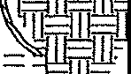
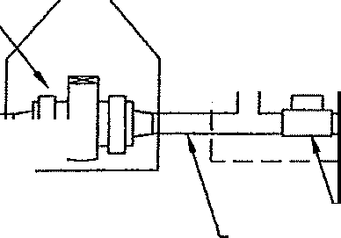
Village of Jamestown, Ohio Standard Construction Drawings 1_ 1/2-2" Water_ ServJce_
STD-108 2008

METER PIT DETAILS

1" DOMESTIC 1" DETECTOR METER WATER METER
1" CHECK VALVE
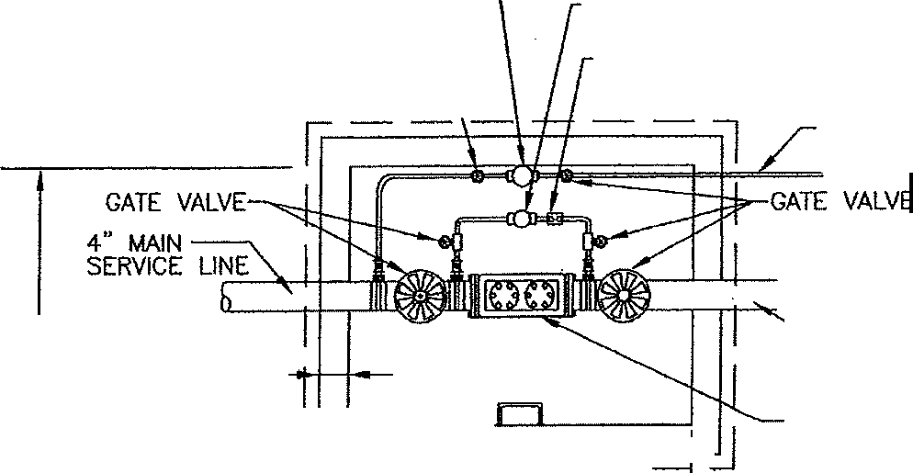
GATE VALVE
1 " DOMESTIC SERVICE

72"
l s· 4" FIRE . LINE

llL d AMES 3000 OR EQUAL
BACKFLOW PREVENTER

96'
PLAN VIEW
POST INDICATING / 4" STORZ-LOG 30· BEND FIRE VALVE
(OPEN/CLOSED)
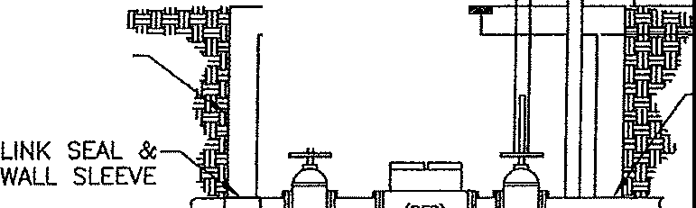
ALUMINUM DOOR------- z
5E
48X48 INCH BILCO DOOR '.N.. 8'

WATERPROOF PERMNlENT\ =
EXTERIOR IADOER l=== LINK SEAL &
{AS REQ'D) WALL SLEEVE
72" MIN
FROM VILLAGE -½!H4J,,J&--IJl,.,;., 7787
WATER MAIN 18" MIN

- · ··-·· \. 8"
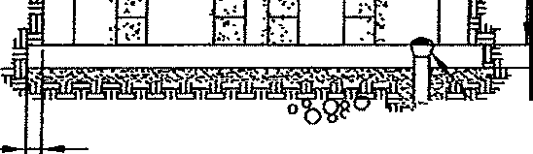
4•
'\:""""' '-BEEHIVE DOME GRATE
'\ 3" GRAVEL (#57) MIN
SIDE VIEW
Vlllage ofJamestown, bhio Construction Detail Drawings  Meter Pit D t_ll_i_L _ | -STD-109  2008

NOTE:
" 64.SEO ON HS20 HIGHWAY t...OADlNGS WITH A. MINIMUM COVER
AT -4'6•.
STEEL N-0 PIP£ SHALL HA.VE A STE£l "l1M STRENOTH
OF 35,000 PSI, UEET AlSM A139 ¢rvDE 8 REQUIREMENTS
NO HYOROTEST IS REQUfRED

CHAAT 8'$'ED ON R£COIJMDIOATIONS FROM N.'.TIONAL IJllUTY
COi/TRACTORS ASSOCIAMN
.

... ..
..
..
REQU!REO CASfNG PIPE SIZES .ANO WAI..L THICKNESSES FOR RAII..Ra-.D & HIGHWAY CROSSINGS
NOMINAL  SlZE | ACTVAL  0.0. | C"R"O''S"S"IN"<'lS  aw: | HIGHWAY  CROSSINGS  8AAt
•• | 8 5/6 | .250 | .250
10· | 10 3/4," | .250 | .250
12· | 12,J/-4" | .250 | .250
, |  | .281 | .250
, | ,16." | .281 | ..2,50
..· . |  | ,321
20 | •20· | .344 | ,312
 | •• | .406 | .312
JO"  ... | JO" | ,469 | .J75
36"  .... | 36"  .... | .532 | .500
 | 42" | .S&J | .500
••• | ••• | .625 | .625
... |  | .688 | .625
60" | •6•0•" | .?50 | .625
 |  | .813 | .625
72• | 72" | .875 | .750

..

THE 1.0. OF THE STE£l CA.SING PIPE 5tW.l. BE AT t.fAST 6 INCHES lAAGfR 1MAN THE LARGEST OUTSIDE DIAMETER Of Mir JOINT APPENDAGE
{INCWDING RfSTMNED MEC!W<ICAL JOINTS FOR OUCTIL£ IRON PIPE.

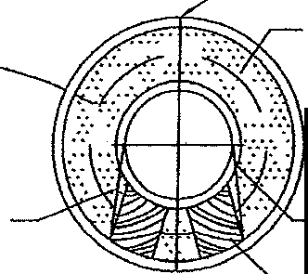
UNLESS ornERWrSE SPECIAEO OR SHOWN ON THE OAAWINOS, WALL TWCKNESS SHAU. COMPLY lilTlf THE CWJ!T
SHOWN ON THIS PAGE. ---

ALL HG PIPE
Ym-1 GROUT

1• STEEL STRAPS BANDED TO PIPE 2 0 EA.CH BLOCK

TO BE AN EQUAL DJSTANCE OR AT LEAST J" OFF THE BOTTOM OF CASING PIPE.

CAARl£R PIPE

8LOCK1»G OR SPACERS
RESTMNED MECHANICAL JOINT PIPE (SHOWN AS EXAMPLE ONLY)
flLL CASING PIPE WITH GROUT

•1 STEEL STRAf'S,/ B>JlDED TO PIPE

t CARRIER PIPE

L•. MIN-'
CONCRETE MASONRY BULKHOO O (ACH END PllOVIDE GROUT HOLES AS REQUIRED

SPACERS M OAK BLOCKING WITH GRE'.ASEO BOTTOMS, STRAPPED TO EACH ENO OF EA.CH PIPE. PIPE Bal MUST BE SUPPORTED OFF CASfNG PIPE. MAXIMUM SPACING OF BLOCKING IS 8'-0" CENTm TO CENTER ALONG PIPE.

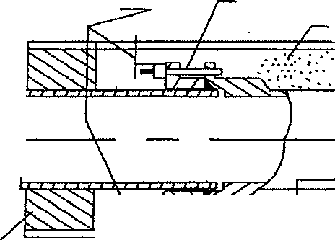
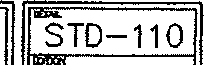
Village of Jamestown, Ohio Standard Construction Drawings
Steel Casin 2008

GENERAL NOTES
- srm PlATES SHAI.L BE PlACED OVER TRENCH WITH CONTROllEO DENSITY All fOR A PERIOD OF 24 HOURS PRIOR TO PlACING CONCRffi OR ASPHALT

- CONCRETE STREETS SHALL BE REPlACED WITH A MINIMUM OF 8" CONCRETE or REPLACED WITH THE {EXISTING THICKNESS + 21 CONCRETE, WHICHEVER IS GREATER

- ASPHALT STREETS $HAI.I.. BE REPLACED WITH 1 3/4" ODOT ITEM 402 L£VfUNG COURSE AND 1 1/ 4• ODOT ITEM 404 or EXISTING PAVEMENT THICKNESS, WHICHEVER IS GREATER
U) (f/5) !z:  c, o C, -o  <zO->,NI <z N I  5 -'<! 5  o w:r: oW  c3?:i F ;;,: E  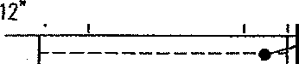  u..:§:: LL::!=  12" SEE NOTE  FOR MATERIAL  =1I1 I 1-11 :. •·•-•::.. ! • · ,.,•:.II 1I...:-'EXIST  ·:::•. STREET MATERIAL  w,11' J'i ? /-.\II ·:osliNSITY ll\<l<All  - adl=I ....·•'·:• ·• •., I I (fLOWABlE Fll)    :,;;:  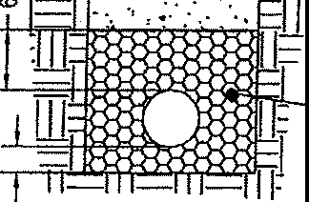  .,_-:'.• ,,-,--, . . "•rn  #B STONE  75lHOOX CR\JSHEO  ;z;;;  ....  TRENCH WIDTH  PIPE DIA + 12'  EXISTING STREET CROSSING | PROP PAVEMENT SUBGRAOE  10" ODOT ITEM 304  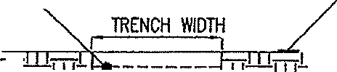  _COMPACTED IN 5" LIFTS  =1J1 11--1-11-n^{L}::a.o_.., .,,,&!o:J-L/-" •-  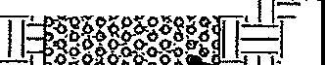  11 I  ;I=w,11' t"'<t>"9"go• "Q·11- - 310 G1lAMJIWNl 1-2 LJflS  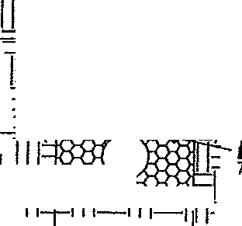  ---·-, -f gi, g [o -, COMPACTI])  - o°" 9° t>o-.O  - ... c,bo" ·" I.III  L  =i- <t::::I  :··· 'B STONE  '5%-100% CRUSHED  Nnf 1lj  i TRENCH WIDTH=  ':.,- .  PIPE DIA + 12"  INSTALLATION WITHIN PROPOSED ROADWAY  -
Village of Jamestown, Ohio  Standard Construction Drawing Trench Detail Under Pavement |  | STD-200 2008

6" TOPSOIL MINIMUM
TRENCH WIDTH, SOD OR SEED PER PLAN

T'' ''rtM, ·E'+.! i-' 'm:1:
::w1 CAVAITD MATER!Al
- _, _ _ .. _ AClID IN 24' URS

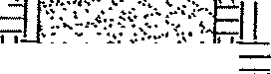

t iL
=l
j - SfOT N75X-I£OO,: CRUSHED
"' 111 1:
:z
5s TRENCH WIDTH=
,.,_ PIPE DIA t 12"
Viflage of Jametown-;Ohio  Standard Construction Drawings Trench Detail, Non-roadway Areas | STD-201 2008

/
TOP VIEi,'
NOTES
All sanitary Manholes shall be preco.st with o.n eccemtrlc cone. Steps sho.ll be a MO.Xl<'IUM of 16' o.part o.n<l Mo.de of Metal coated with flberglo.ss or aluMlnuri alloy,
To adjust to gr<>de concrete t"ings "donuts'co.n be used, Mo.xfMuM gro.de o.clJustMent sh<>ll be 16", Greo.ter a.dJustMent re-qulr-es bo.rrel sections to be cho.nged, Poured

ECCENTRIC CONE
floor's sho.ll be o. 'MlnlMUM of' 8' thick 4000 PSI <relnf'orced) with a. MlnJMUM of 6' #57 stone under

CHIMNEY SEALER
1---a•MIN
I r GRADE RINGS
7
l'l<>nhole, Soft ground (wet) sho.lt
be bridged with tt2 stone o.s

OR APP'D EQUAL\ -----,---'
I

32' ECCENTRIC CONE

BARREL
SECTION
I
VARIABLE
4'MIN
!6'MAX

- MIN.
cllrected by the Village.
Seo.ls sho.ll be>
I. Kor-N-Senl
- Durn-Senl
- Pl"ess \ledge II
Mo.nhole section Joints sho.ll use
'O' ring type seo.l,
Mo.stlc sho.ll be used on shelf' of
Mo.nhole In wet o.reo.s.
ChlMney seo.ls shall be used o.s
constructfon dro.wlngs lndlca te.
Costing shall be1 Neeno.h R-1767 4 hole lid E<>st Jordan 1600 Type C lid (2 hole) \l<>tertlght Neeno.h
R-19!6D
Enst Jorclo.n 1600 \IT
Additlono.l lnf'orMo.tlon con be found In the Mo.terla.l a.nd Construction Procedure sections of' this Mo.nuo.l.

DIM. TO SUIT
30', 36* & 4g•
BASE SECTION

8' MIN.

6' #57 GRAVEL BASE MIN,

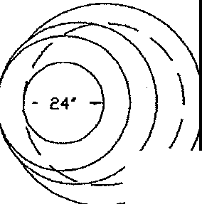
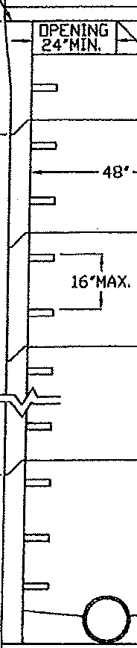

Village of Jamestown, Ohio Standard Construction Drawings
Precast Manhole
STD-202 2008

NOTES
ALL PRECAST MANHOLES TO HAVE '0' RING TYPE
SEAL AND MASTIC IN \JET AREAS.
ALL GRADE RINGS AND "\ "'
CASTINGS TO BE MORTARED
IN PLACE. ' \_--=::
ALL CONCRETE TO BE
4000 PSI MIN. ;-

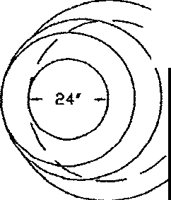
TOP VIEIJ ECCENTRIC CONE
' 1-,-e• MIN
CHIMNtY SEALER I rGRADE RINGS
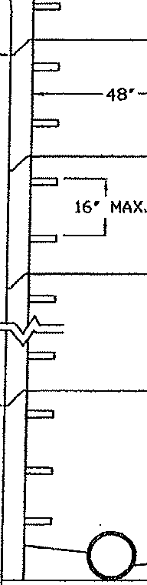
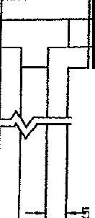

DR APP'D EQUAL r ,--14'MIN
16' MAX
OPENING
- ' 24' MIN,
32' ECCENTRIC CONE

' MIN.
BARREL SECTION
I
VARIABLE

SAN. SEl,IER PVC SDR 35 MIN.

' MIN,

DIM. TO SUIT 30", 36' S. 48'
l BASE SECTION

8' MIN.

6' 11S7 GRAVEL BASE MIN.
 | Village of Jamestown, Ohio  Standard Construction Drawings Eccentric Drnp Manhole | STD-203 2008

GENERAL NOTES
  - STfil PLAlES SHALL BE PLACED OVER TRENCH WITH CONTROLLED DENSITY All FOR A PERIOD OF 24 HOURS PRIOR TO PLACING CONCRETE OR ASPHALT
  - CONCRETE STREETS SHALL BE REPLACED Wllll A MINIMUM OF s• CONCRETE or REPLACED WITH THE (EXISTING THICKNESS + 2j CONCRETE, WHICHEVER IS GREATER

  - ASPHALT STREETS SHALL BE REPLACED WITH 1 J/4" OOOT ITEM 402 LEVEUNG COURSE ANO 1 1/4" OOOT ITEM 404 or EXISTING PA\lfMENT THICKNESS, WHICHEVER IS GREATER

i'1i
: o
«z:: -^{O},^{N} I

I-
1:;,5: w!ti,,
ti c.::s=
...,
.:i
!z
V,
0 -o
Z ON
<C-, I
5
(..) w
E
VJ u.:;,;

PROP PAVEMENT SUBGRADE 10• ODOT ITEM 304
.COMPACTED IN 5" LIFTS

12" --j12·

SEE NOTE FOR MATERIAL
13
ENCH WIDTH
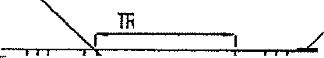

rr-'""ITT'-t:;; j]J=iiT!

=1II 1-1- II :.··\•·.•.•• • · , •
-! :::-:t
1--=-----...EXIST
STREET MATERIAL
oK&;;:a::o oA

113

111I, 1' ;;_· : .\/·.":I1=· 6 11Y ll'OOlll

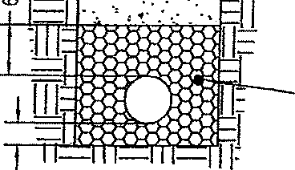
J I. I ·" . ··:· '• '. • ., IT {fl0\VJIII£ All)
:;=_ '-'····· ..,.....
. ". ,, ,..,.....,.....
II I i 310 CIWMAR TmAL
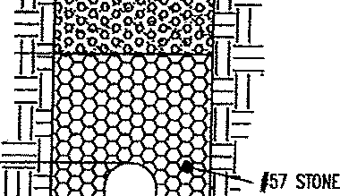
' .11l=t.!¼: ,Jgij[T:::: COMPICl£0 IN 12" UfTS
f
:[

#57 SIOIIE
;;.
f"'
-t '' 111:

•_,,.

TRENCH WIDTH PIPE DIA + 12
....
TRENCH WIDTH= PIPE DIA + 12'

EXISTING STREET CROSSING

Village·of :famestown, Ohio
INSTAUAT!ON WITHIN PROPOSED ROADWAY

-STD-300


Standard Construction Drawing Trench Detail Under Pavement
2008

6" TOPSOIL MINIMUM
TRENCH WIDTH, SOD OR SEED PER PlAN

1'''111- -!:".--,!..[ , 'm
n111111 111
, 11 ;c·:=..u EXCAVATED W.TffilA!.
' III .. , ,. -·.. COMPAC!EO IN 24• LIFTS
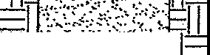
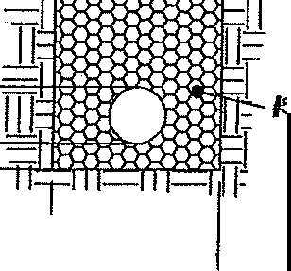
111 '''
:l
,7 STONE
z
<
'° l
";;;":; ITRENCH WIDTH=
o;.,. PIPE DIA + 12'
Village of Jamesfown, Ohio  Standard Construction Drawings Trench Detail, Non-roadway Areas | STD-301 2008

NOTES:
CASTING SHALL BE NEENAH R-3290 OR ITS EQUAL THE DESIGN SHALL BE ESSENTIALLY THE SAME AND EQUALLY AS STRONG AS THOSE HEREON AND SHALL BE GrVEN ONE COAT OF PAINT. WEIGHT 540 lbs.
BEARING AREA OF FRAME AND GRATE SHALL BE SO FITTED AND FINISHED AS TO PROVIDE A FIRM
AND EVEN SEAT FOR ALL PORTIONS OF THE GRATE IN THE FRAME. NO PROJECTIONS SHALL EXIST
ON BEARING AREA Of EITHER CASTING AND THE GRATE SHALL SEAT IN ITS FRAME WITHOUT ROCKING. FRAME AND GRATE SHALL BE F!Ti£D, AND HARKED BEFORE DELIVERY TO THE PROJECT.
CONSTRUCTION - CATCH BASIN BOX - SHALL BE BUILT OF A PRECAST CONCRETE BOX DR CAST IN PLACE CONCRETE. WHEN CAST IN PLACE CONCRETE IS USED IT SHALL BE OF 4,000 PSI. BASE Of THE CATCH BASIN SHALL BE 4,000 PSI. CONCRETE.
ALL CASTINGS SHALL BE OF THE BICYCLE FR!ENDLY TYPE

CB-2
- B
 | ,-- |  |  | ---,
 |  |  | CJClC  = Cl' | > Cl Cl  = c::,
A |  |  | c::I 0 C  <=> = C  == =Cl C  t | Ip:>== <==>  I:>== <=>  =
A |  |  |  |  |  |  | A

1'-5

ALL CASTINGS SHALL HAVE ENVIRONMENT AL LOGO CAST IN PLACE
1'-5 3/4'
,
3' ,

6' 1--2'-0'-i
I 2•-7•·---1
:314' | c::J t::::J t:::l c:::J c::J CJc::Jt:::Jc::Jc::t c::J c:l CJ C] CJ  c::Jc::JOOCJ  Oc:::tCJClc:J c:JCJ C c:J c:J CJCJClr:::Jt::1
 | (3'-0 1/2'-I

I 2•-9•
11 | 1-3'-0 1/2'-I
11 | --2·-11 11c·-
11 | i_ D O D t

3'-0'

- B
TYPE 'C' GRATE
3'-7'

CURB BOX

-'
...
.'

•·7.7.
L D D D

- .-•·
...
ADJUSTABLE G' TO 9•i!=
"'-".!!¥-91
.
.....
....•

--
.... ^{I}
•
..-,.
,•'.
.

. ..
.":·.
.-..•·...
•
vorli,lole
  - :<
...
.
'•
, ....

.'4.•...••,

' : .
··•

•••,r-1

. ..
..,. ·'

.".... -,. .
- .-i·· ..,I .
• •"!.:.·1· .'-.,;
£:_o: [j

..\., 'ld'• ··•.· ·4 -: , ◄

3•-0-
SECTION A-A
" - 8' IF POURED IN PLACE 6• Jr PRECAST
f::::·(· :
SECTION B-B

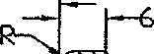
Viflageof Jamestown, Ohio Standard Construction Drawings Catch Basin Type 2
STD-302 2008

NOTES•
CASTING SHALL BE NEENAH R-3295-A DR ITS EQUAL THE DESIGN SHALL BE ESSENTIALLY THE SAME AND EQUALLY
AS STRONG AS THOSE HERE-ON AND SHALL IJEIGH 1,090 lbs ..
BEARING AREA OF FRAME AND GRATE SHALL BE SO f!TTED AND FINISHED AS TD PROVIDE A FIRM AND EVEN SEAT FOR ALL PORTIONS OF THE
GRATE IN THE FRAME, ND PROJECTIONS SHALL EXIST ON THE BEARING SURFACE OF EITHER CASTING AND THE GRATE SHALL SEAT IN IT'S FRAME IJITH UT ROCKING, FRAME AND GRATE SHALL BE FITTED, HATCHED, AND MARKED BEFORE DELIVERY TO THE PROJECT.
□
CONSTRUCTION - CATCH BASIN BOX - SHALL BE BUILT OF PRECAST CONCRETE BOX OR CAST IN PLACE CONCRETE. IJHEN CAST IN PLACE CONCRETE IS USED IT SHALL BE 4,000 PSI. BASE f THE CATCH BASIN SHALL BE 4,000 PSI, CONCRETE.
□
ALL CASTING tRAME SHALL HAVE □NE FIELD

ALL CASTINGS SHALL HAVE ENVIRONMENTAL LOGO CAST IN PLACE
l'-5 3/4'
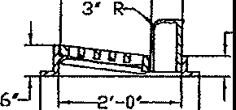
1 €'-7

c:J c:::i c::::i c::t c:J CCJCCt:::J

COAT OF. ASPHALT BASED PAINT,
ALL CASTINGS SHALL BE OF THE BICYCLE FRIENDLY TYPE.

,-- B
1'-5 :3/4...
Cl Q r;;:I c;;;:t c::J Cl O c:::t C C t:::ICICJCCJ c::JOOCJO Q Q c::J c::::J c;:.t

, ._,._z 112' 1
 | --- |  |  |  | -- -- |  | -- -- ---
 |  | =  Q |  | =  0 | =  0 | = =  "" <=> | ₌ =Q <==> =  0 | =
 |  | Q  =  C,  = |  | =C  = | Q  =  = | Q =Q  = =  <=> <=> | ==<==> =i=i =  = = C, 0  <=> 0 | c:i  =<=>  0
A |  |  |  |  |  |  |  |  |  | A

;3'-0 1/2
'-11 1/2'

'-B
TYPE •en GRATE
,I I

B Cl Cl

I 2(3•'--90,•' I/
;3'-4 1/2
CASTING
.._..
·<·
r
,,_
-..:
.
;7:a.'
l- : •
.-..
.-.. ·
:.t;
-·: 1
- -..
::-.;.. :t:/.:.-{:> {· .,
-·..:·
;_
·

CURB BOX

_El 0 0

f.·
.-.-.
1,.·...•' •.
:, :..:
.,,·!·
-._:··.1
LB B B

VAR(ABLE
I·
0 0 0 J
)t
:: ,
- .
:::•:
ADJUSTABLE 6' TO 9'

:D\;.:.'.\>·.>··,_;::·':··--f·::/.< ·;. ;;_.)t;.Jj"

2
,...i SECTI□ - -A
L,.
..
3 GRAVEL (#57) MIN

  - I I 2' ·O' I I ,.

SECTION B-B

>< - 8' IF POURED IN PLACE 6' IF PRECAST
VilligeofJamesfown, Ohio


Standard Construction Drawings Catch Basin Type 3
STD-303
2008

NOTES
2•-3• j
LOCATION ANO ELEVATION WHEN GIVEN OH THE PLANS IS TOP C£NTm OF THE:
CRA11S. Ti = c::, == =
GRATING AND FRAME - THE DESK™ SHAU. BE ESS£NTW.LY lHE SAM£ AND =c:, c::, c:, c:,
EQUALLY AS STRONG >S THE ONE SHOYm HrntON. c:, c:, Cl
WEIGHt OF' GAATE. MIND.IUU, 120 lbs.. z Cl c::, c:,
WOOHT Of' FRAM£, WNIMUM. ,4Q lbs. Cl CJ = c:,
c:, CJ = =
CAST-IN-Pt.ACE WAU.$ HAVE A NOMINAL TH.ICKNESS OF 8 INCHES. PRE.CAST c:, c:, = =
WALLS SHAU. HA\£ A MINIMUM THICKNESS Of 6 INCHES D 8E REINFORCED li CJ Cl = =c:,
SUFflCIENll..Y TO P£RMJT SHIPPING JlNO twroUNG WITHOUT DAW.GE. BRICK OR CJ CJ =
CONCRETE BLOCK StW..l. NOT BE USED. = c:, c:, c:,
CJ Cl CJ =
OONCR£l£, C\S'HN-Pl.ACE. lO 8£ ClAS'S' C. All PREC\Sf C0NCR£TE SHAU. MttT TifE REOU1ft£M£NTS OF 706.13 WITH 6 +/-2Y. AIR VOID CONTENT IN IB£ I-WIDENED CONCRETE ANO BE MARKED MTH CATCH BASIN NUMBER
OP9UNGS FOR PIPES $HAU. 8E O.D. +2" WHEN FAB/UCAT£0 OR flElD CUT.
ALL CASTINGS SfWJ. 8E OF THE BICYCLE FRIENOt.Y f'l1)E


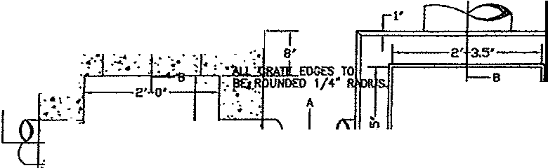

:: -:: ::·.'.::J - . -1:-:::.1.-:_,::",: !.
, ..<_.
A A
. ,. ·
-t1- t t.₋:·'·.1₍{ 1 Pllr II -l
• 1 .•
·.i·.:
sr;;: :-(
: ;..:?: !l/ ) -:.: -·t \ ·/ 8'
I-• •-I
B B
SECTION C C
,. I'
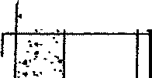
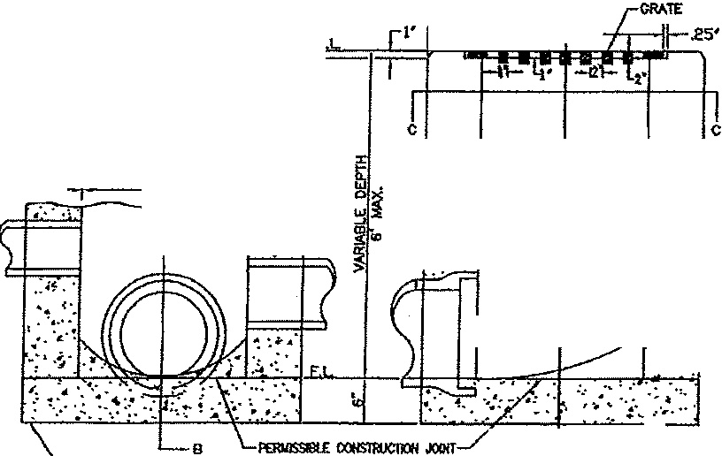

.2 :- :.-.--r•["'; ..-ll .25' A7
-
1 l.J! r2'c3.5'
,·.. JCRAT£j , r·.-
·.·.' .••j'
C : C
- ..:t
I-•· 2'--0' f.:.c.•.·.-. -2•'-o• f.•.•=-.:J
::-- -..: ., •·.· i·
:-•..·.. : ,J<
•f ...:. ·•

I '¥ /r:<·,f.:
A-' o'l)Q80
SECTION A-A SECTION B-B '-3" GRAVEL (#57) MIN
BO'TTOM SlA8 W.Y BE PRECAST S£PARATElY ANO THE OUTl.ET PfPE Pl.ACED ON TOP Of' IT WITH Tl1E 80TTOM sw.PEO TO DRAIN

>< - 8' If POURED IN PLACE 6' IF PRECAST
Village of Jamestown, Ohio Standard Construction Drawings Catch_ Basin 2-2-8 | .S..TD-304  2008

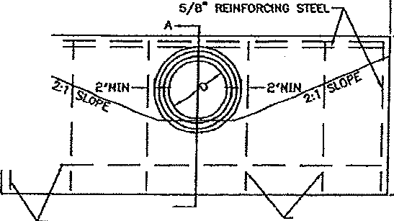
t---------l J
-•• ,-
FlOW UN£""\.

12·,--1

H H l_./1111--+------
J

11 \--01a· w..
RElNF'ORCfNO STEEL

A
5/8"' REJNfORCING STEEL
ELEVATION. VIEW

EQUAU.Y sPACW NOT TO EXCEED 21-•

SECTION A-A

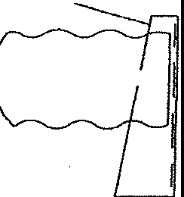
2 1/4"
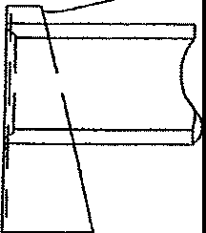
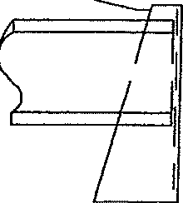
l_

.,

lNL£r ENO Olffi.Ef ENO
GROOVE OR B£ll UPSTREAM TONGUE OR SPIGOT OO'nWSTRE'.AM
RIGID PIPE
INLET END OUT1.£T END
CORRUO>.TEO PIPE
END TREATMENT AT HEADWALL

ALL INLET AND OUTLET CHANNELS ARE TO BE PROTECTED FROM EROSION USING SILT FENCE, CHECK DAMS AND/OR RIP/RAP AS SHOWN ON THE APPROVED PLANS OR AS DIRECTED BY THE VILLAGE.

l CIRCULAR SECllOHS = 50 + -4-T
L EWPTICAL OR PIPE-ARCH "' 4R + ,4.T + S H CRCUlAR SECTIONS c O + T + 44" H O.UPTlCAL. OR PCPE-ARCH = R + T +
«•
0 = DIAMETER OF PIPE
R = RISE Of PIPE
S = SP.Ni OF PlPE
T ::: THICKNESS OF 8ARRU. L = LENGTH Of HEADWAU. H ,.. HOOHT OF HEAOWAL.l.

J:l.QID
TYPE •A• HfADWAU. HEAOWALL WHER£ REQU!REO WllL BE PROVIOEO FOR NONsKEWEO CULVERTS W.VINO A OWAETER OR RISE OF 36 INCHES OR l.ESS.
CONCRETE SKALL BE CLASS "c•. {-4000 p,1)
A'ElNFORCINC STEll. BARS SHALL BE 5/8 INCH DIAMEiER,
OIMENSl:OHS ANO QlWffillES ARE SHOWN FOR CIRCULAR S£CTIONS ONLY. JT Will. 8E NEC£SSARY TO OETmMINE DO.IENSIONS f'OR TH£ lYPE: "'A• Hf.ADWAU. REOUIRE:O fOR REJNfORCEO EWPTICAl. COl'ICfi£J£ PIPE OR CORRUGAlEl UETAL PIPE ARCHES tN ACCOROANCE W11H TH£ EOUAllONS USTEO ON THIS DRAWING.
OIMEN5'0NS |  |  | QUANTITI£S  ONE HE'ADWAU.
DIA,M,rnR | H | L | CONCREI£ NR  CU. 'tDS. | lR-  m, sltEl
 | 5-2 | •1--0 • | ,2,  1.7 | 41
1n | "-5 |  |  | !i7
,2.1 | f>"-8 | 9-8 |  | 62
 | 5-11 | tt -0 | 3.3 | ••
30 | 6-o | ,3 ,, | 4.7 | 92
36 | r-o | 16-'4 | 6,5 | 105

Ctw.cF'ER All EXPOSfD CORNERS 3/4 INCH.
WHERE THE SOIL BORINGS INDICATE A BEAAING CAPACffY Of l.ESS TIWi 2600 POUNDS PER SQUARE FOOT, lT Will BE NECEsSmr TO INCRE"AS£ THE WIOTl-1 OF lHE BASE.
lliE MINIMUM COVER FOR R£1NJORQNG STEo.. SHAI..L BE
2 INCttES.

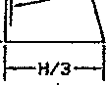

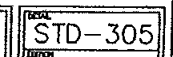

Village of Jamestown, Ohio Standard Construction Drawings
Headwall Type A 2008

AU. INL£r AND OUTl.ET ctwmas AR£ :ro BE OROCTEO USING stLT FENCE. CHECK DAMS NiD/OR R1P/RAP AS SHOWN ON lHE APPROVED Pt.ANS
OR AS OIR£CTEO BY THE VILLAGE. .-NfCHOR 80tJS AT -7
,
M'PROXIIMTELY 1•-5• C£NTERS
-
VM
,, y

4• RECOMMENDED
,µ.),. ...-, i "

- -12'
;I
"

""!;uLAR W...¾..l
I r--...._

r
. . -/
--SPAN-
H
I

,,
ANCHOR OOLT_/
(Sf£ OETAIL)
" !
I l--v V

PROFILE -l T ,.._ CIRCULAR PIPE ARCH
m
CORRUGATED METAL PIPE I

HEADWALL FOR CORRUGATED METAL PIPE
/2"•*Q'

.. -- .
w
CllCUl-'R
--

CtJ.
n•
PIPE ARal
w "
. .

T CONC CU.

1 ',••• OOLT

.. .-- . -- -
.
-
-

.- .. -
. ._,,.. ' .

R=J/◄'' MAX. J/8" MIN.
•
ANCHOR BOLT

- --
. -- -

NOT£: ANCHOR BOLTS f'OR mcttOR1NG

-- -
-
,..
. . . _·.,-_R• ,.
UPSTREAM ENO OF' METAl PIPES SHAll.
MEET ASTM A307. THE TOP 6" MIN Of
BOLT SHAU. 8E GALVANrzED ACCOROlNG

- ..
- - .,.
TO A153.
NUTS SHAU. MEET >.325 ANO A163 UNlf.SS OTiiERMSE SPECIFltO. ANCHOR 60L1S SHAU. 8E USID ONLY ON PIPES WJTlf A sPm OR RISE OR£ATER THAN: 24 INCHES.

-···
l RECOMMENDED ., rl? .,\, 1/
"
1 r-5 -=f -12•
- 1
:1
,
I
" 0-
., /2 't,--"" I

'8W 1L L $I i
H
I V
. 1
..,

PROFILE
-l rl-
CIRCULAR EWPTICAL
CONCRETE PIPE

HEADWALL FOR CONCRETE PIPE NOTES

CIRC<JLAR
w
cu.
CAI. TYP£ .,,A. HEM>WAU. H£AOW.&.U. WHERE REQUIRED wtl1 9£

- -'
SPAN RISE w " ' cu. ms PROVIDED FOR NONS'KEWEO CULVERTS HA G A DlAMETER OR

- - "'-
-
- - --
- - -- -
,._
-
-
RtsE Of 36 INCHES OR LESS.
SHAU. BE ct.ASS •c•. {4000 pst) REfif'ORCiNO STm BARS SHAU. BE 5/8 IN.CH DlAMtTER, DlMENSfONS NID QUANTITIES ARE SHOWN FOR CIRCULAR
SECTIONS ONLY. fT WllL BE N£C£$SARY TO otrmMJNE O!MEXSfONS fOR THE l't1'£ •A• HOOWAll. R£QUIRE'O FOR REJNFORCEO EWPTICAL CONaU:TE PIPE OR OORRIJGUED METAL PIPE ARCHES IN ACCOROANC£ WITH THE EQUATIONS LJSTO) ON mis DRAWIOO.
CHWF'ER AU. EXPOSED CORN£RS J/4 INCH.

.= -- -
-
Of'
WHERE lHE SOIL BORINGS 1NOIC\T£ A B£ARING CAPACrrY
LESS lHm 2600 POUNOS PER SC!lAAE FOOT, IT WILL B£

'=' ^{.=}
NECESSARY TO INCROOE'. THE WIDTH Of THE BASE.
- -- lHE MINIMUM COVER FOR RElNFORCtNG STEEL SHALL BE

.= - -
2 INCHeS.

Village of Jamestown, Ohio Standard Construction Drawings
STD-306
Headwall T•me B 2008

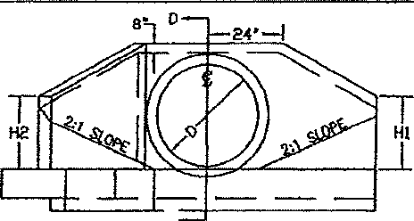
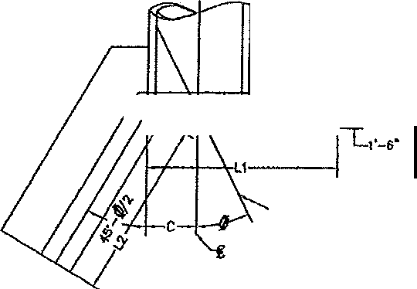
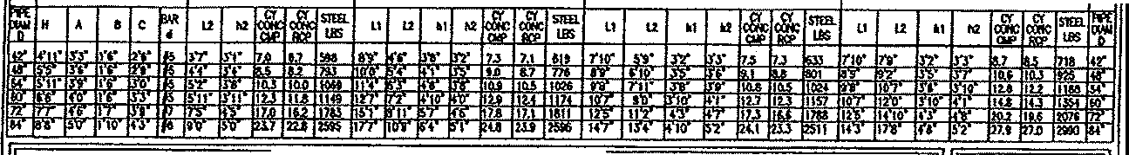
B
r

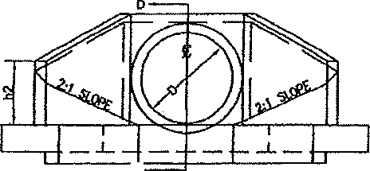
ELEVATION
7
0

«OF' CULVEffT HORWJ.
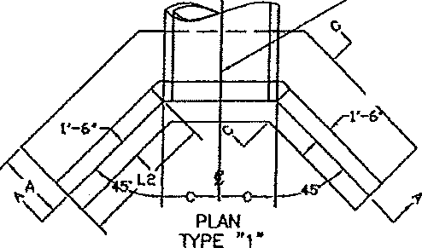
fo £Of' ROMYNl,,.Y, HEADWAU. ts SYMMETRICAL. AB-OUT£.

l)
ELEVATION

T
A

i'-

t)l:-J;, '11 J

CUI.VERT
PLAN
TYPE "2"
NORMAL TO£
OF ROMMAY

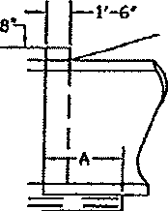
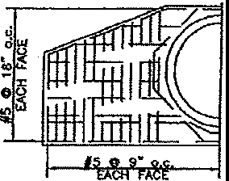
H#O5O0IZ1""8IJLo.c-.-._ Irj

H D

B
""tl i
•I
m .
3•xe• CONST. • 'I O -9""' "o..'c.

JOOlr Kf:Y .

12-T
SECTION 0-D

NOTES

SECTION C-C

HALF-SECTION A-A

- 'NPE C HEAOWAU. WHERE REQUIRED WIU. 8E PROVIDED FOR SKEWED RIO NONSKEWEO CULVERTS HA.YING A OW,IETm 00 RISE Of 42 TO 84 INCHES,
- TYPE I tS USEO WHEN TI-IE SKEW MGlE JS 10 DEGREES OR l£SS AND TYPE
2 WHEN lHE SK£W ANGt£ JS 11 DEGREES OF GREATER.
3l ALL CONCRETE. SHN..t BE Ct.ASS "c .
srm s;s·
4 ALL RElNFORCtNG SHAU. BE ROUND.
5 OIMENSIONS AND Qt.WfflTIES ARE SHOWN FOR C1RC\Jt.AA SECTIONS ONLY MiEN USED Wfrtt RElNf"ORC£O EUJPTICAL CONCRETE PIPE OR CORIWOATEO METAL ARCHES rr Will. 8E NECf:SSARY TO OETmMINE SUCH DIMENSWNS N-10 QU,\NTITIES
WHICH S1iAU. GENER>LLY CONFORM Wlffl THOSE ustro fOR THE NEAREST SIZE
PIPE. THE OIM81SIONS ESTASUSH£0 B'i VERTICAL ov.METER 51-W.l
6l
APP\.Y TO SP..-N.
CtW.lfER ALL EXP0Sro CORNERS 3/4 Of AN INCH.
7 WHERE SOIL BORINGS ™DICATE A BOOING CAPACITY Of LESS THm 2600 POUNDS PER SQUARE FOOT rr WILL BE NECESSARY TO INCREASE TrlE 'MOTH Of THE FOOTING,
6) THE MINIMUM COVER FOR RONfORCtNG sn;a SWil BE Z INCHES.

. o·
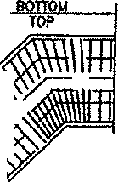
o·
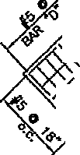
HALF-SECTION 8-8

,.,, .... ..., .,.,.

Village of Jamestown, Ohfo Standard Construction Drawings Headwall Iype C
STD-307 2008

"'- ,,,,-sLOPE OF FILL -
/\ "­
-'--

I RIP \
WHEN
l\ +-J--1 ! CAI.LED FOR-
,,,_ ,o LAN_:j
- '="--1=
L cl --;Tl
r Fj L.:: "
SIDE VIEW 1-12·_
- T D\./VIEW 'I
-------........"'"' .!JQID
/ I. l£NG1H OF CR!lll£ ID BE 10·-o· rOR
/ flllS UP TO 15'-0" Dill' IJID EQU!I. TO
1HE OEPlll OF All FOR OEPll!S 15'--0'
/ RIP RAP WHEN CALLEO FOR ON PLANS '---. HID <MR
/ CRADLE I '---.:2. RP RAP MAY BE PlAC£D AT INl£T ,VlO
- OUTlfT Of CIJLV!RT /.S OC!£RUINEO BY
Tl£ EHGINEIR.
I
I I
\ '----1E_ " --- --=- _- :::: l­
----'----'----'-i...

PLAN VIEW
PIPE CRADLE
1-□.D. + 1'-0°7 CONCRETE CRADLE DIMENSIONS AND QUANTITIES
QUANTITIES
_ ...:, ....• t. ; ..,. ' • •.. CUBIC YARDS
o I a I c H _g_/\SS •c• CONCRETE
/(-_ r;\ '\if w ' 1WO Ltl"I"FFT.
"""-£
12"16"114• lo•11•J11•0•1 o.2 I o.0476
t5"16'1 1•4• I t·o· I 2·1· I o.2 I o.0580
··-•.•··,.• - •• ·.4 -.-i-. 6' 18"16"! 1'4" j 1•2• I 2'5" I o.2 II o.0601 24"1"Tj'3• 11••· 12·11·1 o.3 o,0924
27" a· 1·3· 1•5• 3'3' o.3 o,0144
:\:·;/\:\:?:../·::):; 1.10·1 a·! n· j 1'6" j 3•s· j o.3- [o:TTB1
33" 8" 1'3" 1'7" 3'10· o.3 _o.1_325
r 36"11!"!1'3" ! ,·a· [IT I o.4 -- I o l462
39"js•J 1•3• J 1;9•·1« J o.4 I o.1606
42"1 a"I 2•2• 11'11" I ••a• I o.1 1 o.1768
48"18"12·2· 12-i==1 s•3•I o.8 I 0.2110
CLASS •c• CONCRETE - 6' 54• 8" 1'11"' 2'4 5'1l" o,9 o.2972
NOTE, 0.0. OF PIPE SHOWN 0 I!Ii I·11.12•9•I 6'6"I o.9 I o .3398
CONCRETE ENCASEMENT IS THAT OF PIPE 66" 1 1•9• 3•0• 7•3• o.9 o,4468
BARREL ONLY. 72"J1011'8" I 3'2" J7'10"I o.10 j o.4980
DETAIL s••11011•7• I 3'6"WU::Co.11 J 0 6126
 | Village of Jamestown, Ohio Standard Construction Drawings  Pipe Cradle and Concrete Encasement | STD-308 2008
" "'"'
CRADLE"-. '---.
 | 1-- | r B "- 2·-0·
 | 1-- | L ....L. -TO-E O-F SL-OPE1'-1..-._ ---1

(IN)  _DIA. | ¾
4 | O.oJ
6 | 0.08
8 | 0.10
to | O.t t
12 | 0.13
14 | 0.14
16 | 0.16
18 | 0.18
20 | 0.20
24 | 0.25

-a·
I' 6' CONCRETE PAD
r112· r CONC BARRIER CURB
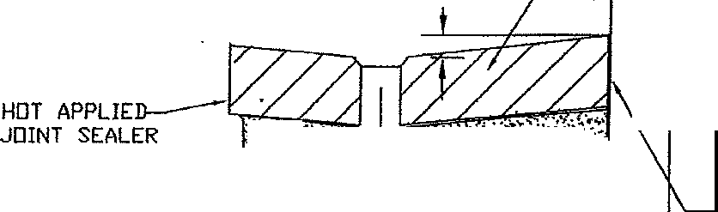
ASPH4LT I

;-,:.,,:):>- ,,-;r,· I J,-, ',J·'•:•-:;,: ·.,..,,.
t?t/ i i tt{
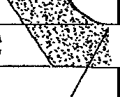
':..;:• Ir>• <..,... :-dtc-.,-:..,,--;--_.•.1:,.-•,.-;.:,,-,;,_,..f,t, HOT APPLIED
H[GH SLUMP C□NCRET 'ii:· -.: .l:.f;,, .\ !.t·'·.;,;.

.:-.-.. 't ,-: li";-x -'t 'r - -- JOINT SEALER
:. £ rf!J{''':•
z - TRENCH
ii:
'(")

12¢' , 16 GAGE, SLOTTED DRAIN 111TH 6' GRATE PIPE SHALL BE CORRUGATED STEEL PIPE <CSP) AND
SHALL CONFORM T□ AASHTD M36,
ALUMINIZED STEEL, TYPE 2
CAP END OPPOSITE CATCH BASIN

NOTE, CURB \/ILL BE PAID UNDER
'ODOT 609 - CUTB & GUTTER JAMESTOWN - TYPE A'

$)..OTTED DRAIN
NOT TO SCALE
 | Village of Jamestown, Ohio Standard Construction Drawings  Drain | STD-309 2008

" - 8' IF POURED IN PLACE
6' IF PRECAST
CASTING SHALL BE NEENAH R-3408-L, R-3408-AL □R EQUAL CITY ENGINEER SHALL DETERMINE IN EACH CASE THE P□SITl□N OF THE GRATE <TRANSVERSE □R LONGITUDINAU
ALL CASTINGS MUST BE or THE BICYCLE FRIENDLy TYPE,
D

l-1'<-1----30''---+--i,,-
C oomoooooo C

•' • '
.

1-·

- .
.:.

: \?-:<:::;":;:; ?5:
D
GRATING PLAN VIE\,/
11111111111111111

_!_.1

- 4 ·.,
.
•.._
.:..
-: .•
:·•
;:::9,5,
I I
37'

,:..
•. .:. ,_

;- T_._:;,
...
•..

: ;l f
2-J
II 11 I I " 7'

-
I
28.5'-
30'
SECTION C-C

··<..·.-_\- _·i :-_t.-: ;:·:_;·
••• • " .o'6Q80
'-3" GRAVEL (#57) MIN
SECTION A-A (TYP)
r*r 0'7*1
3

'

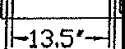

SECTION D-D
19.25
14.5'
15'

7,7.5'
·.
...•.
:•·•J•I" ,t;•I

·-.·.,-.,
4 B
.'..
•
·•::,.
,.·>

A

000000000
000000000

' ., .....
••
•• ": d" ,·.;

.. .. ..i -·.
. •• d • •.
'• •.·

·.--• ,' ,(\•· 4"
•
a " •.., ,. . ,.. . .._
... • .••.. :· <ti• !' · - B"
SECTION B-B PLAIN VIE\,/

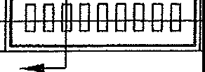
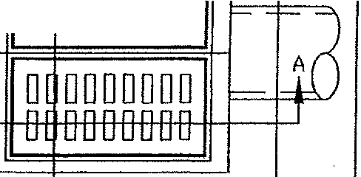
Village of Jamestown, Ohio Standard Construction Drawings Drip Drain
STD-310 2008

..?-;::;>---...-

TOP VIEW ECCENTRIC CONE

.....j H•MIN
CHIMNEY SEALER I l_rI GRADE RINGS OR APP'D EQUAL.\r-------, 4'M!N
I
16'MAX
O!,P,,iE,1N.nIN..,G ;;:::J
32• ECCENTRIC CONE

5• MIN.
BARREL SECTION
I
VARIABLE

DIM. TO SUIT

NOTES
All storM Mnholes sho.ll be preco.st wHh o.n eccentric cone. Steps shall be n MnxlMW'I of 16' npo.rt nnd Mde of r,etnl conted with flberglo.ss or o.luMinuM nlloy.
To o.dJust to gro.de concrete rings "donuts•co.n be usecl, MO.XIMUM gro.de o.djustr1ent shnll be 16', Grenter o.dJustnent requires bo.rrel sections to be changed. Poured floors sho.ll be o. MlnlM.uM of 8'
th/ck 4000 PSI <reinforced) with n MlnlriiuM of 6" #57 stone under Ma.nholE'. Sof"t ground <w "t) sho.ll be bridged with #2 stone o.s directed by the Village.
Seo.ls sho.lt be1 1, Kor-N-Sea.l
- Duro.-Seo.l
- Pr-ess \./edge II
- Concrete cello.rs
Monhole section jolnts sho.ll use
•□•
ring type senl.
Mastic shall be used on shelf of
MO.nhole In wet o.reo.s,
Co.sting sho.ll be, Nc,c,nnh R-1767
4-hole lid, Ea.st Jordo.n 1600 Type C
lid (2 hole)
Adclltlono.l inforMcdlon ca.n be found In the Mo.terlo.l o.nd Construction Procedure sections of' this rrto.nuo.l,

30", 36' 48'
BASE SECTION

e• MIN,

6' #57 GRAVEL BASE MIN.

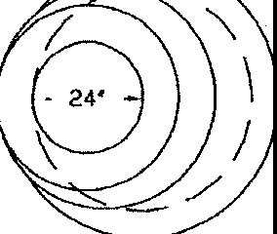
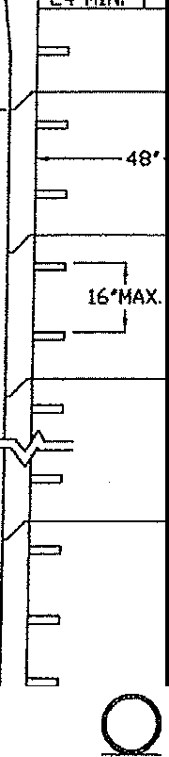
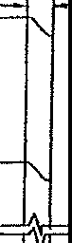


Village of Jamestown, Ohio Standard Construction Drawings
t Manhole
STD-311 2008

AP | WIDTH B/B OF .CURB  1i£_j_ ft 0.0208  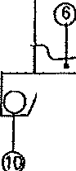    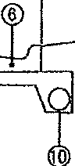  :a)(9 ·2 ;i_ :1 11)<9.  TYPICAL SECTION FOR STREETS    WIDTH B/8 OF CURB 50% OF 8' (MIN2  STANDARD STREET WIIJTH PER  (ADO a· FOR PARKING)  . ,14• I ft II 0.0208 15  "6'    - 41 1r1 I I I I  :a) (9 ·2 7) (8) (9) (1 :,, :s :S) (9  TYPICAL SECTION FOR ALL BOULEVARDS  WIDTii BLB OF CURB  1LLJft 0.0208  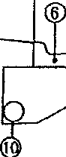  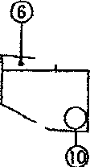  Jl) (9_ .5 ;i )!)  TYPICAL SECTION FOR INDUSTRIAL STREETS SUBJECT TO TRUCK TRAFFIC  z'  j LEGEND  - ntM 203 SUBCR>DE ClOMP>.CTION  2) na, J04 ur AGC11ro\t:E TM'.> COORS8S oo  lfEM JOI 6" 81\IWNOUS IDGRfrnlt 8'.5£. two OOORSES  :l ITEM 402 1-3/♦• ASf'W.l.T <XlNCREJE ftDI <404 1-114• ASffW.T COffC:RaE  fIDI 46' PftlWE COO (lff'lJED MA R\'lt Cf' 0..:, .Oft  iREM 40) TJia< CQ!.T (lffUl) 11 A 1WE Of 0..075 CN./St)  QCVRa t 8 ITEM &09 BAAR£R CURB,, SEt VILLAGE SfANl'.)I.RO  fl£M 609 COWW.llOtlCVR8&WTTER,5a.YlllAGESTN«l,W):  REM 6SJ 3• TOPSOO. FIJRtfSt-lft> & Pl.AC£D TO Rftl  ITtM 0$9 stmHO 6: MlU:tt!HO TO R/W  NTS 10 ffat ffi 701.:$.l ti• $KI.U.OW UHDERORAIH  PLIES TO AU. <:ORB k GUTTER ti #8 STONE  11) ITEM .-SOI W BlJ\lNJ«lUS 8lSE. THR££ OOllRSES
AP | Village of Jamestown, Ohio  Standard Construction Drawings Typical Street.Sections | 2008
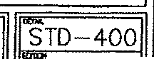

5' 6' -•st-
Rl/4' '-
Rl/4' £)' l'R [ 7 1/4' J,,. ..,_--3' R "
--. . "
Lru··_••... ·-,. :-T .N........-.......-4 I'
_:.l"·_:' ._-- •:,·,
···0°
_I 24'- □3' DDGTR3A0V4EL MIN 24' □3'D GRAVEL MIN
OT 304
!' RADIYS CURB 8, GUTTER 3' RADIUS CURB 8. GUTTER
TYPE "C" TYPE "C"

s·, ''°
uI _l_:1 i 6' [ 7 1/4'
_{T}C· ·-• 1
. t::::· I
---l 1-G• 24'
BARRIER CURB DROP CURB FOR DRIVE

TYPE "8" TYPE "D"
7 s·r
t _-t'l21"RI _L
12' •• _;, ·' '• ,• 7 5/8'

,- • 0WCT

l---30' '-------3• GRAVEL MIN
□DOT 304
ROLL CURB 8. GUTTER

TYPE "R"
 | Village of Jamestown, Ohio  Standard Construction Drawings Curb !k Getter Details | ...S.TD-401  2008

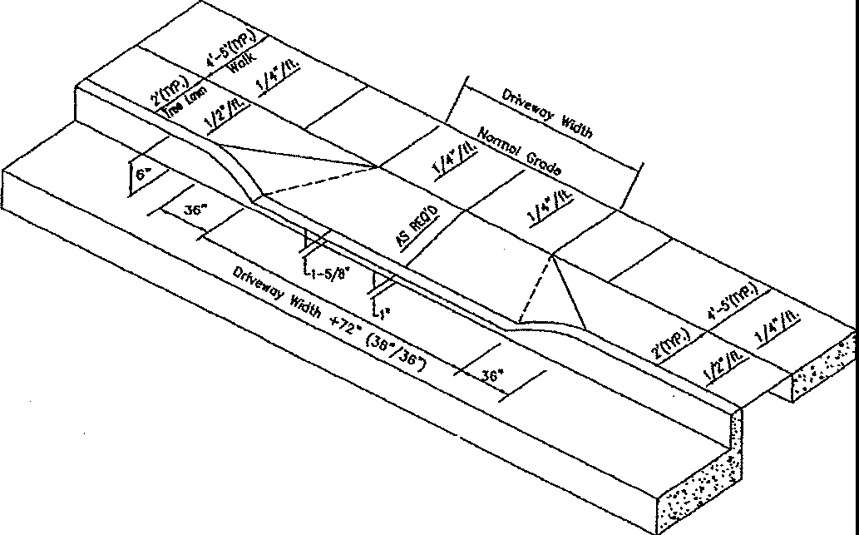
C\flS f(rn',) N'fR(W)f I 4• • 00/<C. WIil(
ISOMETRIC \IIEW
..

. -·-l ,
ro I
.· i.· ·::..:·u:-.: :;.:-:::.--:;r :-··!·;_
..J/£11!,. . -

;!- ,,.,...;-. :.-.,;\\:d·y,,'.•···•·· •··. .N Joiit
7 •• ? ••• •· •, • " , .... .._. ,.,
- ,. : l..'►• ·: S' Cf COOT SWU. BE PlACfD uaR
-·.. 1/2'£••·"""""''
DRIVEWAY PROFH E

t:--Ori,owoy lll<lth-j /1/2' - Jdol
-
,.-- S'(m>J ti,,
t
4•OOte SlOfU ' 4• JOINT

'1m: U.11'7
7 //,,;, < J \. \""
"'11<£ l.Q!i7 t],

I : I '
""""PIii DrNewoy Width
  - >wu7
DRIVEWAY PLAN

GRADE CONTROLS
=--
1. 12,i; MAXIMI..N GRAO£ 8R£.IJ(. SNl CURVE
WITH K=0.8 w,y 9t US£0.
fillIDi
- ORN£ APPROACHES SHAU. 8E ct.ASS •c• CAST IN PLACE CONCRETE
- MAXIMUM JOINT SPACING stWJ. 8£ 12' LOHGfTUDUWJ.Y AHO TRANSVERSfl..Y
- ALL RESIDENTW.. DRIVtS SHAU. BE A MINIMUM Of 6" iHlCK
- JJ..L COMMERCIAL DRrYES Slw..l BE A NINIMUM OF 8 THICK
- RESfOENTW.. ORM: M-\1<WUM wmH = 20' (BACK OF WALK)
- COMMERCIAL DRIVE IM'<IMUM WIDTH = 30' (BACK Of. WALK)
- EXPANSION MATERW. SHAU. BE 1/2" PREMOU)EO
- 3" OF OOOT J04. StWJ. BE PLACED UNDER APPROACHES
- PR0Vl0£ BROOM f1NJSH 00 EOOING TO All. EXPOSED SURFACES

.. m
= ,..-

C\ll'/E
- WHERE ASPIW.T CONCRETE PAV[MENT HAS 8£EN DISTURBro, THE ASPHAl.T
SHAlL 8£ REP\I.CED f,S DIRECTED 8Y THE VILLAGE

Village of Jamestown, Ohio Standard Construction Drawings Residental / Comm_grci.al Drive
STD-402 2008

PROPERTY LINE 1/2" PREMOLOEO EXPANSION JOINT MATERIAL,

1/2" PREMOLOED EXPANSION JOINT MATERIAL
r 1" JOINTER CUTS FINISHED TO
A I A RADIUS OF 1/4• OR 3/8"

•

  - ----t-----50'-0' 1
VARIABLE WIDTH TREELAWN
===================LL.:======,-- =====================-=----
A '-CURB

PLAN VIEW

mIES
    - PROVIDE BROOM flNISH TO All EXPOSED SURFACES.
    - CONCRET£ SHALL BE 4000 PSI MIN.
    - PROVIDE A MINIMUM OF 2• EDGING AROUND ALL EXPOSED SURFACES.
    - A MINIMUM OF 3• OF COMPACTED GRAVR (OOOT 304) SHALL BE PLACED UNDER ALL SIDEWALKS.
    - 1/2• EXPANSION JOINT MATERIAL SHALL BE USEO EVERY 50 FEET OF WALK, BETWEEN NEW AND
EXISTING S1DEWALK AND CURB, ANO BETWEEN DIFFERENT CONCRETE THICKNESS.

NOT£! WALK THICKNESS SHALL BE 4 MIN.
WALK THlCKHfSS AT RESIDENTIAL DRIVES SHAI.L 8E 6"' WALK THICKNESS AT row.!ERCW. DRIVES SHAU. 8"

_{•b} > 4'
l SLOPE AT 1/4• PE
4000 PSI CONCRill


•ll;,l•i,
• • • •
R 1'-0"

'1:;'"" ' T
7 ,.,,- •un/rnffi ,·

REQUIRED
" ,liJ1:
BACK OF CURB

1'-0" 4'-o" OR s·-o·
SEE STREET TYPICAL SECTION

SECTION A-A
-
VARIABLE

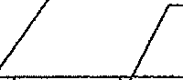
Village of Jamestown, Ohio Standard Construction Drawings Con cete Sidewalk Detail
STD-403 2008

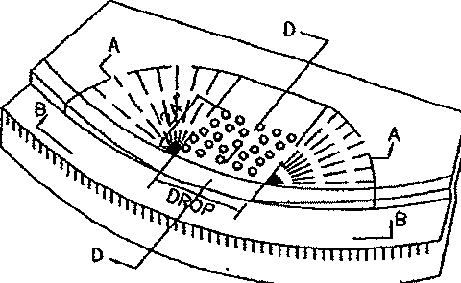
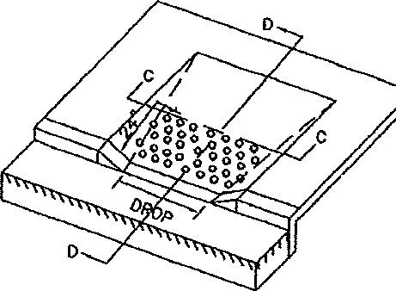
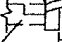


STD-404 2008
-
TYPE "1" = r
,,,. "'"\ L12,,
1 1

SECTION A-A
I ··:I •·-o- I o· I
NOMWAt
DOMED AREA EQUALS THE FULL WIDTH OF THE CURB RAMP I OEPR!SSEOCURS I
BY 2•4 MfA5\IRED FROM THE BACK OF CURB SECTION B-B

TYPE "2"
a· ro 12ll 1·-2· "'" I1-s· ro 12·
;:,-=
wm</ SECTION C-C
1/2" EXPANSION ·
R£llOVE \ JOINT
Jl"G -- _r12I!1SLOPE 4'
"-I/•·""""""' f_= I
J ffltam Eki§l::ALK I ,w$ G!H rWMY.
ooi&JWA
DOMED AREA EQUALS THE fULL WIDTH OF THE CURB RAMP SECTION D-D SECTION D-D
BY 2•4 MEASURED FROM THE SACK OF CURB IN EXISTING WALK

NOTES
All RAMPS SHALL HAVE TRUNCATED DOMES IN ACCORDANCE WITH ADA REQUIREMENTS. ARMOR-THE OR EQUIVALENT N3 DETERMINED BY VILLAGE ENGINEER.
JOINTS SHALL BE PROVIDED IN THE CURB RAMP />S EXTENSIONS OF WALK JOINTS AND
CONSISTENT WITH REQUIREMENTS FOR NEW CONCRETE WALK. A 1/2" EXPANSION JOINT FlLLER SHOULD BE PROVIDED AROUND THE EDGE Of RAMPS BUILT IN EXISTING CONCRETE WALK. 3" OF COMPACTED GRAVEL (ODOT 304) SHALL BE PLACED UNDER ALL CURB RAMPS.
AN'( COMBINATION OF SIDE SLOPES ON OPPOSITE SIDES Of A RAMP MAY BE USED TO BEST
FlT THE SITE CONDmDNS. THE MINIMUM RAMP LENGTH IS 5' FROM BACK OF A s· CURB AND MAY BE INCREASED WHERE FE/\SIBLE TO OBTAIN A FLATTER RAMP SLOPE OR TO BETTER BLEND WITH THE WALK CONFIGURATION.
WALK THICKNESS IN THE RAMP SLOPES SHALL BE 4" MINIMUM OR THICKER AS NECESSARY TO MATCH ADJACENT WALK THICKNESS.
Village of Jametown, Ohio
Standard Construction Drawings
.c.

- STOP SIGN: TO BE ENGINEER GRADE MATERIAL
- SIGN POST: 2 SECTIONS OF 2# U-CHANNEL POST
- STREET MARKER WITH POST MUST BE PURCHASED FROM VILLAGE OF JAMESTOWN STREET DEPARTMENT. CALL (937) 675-6695 FOR DETAILS
- THE VILLAGE OF JAMESTOWN DOES NOT SUPPLY ANY OTHER SIGNS OR POSTS

,.i .,ii t
f IY', ••

1/10
•o


'0 s p
(')

0
J-30•

0

0
r0
'0 lo
;:.I..
NEWMAN SIGN lo
1-800-437-9770
10
S.A.B.I. 0.:
>-
1-800-837-2245 ^{I-} ¹⁰
r•o
VULCAN SIGNS 'o-
1-800-633-6845
0
_{;i} "TTE!ll';l';';Eliml!lEl 1·1 1 11;.•r
'f t-1 I t--11 t--t I 1;0II 1-IJ 1-i I 1-11I-

:.: .tl.L!,, O ll;I;I;lll=IIF-
o·
"(') '
0
 | Village of Jamestown, Ohio Standard Construction Drawings Stop Sign Detail | STD-405 2008

- SIGN: TO BE ENGINEER GRADE MATERIAL
- SIGN POST: 2 - 2# POST, 7'-0" IN LENGTH (U-CHANNEL POST)
- SIGN: OHIO UNIFORM TRAFFIC CONTROL DEVICES, X-4 A

o0. }o { o} o} o o.
{ 0o0o
000 000 000 0 o0·.
,1 1,1 1,1 I
o]

c§ I 1;,.
,1 Joi a 0'I
Cl:'. 111:
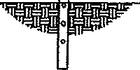
1:1 1:1 di

'..,,

-L- ruI

LI U T
6' TYP. -3• 3'---J 6' TYP.

NEWMAN SIGN
1-800-437-9770
S.A.B.I.
1-800-837-2245
VULCAN SIGNS
1-800-633-6845
 |   Village of Jamestown, Ohio Standard Construction Drawings  n | STD-406 2008

AC-20 JOINT
"

. • PROP SURFACE COURSE\
\if

C - - PAVEMENT

@ lMil\ WM .4$$. .il; %R w&,
'I
I l/4' MIN

BUTT JOINT DETAIL

FEATHERED AREA MIN LENGTH 2' PER 1" OD D

INTERMEDIATE COURSE
oj I ,
SURFACE OF EXISTING PAVEMENT _/

SURFACE COURSE
LJ APP, 2,' --
:LT CEMENT COATING

FEATHERING DETAIL ( requires Village engineers approve!)

Village of Jamestown Standard Construciton Drawings
Roadway Joint Details
STD-407 2008

'
'\
l).

I

./v .

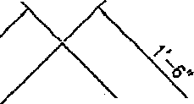
--

--

LONGITUQ!NN.-
JOINT ON ct_

2· r
- \i.i_ ·--:.: .. -;
MONUMENT BOX TO
BE NEENAH R-1970
OR EQUAL

-. -- ••••
:.;. .../! .·.4:- :/

••... B<lST'. ('/ADWAY· - ·- .•
:·\ ..
:'.}· .. ·. ---··· -.· .,

CLASS •c•
CONCRETE

•1 DIAMETER ROD
·JO!,. ri.i -- 9Jio!"Ai::,.
4.'.''··.:$··. -·-=·
KEYED JOINT (lYP)
d

0
. I
N

&I I I I

<$ J '-

§."


Village of Jamestown, Ohio Standard Construction Drawings
onument Detail
STD-408
2008
-

THE TEMPORARY CONSTRUCTION ENTRANCE SHALL BE INSTALLED FIRST TO ALLOW PROPER ENTRANCE AND EXIT TO WORK SITE
2. ADJOINING PAVED ROADWAYS MUST BE KEPT CLEAN AT All TIMES

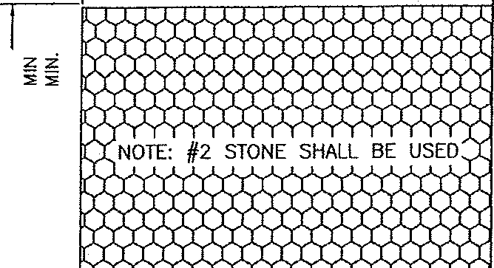
;;
1----------50• 1
•

II II
1z --0
Ww
0::
1(j::,;
Cl ::,;
!l::' 8
Li..0
0
:::c!t::
6-w0
=.::,0,(/)
,:: 0..
n.
L1.A,V..-'vV-,,yyy¥rYYYYYYY'cr1
GRADE @ 1% OR AS SHOWN

PLAN

c!j
0::
(.')
z
8

z
51
;,, PROFILE

Village of Jamestown, Ohio Standard Construction Drawings
Temporary Construction Driv<a../ Entrance
<{
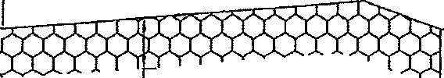
0a::
15• @2.0%n
35• ® 1.0%----
.
I
Cl
z
8

STD-500
-
2008

TYPICAL EROSION CONTROL PLAN PROPERTY LINE ­
FOR SITES OF ONE ACRE OR LESS RIGHT-OF-WAY ­
DRAINAGE SWALE ---------------
BACKYARD DRAINAGE SHOULD BE DIRECTED
TO CONCENTRATED FLOW IN DRAINAGE SWALE EXISTING DRAINAGE ­
AND DISCHARGED THROUGH SILT FENCE OFFSITE
STRAW BALES--0---0---0--
-----PL----- SILT FENCE --0---0-----0--
:.,·.-.,·.·.,·.,·.,
'9'VVVV11'9
--------------- --------------- ,_.._ GRAVEL 7VV9VVV'I'
VT9TTV\t9'
'1'9'1'9VVVV•
/[QJ/e [Q] TREE PRESERVATIONIOI
STOCKPILED TOPSOIL-
_J ////i
0.. G) DISTURBED AREAS TO BE TOPSOILED
, 777777777770! SEEDED AND MULCHED BY OWNER
; 1 ;7-r7;,,7ry7/71} AT COMPLETION OF CONSTRUCTION
/ ,
i BUILDING GARAGE ;
/ ,
//////////////////.
t".,•.,v.,•.,vvv,;f
'VVVl'V99
,V.9,,V.V.,V,,V..V.'
YVVVV1
\ G)\ ,V.,V,.9.,'9,.V.,V.,1
R Vv^{V}.v⁹,.n^{V}•^{V}vl^{V}i'^{I}
..V,..V..,.9.9.9..'.,9 V.,.
,.V.,T,..V,.V,,T, Val
NOTE: STREET NAME '-- EXIST CURB AND GUTTER SILT FENCE TO BE INSTALLED BEHIND
ANY EXIST SIDEWALK AND/OR AT CURB
WARNING!
EXTRA MEASURES MAY BE NEEDED IF YOUR SITE
-IS WITHIN 300 FEET OF A STREAM OR WETLAND
-IS WITHIN 1000 FEET OF A LAKE
-IS STEEP (SLOPE OF 12% OR MORE) TYPICAL LAWN SEED MIXTURE
-RECEIVES RUNOFF FROM 10,000 SQ FT OR MORE FOR EROSION CONTROL
OF ADJACENT LANO
-HAS MORE THAN AN ACRE
GRASS SUNNY/PARTIALLY SHADED SITES
TURF TYPE TALL FESCUE 5Ibs PERENNIAL 1lbs
SEEDING RATE
SEEDING RATE 6Ibs
1000 SQ.FT.
Village of Jamestown, Ohio Standard Construction Drawings  Erosion Control P_ractices for Smaal Sites | -STD-501  2008

SEDIMENT AND EROSION CONTROL FOR COMPLIANCE WITH OEPA'S INDIVIDUAL LOT PERMIT FOR CONSTRUCTION
PRESER'IJNO EXISTING VEGETATION
WHENEVER POSSIBLE, PRESERVE EXISTING TREES, SHRUBS, AND OTHER VEGETATION.
TO PREVENT ROOT DAMAGE, 00 NOT GRADE, PLACE SOIL PILES, OR PARK VEHICLES NEAR TREES MARKED FOR PRESERVATION.
SILT FENCE & STRAW BALES
- PUT UP BEFORE ANY OTHER WORK IS OONE.
- INSTALL ON OOWNSLOPE SIDE(S) OF SITE 111TH ENDS EXTENDED UP SJOESLOPES A SHORT OISTANC€.
- Pl.AC£ PARAUEL TO THE CONTOUR Of THE LANO TO ALLOW WA1£R TO POND BEHIND FENCE.
* ENTRENCH 6 INCHES DEEP.
- STRAW BALES SHALL BE USED ONLY IN MAJOR DITCH LINES WITH THE APPROVAL Of THE VILLAGE
ENGINEER. ALL OTHER LOCATIONS REQUIRE SILT FENCE.
- STAKE (2 STAKES PER BALE OR I STAKE EVERY 3 FEET FOR SILT FENCE).
- LEAVE NO GAPS BETWEEN BALES OR SECTIONS OF SILT FENCE.
- INSPECT AND REPAIR ONCE A WEEK AND AFTER EVERY l! INCH RAIN. REMOVE SEDIMENT IF DEPOSITS
REACH HALF THE FENCE OR STRAW BALE HEIGHT.
- MAINTAIN UNTIL A LAWN IS ESTABLISHED.
SOIL PILES
- LOCATED AWAY FROM ANY DOWNSLOPE STREET, DRIVEWAY, STREAM, LAKE. WETLAND, DITCH OR DRAINAGE
WAY.
- TEMPORARY SEED SUCH AS ANNUAL RYE IS RECOMMENDED FOR TOPSOIL PILES.
- SURROUND WITH STRAW BALES OR SILT FENCE.
GRAVEL ORM:
- INSTALL A SINGLE ACC€SS DRIVE USING 2" AGGREGATE.
- USE TO PREV!:NT TRACKING DIRT ONTO THE ROAD BY ALL VEHICLES.
- MAINTAIN THROUGHOUT CONSTRUCTION UNTIL DRIVEWAY JS PAVEO.
- PARK ALL CONSTRUCTION VEHICLES ON THE STREET AND OFF OF THE SITE.
SEOIMENT CLEANUP
- 8Y THE END Of EACH WORK DAY, SWEEP OR SCRAPE UP SOIL TRACKED ONTO THE ROAD AND IN THE
GUTTERS.
- 8Y THE END Of THE NEXT WORK DAY AFTER A STORM. CLEAN UP SOIL WASHED OFFSET. AND CHECK
STRAW BALES AND SILT FENCE FOR DAMAGE OR S£0JMENT BUILDUP.
DOWNSPOUT EXTENDERS
- NOT REQUIREO, BUT HIGHLY RECOMMENDED.
- INSTALL AS SOON AS GUTTERS ANO DOWNSPOUTS AR£ COMPLETED.
- ROUTE WATER TO A GRASSED AREA.
- MAINTAIN UNTIL A LAWN IS ESTABLISHED.
REVEGETATION
DISTURBED SOILS SHALL BE STABILIZED AS QUICK AS PRACTICABLE WITH TEMPORARY VEGETATION AND/OR MULCHING TO PROTECT EXPOSED CRITICAL AREAS CURING DEVELOPMENT. TEMPORARY MULCH JS TO BE APPUEO AT THE RATE OF ·2-3 BALES or STRAW PER 1000 SQ. FT.
SEEDING AND MULCHING
- SPREAD TO 6 INCHES OF TOPSOIL
- FERTILIZER ACCORDING TO SOIL TEST {OR APPLY 10 LB. / 1000 SQ. FT. Of 20-10-10 OR 10-10-10
fERllLIZER)
- SEED WITH AN APPROPRIATE MIX FOR THE SITE.
* RAKE LIGHTLY TO COVER SEED WITH !,I" OF SOIL ROLL LIGHTLY.
- MULCH WITH STRAW (2-3 BALES PER 1000 SQ. FT.) FROM MARCH 15 TO AUGUST 31.
- ANCHOR MULCH BE PUNCHING 2 INCHES INTO THE SOIL WTTli A DULL, WEIGHTED DISK OR BY USING NETTING OR OTHER MEASURES ON STEEP SLOPES ANO \\INOY AREAS.
- WATERING REQUIREMENTS SHALL BE IN ACCORDANCE WITH SUPPLIERS' RECOMMENDATIONS AND/OR UNTIL
LAWN IS WEU. E:STASUSHEO.

SODDING
- SPREAD 4 TO 6 INCHES OF TOPSOL
* ·FERTILIZER ACCORDING TO SOil. TEST (OR APPLY 10 lB./1000 SQ. Ff. Of 20-10-10 OR 10-10-10
fERllU-),
- INSTALL SOD IN ACCORDANCE WITH SUPPLIERS' RECOMMENOATION.
- WATERING REQUIREMENTS SHALL BE IN ACCORDANCE WTTli SUPPLIERS' RECOMMENDATIONS ANO/OR UNTIL
LAWN IS WELL ESTASUSHE:0.
IF CONSTRUCTION JS COMPLETED AFTER AUGUST 31, SEEDING OR SODDING MAY BE DELAYED. APPLY MULCH AND TEMPORARY SEED (SUCH AS RYE OR \\INTER WHEAT) FROM SEPTEMBER l TO w.RCH 15.
STRAW BALES OR SILT FENCES MUST BE MAINTAJNEO UNTIL FINAL SEEDING JS COMPLETED IN SPRING. MARCH
15 TO MAY 31.
Village of Jamestown, Ohio Standard Construction Drawings  Sediment and Erosion Control_ | STD-502 2008

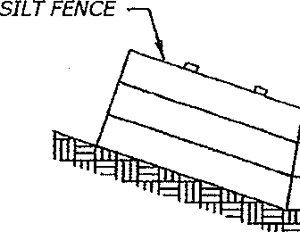
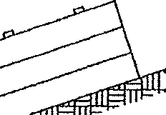
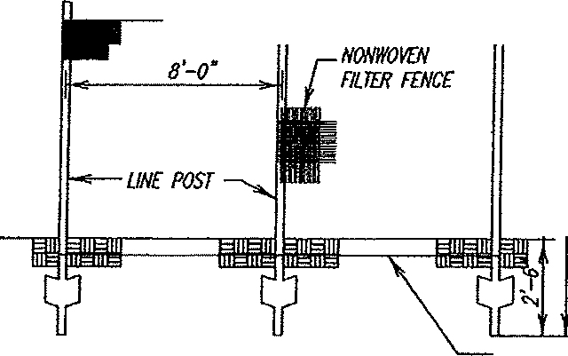
SILT FENCE TO BE STAKED
WITH WOOD/IRON STAKES

SILT FENCE DITCH EROSION CONTROL DEIAIL

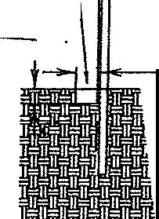
•
FJ#f!f:
6" x6" TRENCH
[J.OW;,,...
6" /JIN.
!
"">I :

SILT FENCE DETAIL

Village of Jamestown, Ohio Standard Construction Drawings 'It Fence and Channel Protection
EMBEO F#JRIC 6"
BELOW CIIO(JNO

-STD-503
2008

' 1 r •:III""-'!I f •TlI IIll.Llrrr-'ff'
-111 .1111111_ \\..t-,--l-,-,-.,-11111!''- I'
- '-:j' '=;:;:;- _? y. =-"''
  - '' -II 1=111=111-111=-11,_

"D"

DEPTH "D" MEASURED PERPENDICULAR TO SLOPE
SHALL BE SPECIFIED BY THE ENGINEER

ALL ROCK CHANNEL PROTECTION MAY BE PLACED WITH OR WITHOUT A 6" BED
OF #3 OR #4 CRUSHED GRAVEL

NOTE:

SLOPE AND ROCK CHANNEL PROTECTION SHALL CONFORM TO OOOT ITEM 601 (current edition). ROCK AND AGGREGATE MATERIAL SHALL
CONFORM TO OOOT ITEM 703.19 (current edition).

TYPE OF ROCK USED SHALL BE APPROVED BY THE VILLAGE ENGINEER PRIOR TO PLACEMENT
 | Village of Jamestown, Ohio  Standard Construction Drawings Rock Channel Protection | -STD-504  2008

